HOBBY SEASON MODEL PRESENTATION 2022
IN YOUR PRESS FOLDER YOU WILL FIND
- New caravan 2022
- New motorhomes 2022
- Company information

IMAGES
Images for the press release and new products for the 2022 season can be found online at https://mediaportal.hobby-caravan.de/en/press-photos-2022/.

As we are currently in the process of completing images for the new products, the photo gallery will be updated on a daily basis. Please check the site regularly for new images.
Images from previous years can be found in our new photo archive.

CARAVAN INNOVATIONS
FOR THE 2022 SEASON

BRIEF OVERVIEW
- New direction for the complete caravan range
- Three new model ranges
  - BEACHY: A beach vibe on wheels
  - EXCELLENT EDITION: Family and design
  - MAXIA: A new generation

OVERVIEW OF MODEL RANGES: 7 model ranges, 54 layouts
EXCELLENT
12 layouts
BEACHY
3 layouts

ONTOUR
3 layouts

DE LUXE
15 layouts

PRESTIGE
13 layouts

MAXIA
2 layouts
EXCELLENT EDITION
6 layouts

(The De Luxe Edition and Premium model ranges will be replaced by the new model ranges.)

NEW HOBBY DESIGN LANGUAGE
Just in time for the new 2022 season, Hobby is launching a brand-new and completely revamped range of caravans: new model ranges, a new interior, and a new look and feel. Hobby development experts have created this new design language in close collaboration with external design agencies and engineers. The fresh model range is aimed at a very wide audience, including design-conscious, trendy campers and young families, for example.
New furniture doors and a homely atmosphere with warm hues make the popular ONTOUR and DE LUXE standard model ranges feel particularly cosy in the 2022 season. The design of the popular EXCELLENT and PRESTIGE model ranges has been improved in a number of areas, and they retain their trendy interiors.
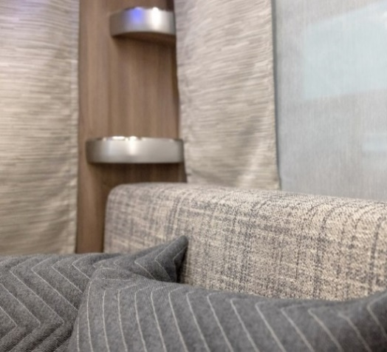
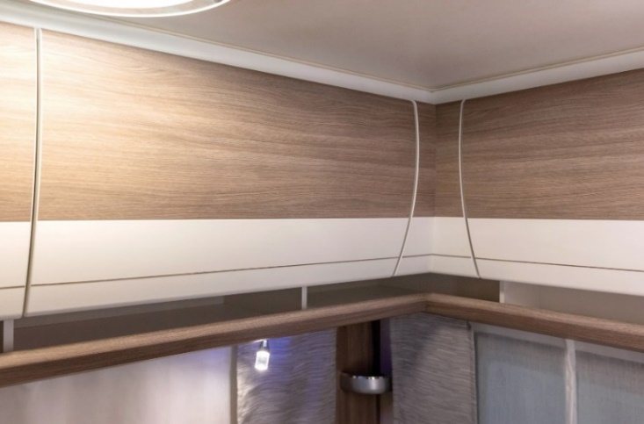
ONTOUR

DE LUXE

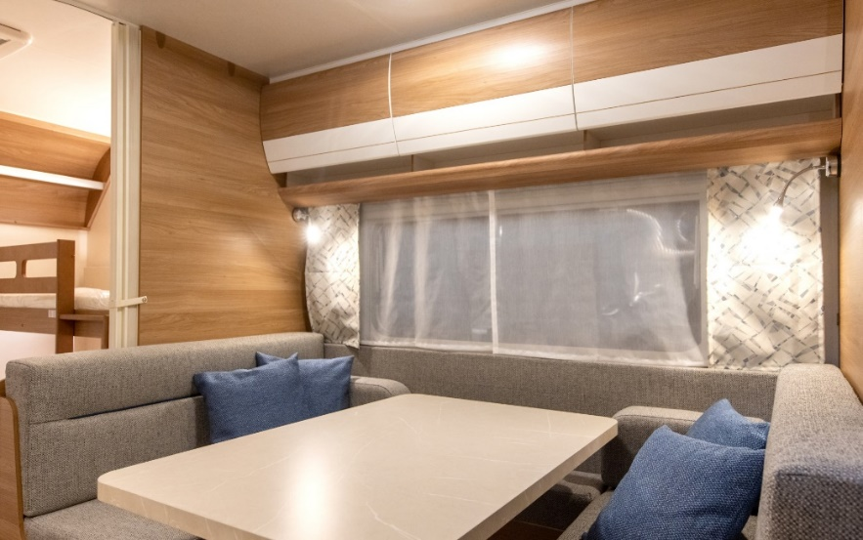

NEW MODEL RANGE: EXCELLENT EDITION
Spacious, bright, versatile, design-conscious and cosy – the new EXCELLENT EDITION combines all of these attributes perfectly. Six different layouts are available, which are mainly aimed at young, modern families. Only four models have a bunk bed for younger campers. The modern, Scandinavian-looking combination of bright colours and straight lines was the brainchild of Harald Striewski. Striking LED lighting accentuates this design language, which is characterised by straight lines.
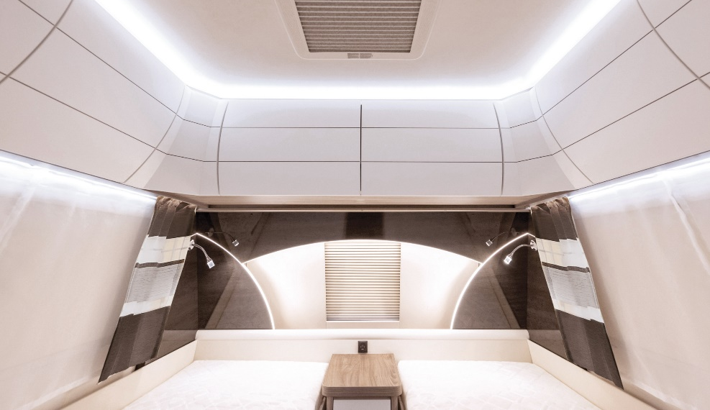
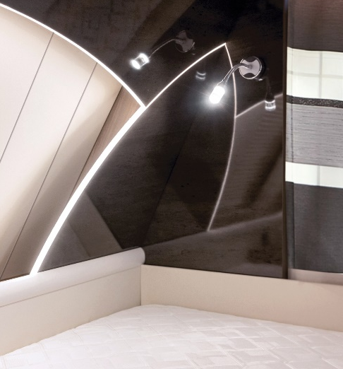
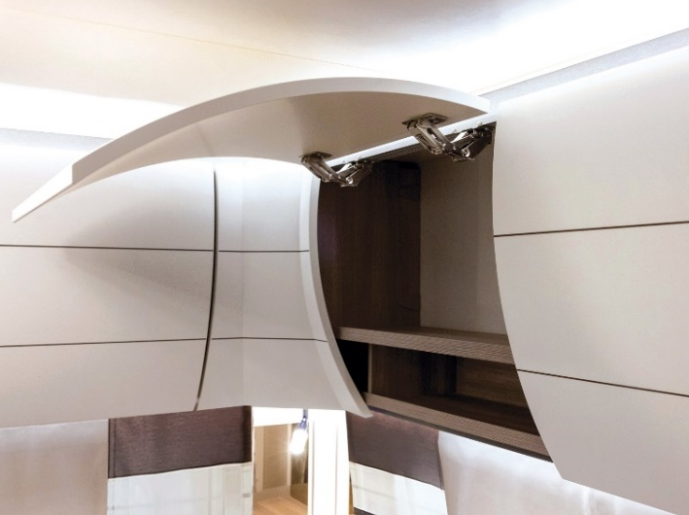

MAXIA – HOBBY’S NEW PREMIUM CLASS
The Scandinavian world fascinates and inspires us with its love of nature and the concept of ‘hygge’. In the 2022 season, Hobby is encapsulating this lifestyle in its new MAXIA model range, transforming people’s caravans into the most beautiful places in the world. The Nordic aspiration is documented in this brand-new Hobby model range by a very clear and functional design language. Perfectly coordinated colours, an open interior design and a stylish interior create a boundless feeling of complete relaxation and pure cosiness. Simply ‘hyggelig’, as the Scandinavians would say.
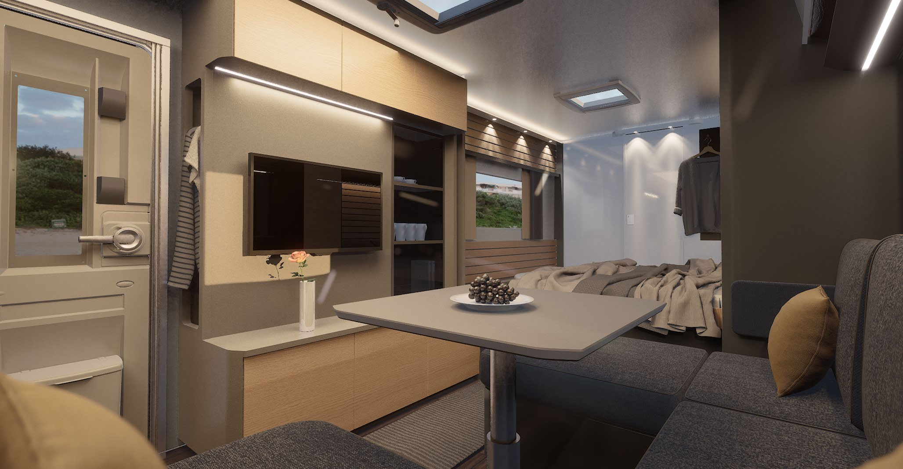
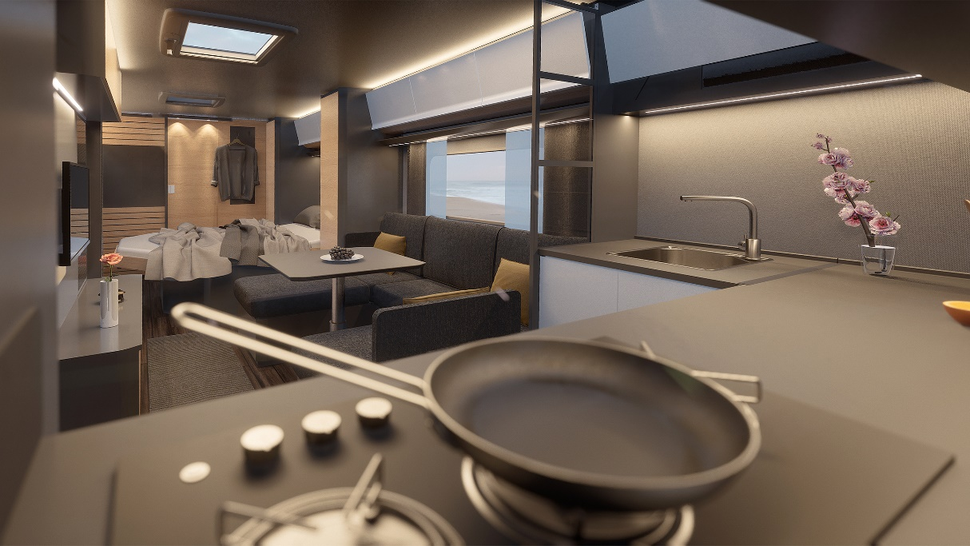

TRIED-AND-TESTED BODY WITH A PREMIUM LOOK
The MAXIA features the tried-and-tested shell design of Hobby’s standard range, but its anthracite-coloured design makes it stand out from the crowd as a top model range. The premium standard is underlined by the use of high-quality attachments as well as the caravan’s hammered finish.
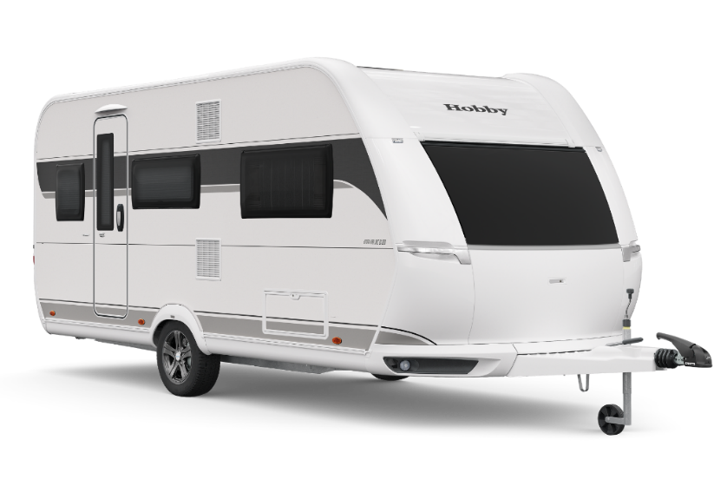
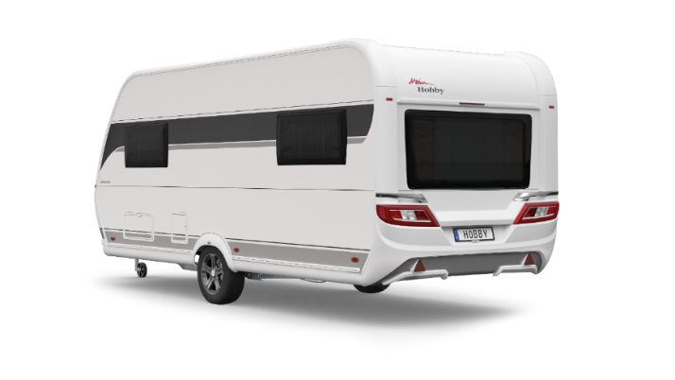

.

MAXIA MODELS
For its first season, the stylish model range is available in two models: the 495 UL, which has a comfortable U-shaped seating area and two single beds at the front, as well as the brand-new 660 WQM. This special model boasts an incredible amount of space and features a generous kitchen at the front, a cosy sofa area, an island bed and a luxurious rear washroom, all in an area of about 20 square metres. The interior of the holiday apartment on wheels is flooded with light thanks to its many windows. A lot of attention has been paid to the kitchen area, which is framed by a large front window and a panoramic roof.

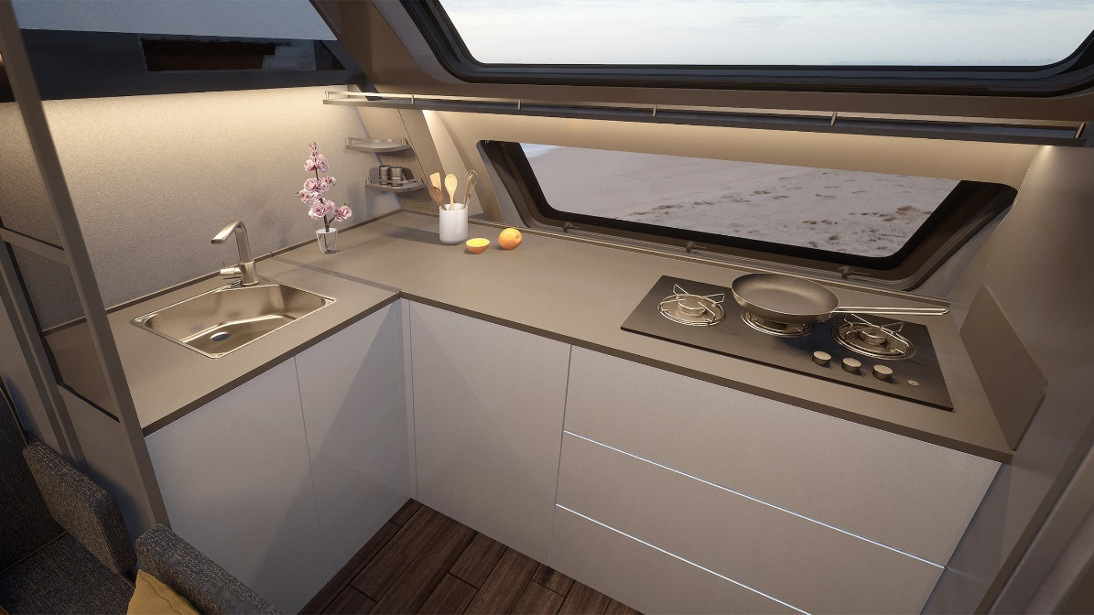
Even fast-food junkies will be transformed into gourmet chefs in this new kitchen.

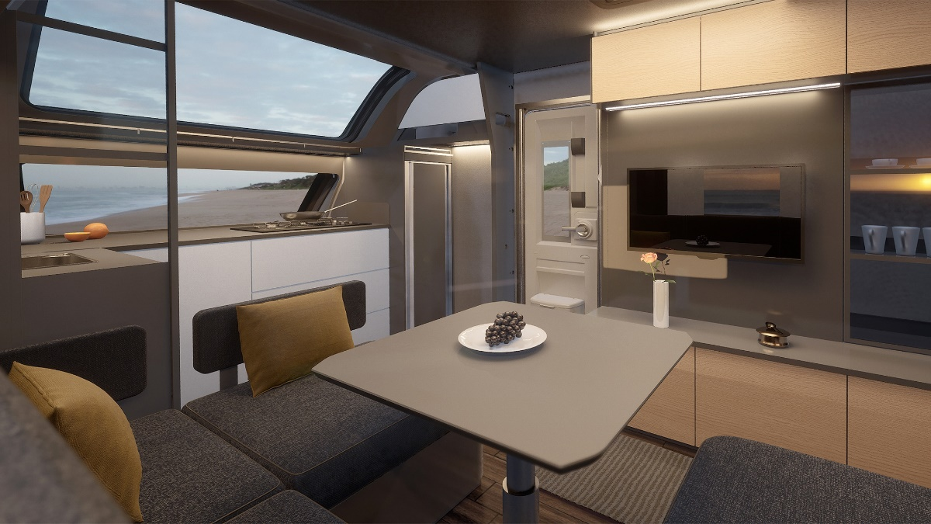
The large front window with the framed panoramic roof creates an incredible feeling of space.

BEACHY – A BEACH-THEMED CARAVAN
Sun, sea and sand – this holiday feeling is the inspiration for BEACHY, Hobby’s new sub-brand. Inspired by countless stories on social media and a whole host of emotions associated with holidays – such as driftwood, shells, sand and Marram grass – the entire Hobby team is enthusiastic about a new vision of a simple holiday companion. Together with a Danish designer and a renowned design agency that takes on technical projects, Hobby’s creatives made their cool idea a reality. The result is a genuine beach vibe on wheels.
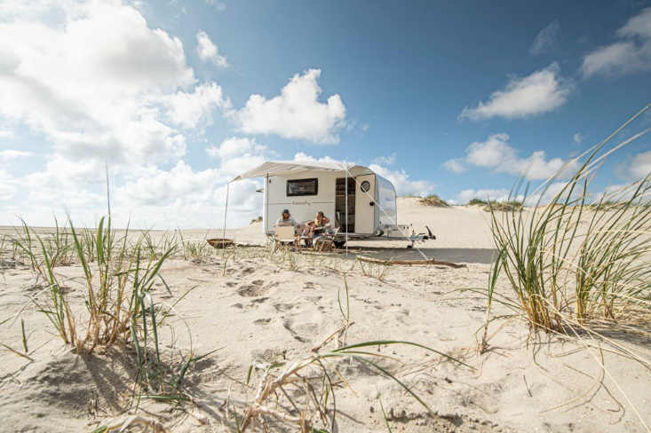

BEACHY MODELS
“Forget everything you’ve ever known about camping”. This statement by Holger Schulz, who came up with the idea, became the Hobby team’s motto when developing the BEACHY. Simple, not too many frills, bright and natural colours, and a real beachy feeling – that’s why the smallest Hobby caravan has a pure beach vibe inside.

Keep it simple: the interior of the new BEACHY is simple and unique at the same time. Fabric-covered baskets and elastic straps provide ample storage space in place of the usual wall units. The cosy seating area features sand-coloured cushions with a natural linen look and can be flexibly converted into a comfortable sleeping area in just a few simple steps. As always, a compact kitchen and a walk-in wardrobe, which can be fitted with a Porta Potti as an option, are included. The new BEACHY is available in three different models, which get progressively larger in size.
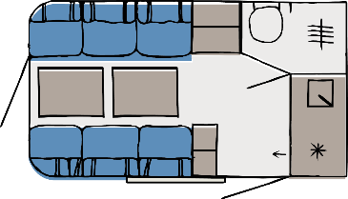
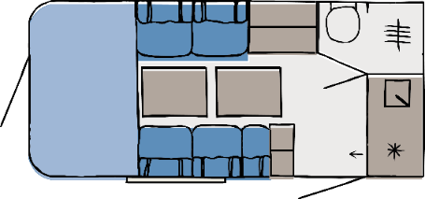
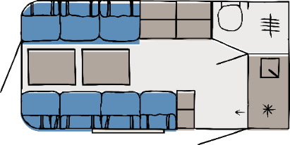
360
450
420

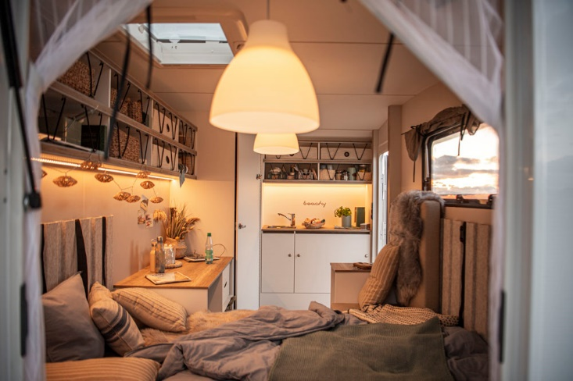
BEACHY EXTERIOR DESIGN
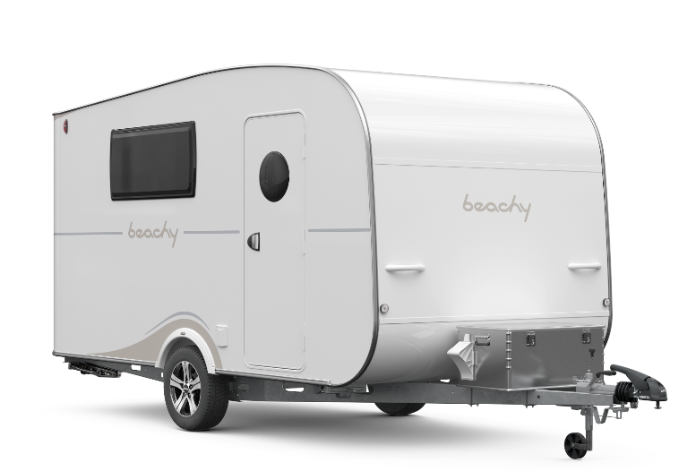
The BEACHY is a symbiosis of a camper van and Harald Striewski’s first home-made Hobby caravan. It is compact and particularly charming with its round shape. One unique gimmick is the large rear door: sitting on the bed and looking at the water gives you a real beachy feeling – whether at the beach, in the mountains or in the city. Born on the beach in northern Germany, the BEACHY is at home anywhere.
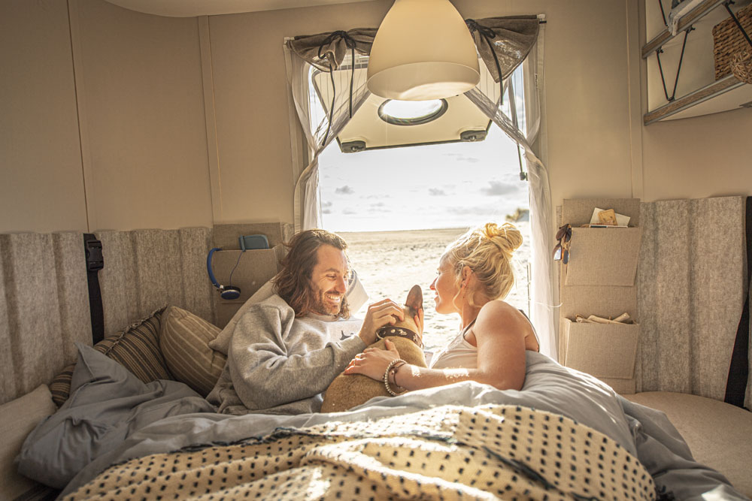

HOBBY MOTORHOME INNOVATIONS 2022

BRIEF OVERVIEW
- Dynamic exterior design for all Hobby motorhomes and camper vans: modern, sporty, stylish
- Top model range OPTIMA DE LUXE with a new premium look
- Camper Vans:
Entry-level VANTANA ONTOUR range on a Citroën chassis with comprehensive EDITION equipment package
VANTANA DE LUXE on the new Ducato available in two different finishes

OVERVIEW OF MODEL RANGES: 6 model ranges, 21 layouts
OPTIMA ONTOUR OVERCAB
(Citroën)
3 layouts

OPTIMA ONTOUR EDITION
(Citroën)
3 layouts

OPTIMA ONTOUR
(Citroën)
6 layouts

VANTANA DE LUXE
(Fiat)
2 layouts
VANTANA ONTOUR EDITION
(Citroën)
2 layouts

OPTIMA DE LUXE
(Fiat)
5 layouts

NEW DYNAMIC EXTERIOR DESIGN
The new exterior design of Hobby motorhomes and camper vans is dynamic and trendy in the 2022 season. The sporty décor of all six model ranges expresses the new, modern design language of Hobby’s motorhome range. Having been completely revamped, the top model range OPTIMA DE LUXE is truly eye-catching thanks to its stylish roof scoop with LED position lights and the new, sporty rear light moulding.
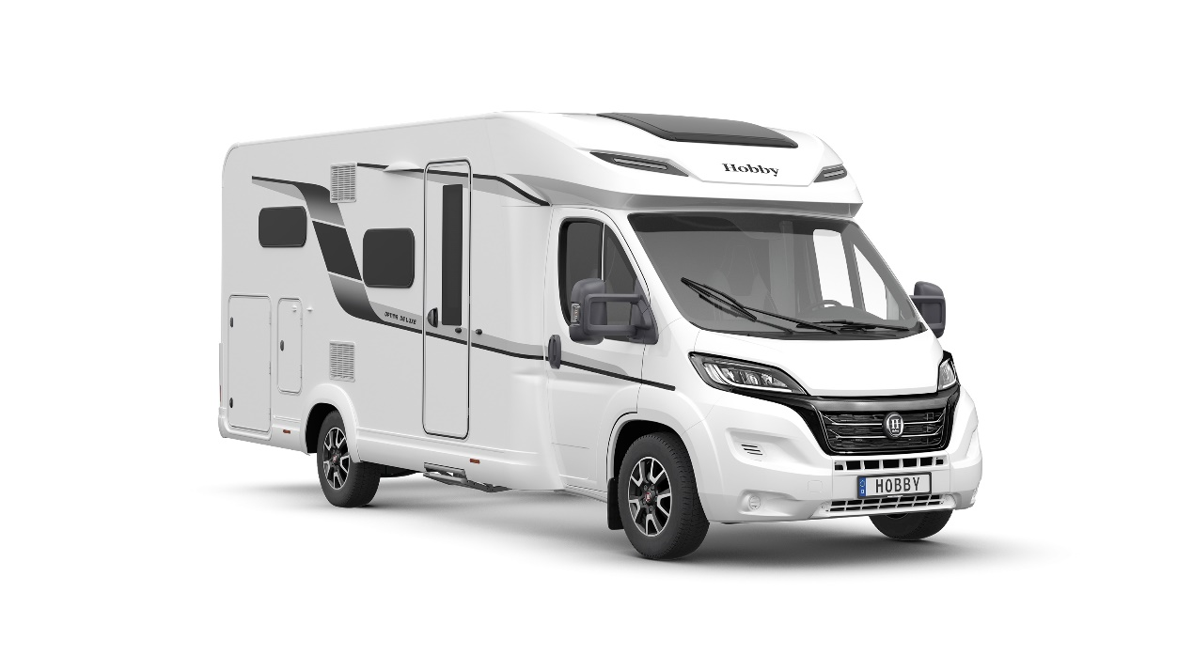

OPTIMA ONTOUR MODEL RANGES
The interior of the successful OPTIMA ONTOUR model ranges on a Citroën chassis is still young and sporty for the 2022 season.
The lavishly equipped, compact OPTIMA ONTOUR EDITION van is available in three popular layout options – with a double bed, island bed or two single beds.
Its big brother, the OPTIMA ONTOUR, represents unbeatable value for money and is available with six semi-integrated layouts and three generous overcab models.
For improved accessibility, Hobby is replacing the cupboard doors of the kitchen base cabinets with handy drawers in the 2022 season.
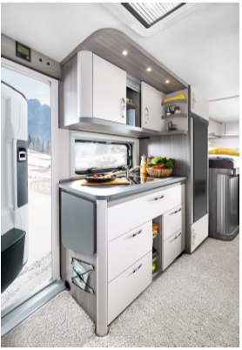

OPTIMA DE LUXE WITH A NEW PREMIUM LOOK
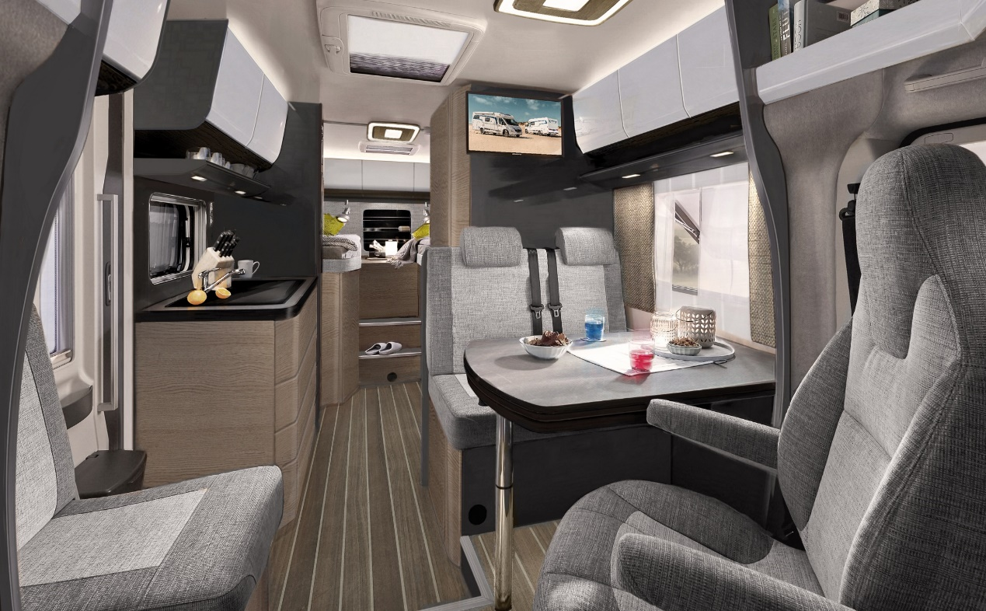
For the 2022 season, Hobby is launching the latest generation of its modern motorhome interior in the OPTIMA DE LUXE. Tailored to the Hobby top model range in collaboration with external developers, the design of the furniture in the new OPTIMA DE LUXE features straight lines, and the colours are perfectly coordinated. The Hobby designers have managed to perfectly blend Scandinavian design with the Nordic concept of ‘hygge’ in spectacular fashion. In the new model year, the model range offers five different layout solutions to choose from: four single bed and one double bed solution.

The latest generation of the Fiat Ducato model serves as the base vehicle and is jam-packed with features, especially where driving and vehicle safety are concerned. Needless to say, the sporty FIAT chassis complies with the new EURO 6 final emissions standard and boasts new LED headlights that are 30% brighter, a completely revamped dashboard featuring a handy mobile phone holder with charging capability, and much more.

VANTANA ONTOUR WITH EDITION EQUIPMENT PACKAGE
Thanks to the CITROËN chassis, the new VANTANA ONTOUR EDITION is the perfect introduction to the world of camper vans. In addition to the wealth of lavish equipment that comes as standard, the new model range comes with an extra, comprehensive equipment package, which includes a gas bottle pull-out shelf for two 11 kg bottles, a comprehensive satellite system package combined with a TV and, as one particular highlight, a high-tech navigation system for complete peace of mind. The layout of the model with single beds has been significantly improved and the comfortable bed on the passenger side measures over 2 metres in length.

VANTANA DE LUXE: CHOICE OF TWO FURNITURE FINISHES
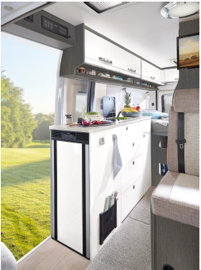
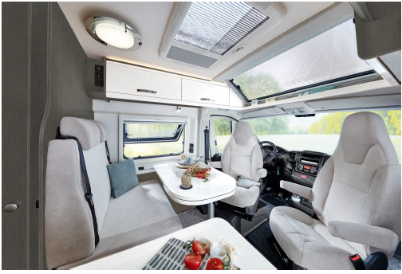
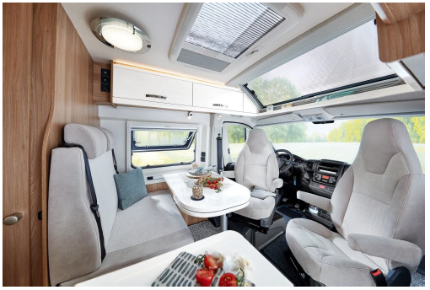
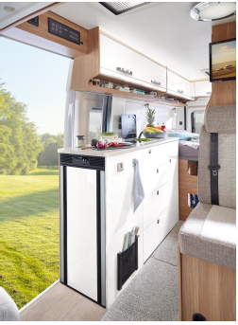
The VANTANA DE LUXE with its standard, panoramic roof vent remains the top model range on the new FIAT DUCATO chassis and will be available with a choice of two stylish furniture finishes for the upcoming season: a warm wood finish with bright, magnolia accents and a modern, monochrome interior design.
IMAGES
FACTS AND FIGURES
BRIEF PROFILE
HOBBY, the north German manufacturer of leisure vehicles, is one of the world’s biggest producers of caravans, a champion of innovation in the mobile leisure industry, and a model company located in the centre of commerce and industry of “Central Holstein”.

PRODUCTS
Caravans and motorhomes; all-inclusive strategy = comprehensive standard equipment packages that are ready to hit the road and represent exceptional value for money; positioned in the mid-price range with a particular focus on affordable quality; series manufacturer.
Product range for 2022:
- In total: 54 caravan models in seven model ranges; from caravans with a body length of 3.60 m or over to large tandem-axle vehicles with a body length of up to 7.90 m; particular focus on family-friendly layouts (14 models with children’s beds and various equipment packages)
- In total: 21 motorhome models in three model ranges; vans, semi-integrated vehicles in the entry-level and mid-range segments, vehicles with overcab

COMPANY
- A medium-sized, family-run enterprise with over 50 years of experience in the leisure vehicle industry
- Production takes place exclusively in Germany at the site in Fockbek (near Rendsburg) in Schleswig-Holstein
- Founded in 1967 by the engineer Harald Striewski
- Family-run: Managing Directors Harald Striewski, Bernd Löher, Holger Schulz

HOBBY TURNOVER
2021 season
- In total: approx. €300 million, comprising:

  - Caravans: approx. €190 million

  - Motorhomes: approx. €110 million

PRODUCTION CAPACITIES
- Caravan production: between approx. 10,500 and 13,500 caravans per season

- Motorhome production: between 2,500 and 3,500 mobile homes per season

LOCATION/PRODUCTION
- Schleswig-Holstein (Fockbek near Rendsburg)
- Up to four assembly lines, flexible according to the demand for caravans and/or motorhomes, modern prefabrication area, high degree of vertical integration, in-house carpentry workshops, upholstery production including sewing room, PU production and large training workshop; annual seven-figure investments in machinery, systems and buildings.
- Company premises: 260,000 m², 65,000 m² of which has been built upon

EMPLOYEES
- Over 1,100 employees, including 36 apprentices in the industrial and commercial fields

SALES
- Over 350 authorised dealers across Europe
- Represented in all European countries by importers or agents
- Sales agencies in Chile, Japan, New Zealand, South Korea and China

EXPORT WORLDWIDE
Share of exports:
- Approx. 40 percent for caravans
- Approx. 30 percent for motorhomes

INNOVATIONS
Creator of many innovations that are blazing a trail for the whole industry, such as:
- Automatic reversing system for caravans
- Galvanised chassis
- Built-in toilet with removable tank
- Slim Tower refrigerator has enabled entirely new layout designs
- Wall-mounted SlimLine refrigerator for vans

GROUP OF COMPANIES
- Hobby-Wohnwagenwerk GmbH, Fockbek (Schleswig-Holstein)

- Fendt-Caravan GmbH, Mertingen (Bavaria)

- Rendsburger Feuerverzinkerei, Rendsburg (Schleswig-Holstein)

- Formlight GmbH, Warburg (North Rhine-Westphalia)

ADDRESS
Hobby-Wohnwagenwerk, Ing. Harald Striewski GmbH

Harald-Striewski-Straße 15, D-24787 Fockbek

Phone +49 (0) 4331 / 606 – 0, fax +49 (0) 4331 / 606 77 430

www.hobby-caravan.de, e-mail presse@hobby-caravan.de

