**BEACHY – CARAVAN OF THE YEAR 2022 IN HOLLAND**

**Hobby’s BEACHY was awarded the title of *ANWB Caravan of the Year 2022* at the Dutch caravanning trade fair “Kampeer & Caravan Jaarbeurs”. The caravan’s unique design and focus on the essentials were a real hit with both the public and the expert jury.**

*Fockbek. 7 October 2021:* The Dutch are renowned for their love of caravans and know a thing or two about caravanning. That’s why the “Caravan of the Year” award in the Netherlands is all the more important for every manufacturer. At the largest caravanning trade fair “Kampeer & Caravan Jaarbeurs”, which is held from 6 to 10 October in Utrecht, the BEACHY was selected as this year’s winner by a jury of experts and the public. This annual award traditionally goes to the most innovative caravan of the season. The jury, consisting of the most important trade journalists and members of the largest Dutch camping and tourist association “ANWB Kamperen”, liked the caravan’s extraordinary design, which “… rather impressively evokes a wonderful holiday feeling at first sight”, both from the outside and the inside. The flexible interior concept came in for particular praise: “The split rear door is incredibly practical, making it easy to transport a bicycle or surfboard. The comfy sofas are transformed into a huge bed with panoramic views through this door. The designers have created a caravan with the perfect atmosphere as well as looks. And that’s important to appeal to a young audience,” was the verdict of the jury in support of its decision.

“We’re grateful and absolutely delighted about this award, not least because it shows that new, courageous and unusual concepts can work,” says Hobby Managing Director Holger Schulz, who came up with the idea of the BEACHY and who accepted the award in person in Utrecht together with Ron de Graaff, the owner of Hobby Benelux. “Following the successful launch and the unwavering interest from customers to this day, it makes us incredibly proud that we’ve now also been able to impress a distinguished jury in the all-important Benelux region with the BEACHY,” says Ron de Graaff.

---

All the BEACHY images (outlines, interior and exterior shots) can be found in our media portal: <https://mediaportal.hobby-caravan.de/pressebilder-2022/wohnwagen/beachy/>

Further information is available from the Hobby press office:

[presse@hobby-caravan.de](mailto:presse@hobby-caravan.de) or at [mediaportal.hobby-caravan.de](https://mediaportal.hobby-caravan.de/)

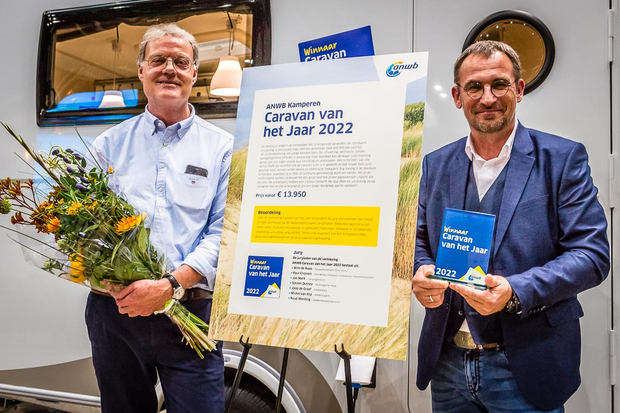

Picture caption: Ron de Graaff (left) and Holger Schulz (right) jointly accept the “Caravan of the Year” award at the trade fair in Utrecht. Photo credit: SERV-Media.nl / ANWB

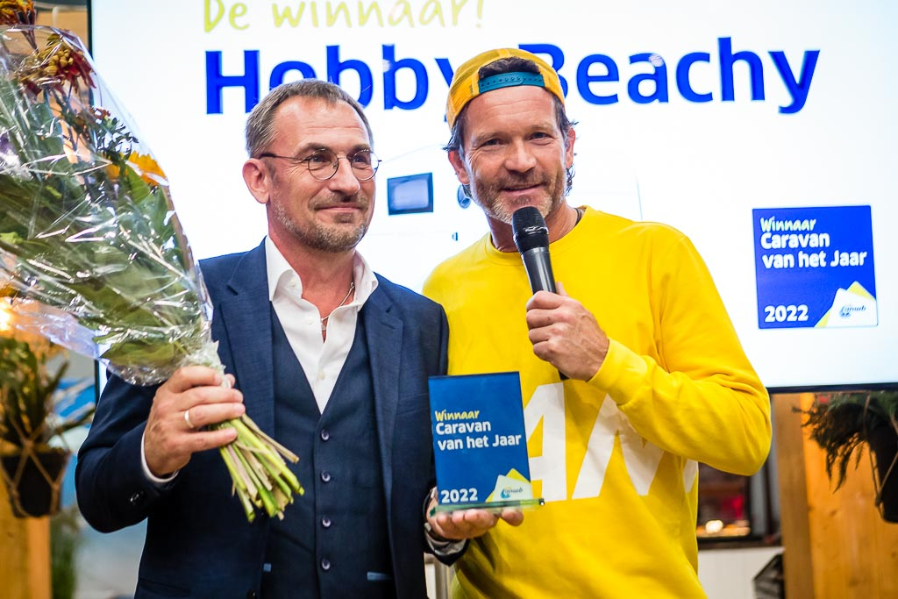

Picture caption: Holger Schulz (left) gratefully and proudly accepts the award and congratulations from the presenter Sander Janson (right) in Utrecht. Photo credit: SERV-Media.nl / ANWB