TRIPLE WIN FOR THE BEACHY AT THE EUROPEAN INNOVATION AWARD

The BEACHY wins big-time: The new Hobby caravan went and took first place three times at the European Innovation Award 2022. Just one aspect that garnered particular attention was the concept, which is perfectly tailored to the needs of its target group.

Best exterior design, best target group focus, best marketing and PR campaign: At the European Innovation Award 2022, three gold medals were awarded to the young BEACHY, a sub-brand of Hobby. For the twelfth time, the DoldeMedien Verlag honoured intelligent, useful and sustainable products in the camping and caravanning industry with the award.
The international jury of specialists also highlighted the exceptional target group proximity of the BEACHY. “Our goal is to communicate the feeling of the beach and freedom with the BEACHY”, explained Frank Maukel, Head of Marketing & PR at Hobby. “The new generation of campers wants flexibility, spontaneity and individuality. With natural materials evocative of driftwood and beach grass, it is precisely these desires that we appeal to. The flexible design of the BEACHY and the Nordic, no-nonsense approach are also right in line with the times.”
Young and wild also describes all communication related to the BEACHY, which the specialist jury named as the winner in the best marketing and PR campaign category. The headlines “be ready”, “be free” and “be wild” underscore the sense of awakening and understated rebellion embodied by the BEACHY. “We are delighted about the awards and are extremely proud to see the BEACHY receive such a great deal of international recognition as well”, said Frank Maukel. “This strengthens our resolve to continue our efforts in this direction.”
In terms of visuals as well, the BEACHY stands apart from other caravans. The symbiosis of a camper van and Hobby founder Harald Striewski’s first home-made caravan was honoured by the jury with the first place award in the exterior design category. In addition to the compact shape and charming rounded edges, which were developed in collaboration with the Danish designer Anne Halskov and the lightweight construction specialists Ross Design, the large rear door stands out as a particular highlight – enjoying the view from bed is exactly what defines the BEACHY.
---
All the BEACHY images (cut-out images, interior and exterior shots) can be found on our media portal: https://mediaportal.hobby-caravan.de/pressebilder-2022/

Further information is available from the Hobby press office:
presse@hobby-caravan.de or at mediaportal.hobby-caravan.de

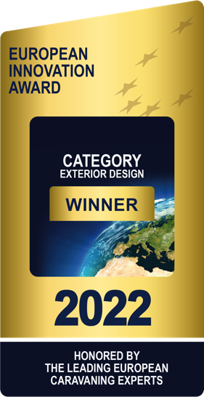
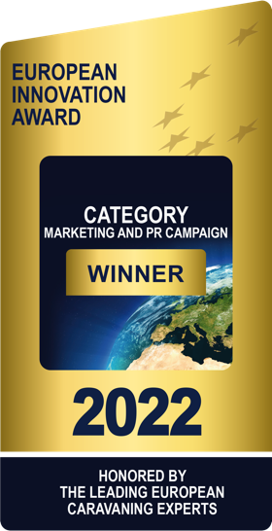
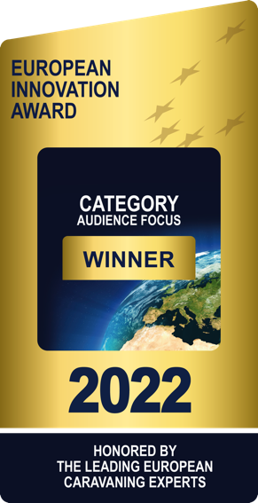
Best exterior design, best target group focus, best marketing and PR campaign: the BEACHY wins big time at the European Innovation Award.

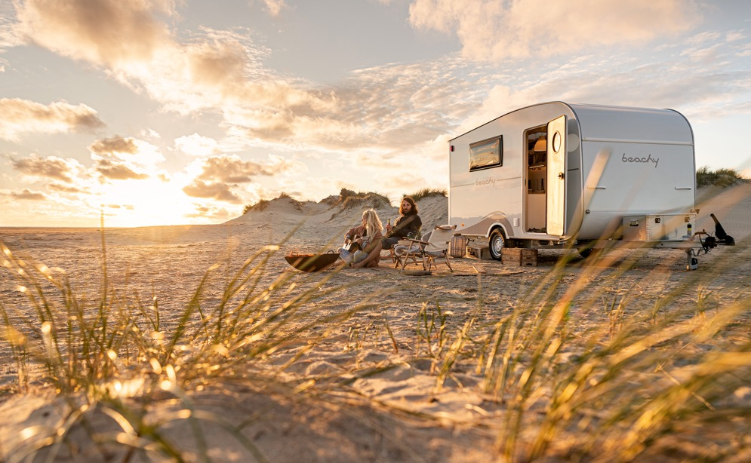
Unmistakable shape, iconic rounded edges: the jury honoured the exterior design of the BEACHY with first place in this category.
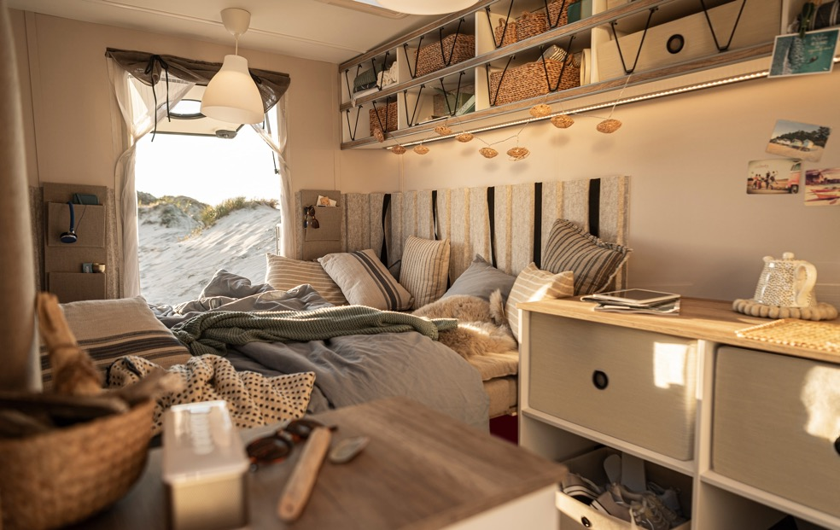
The large rear door is a highlight of the BEACHY design.

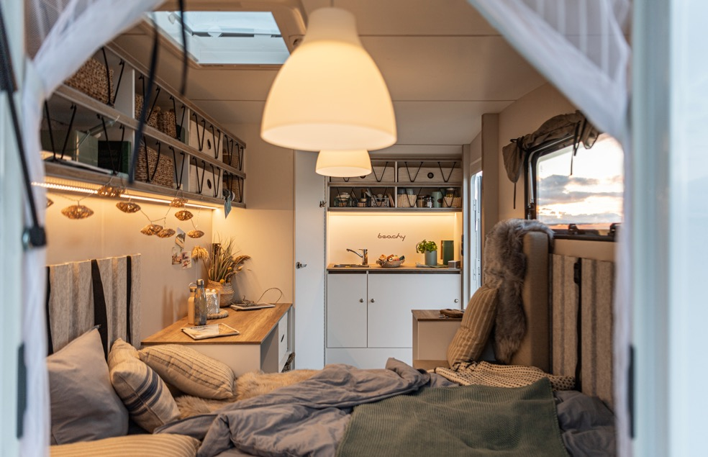
Minimalist, individual, flexible – the BEACHY concept impresses on the international stage as well.
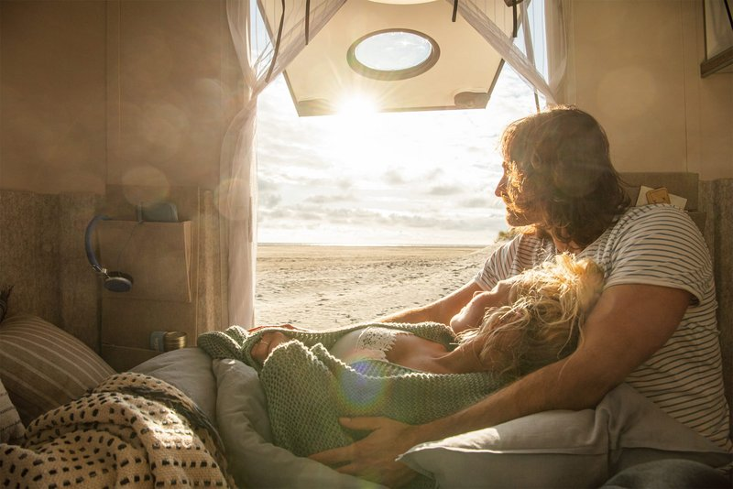
The new generation of campers wants simple freedom. The BEACHY provides just that – and took first place in the target group focus category.

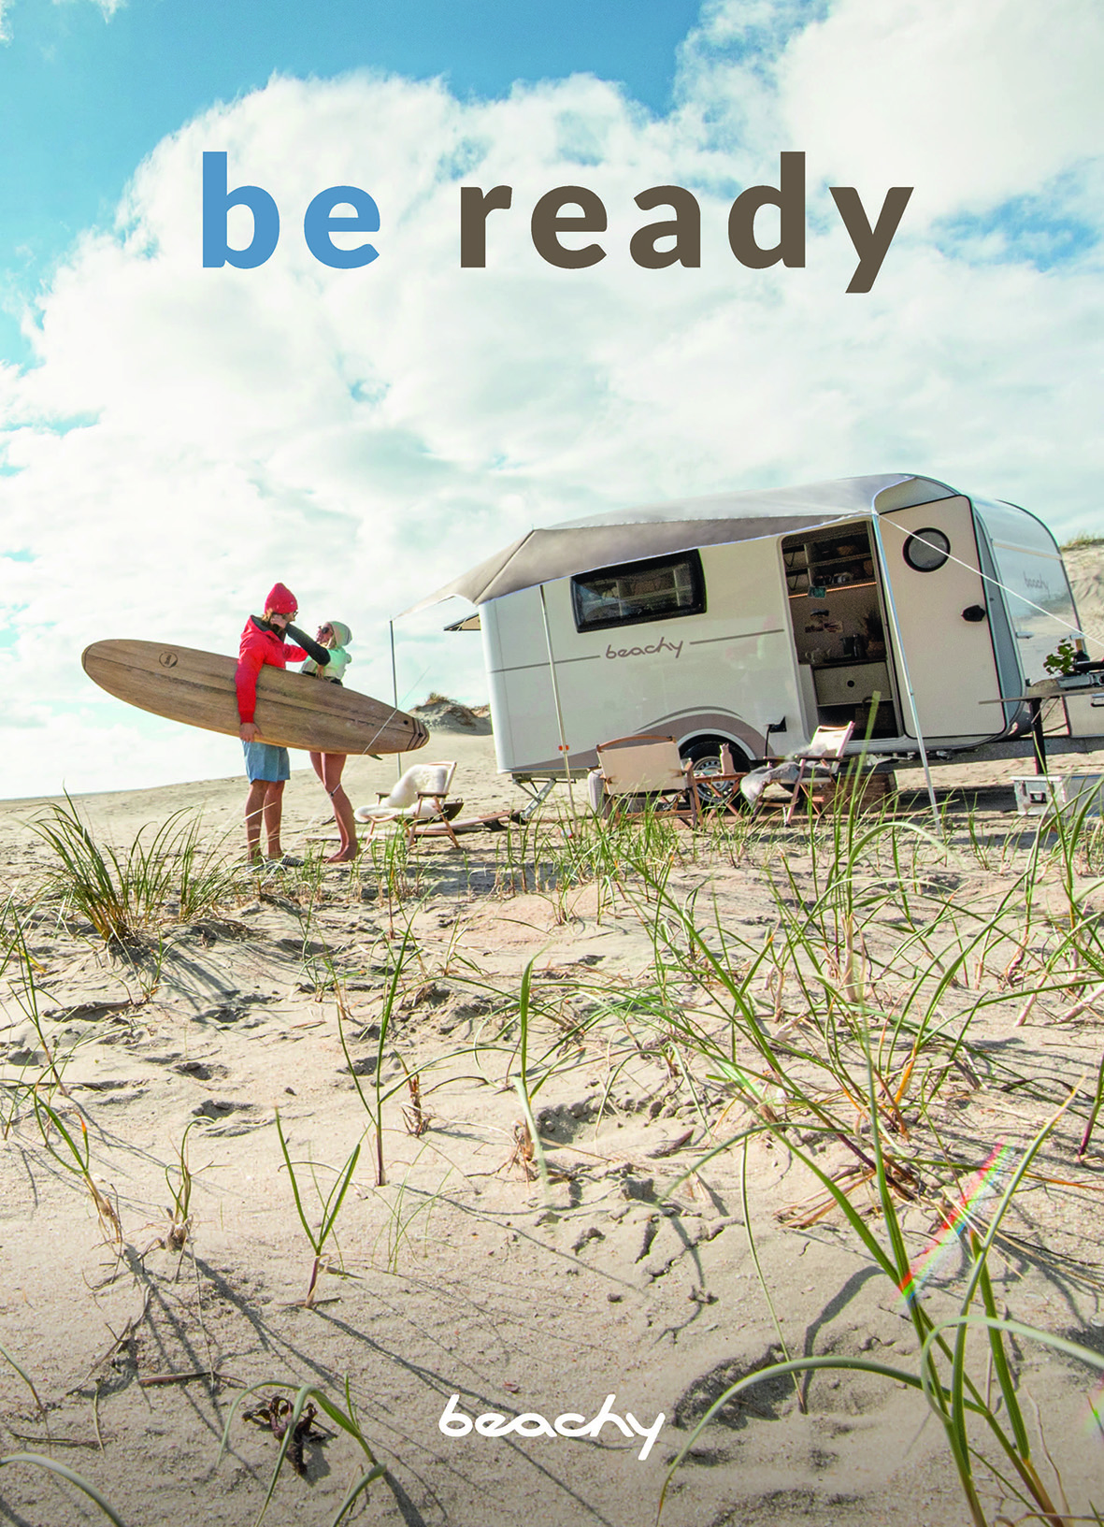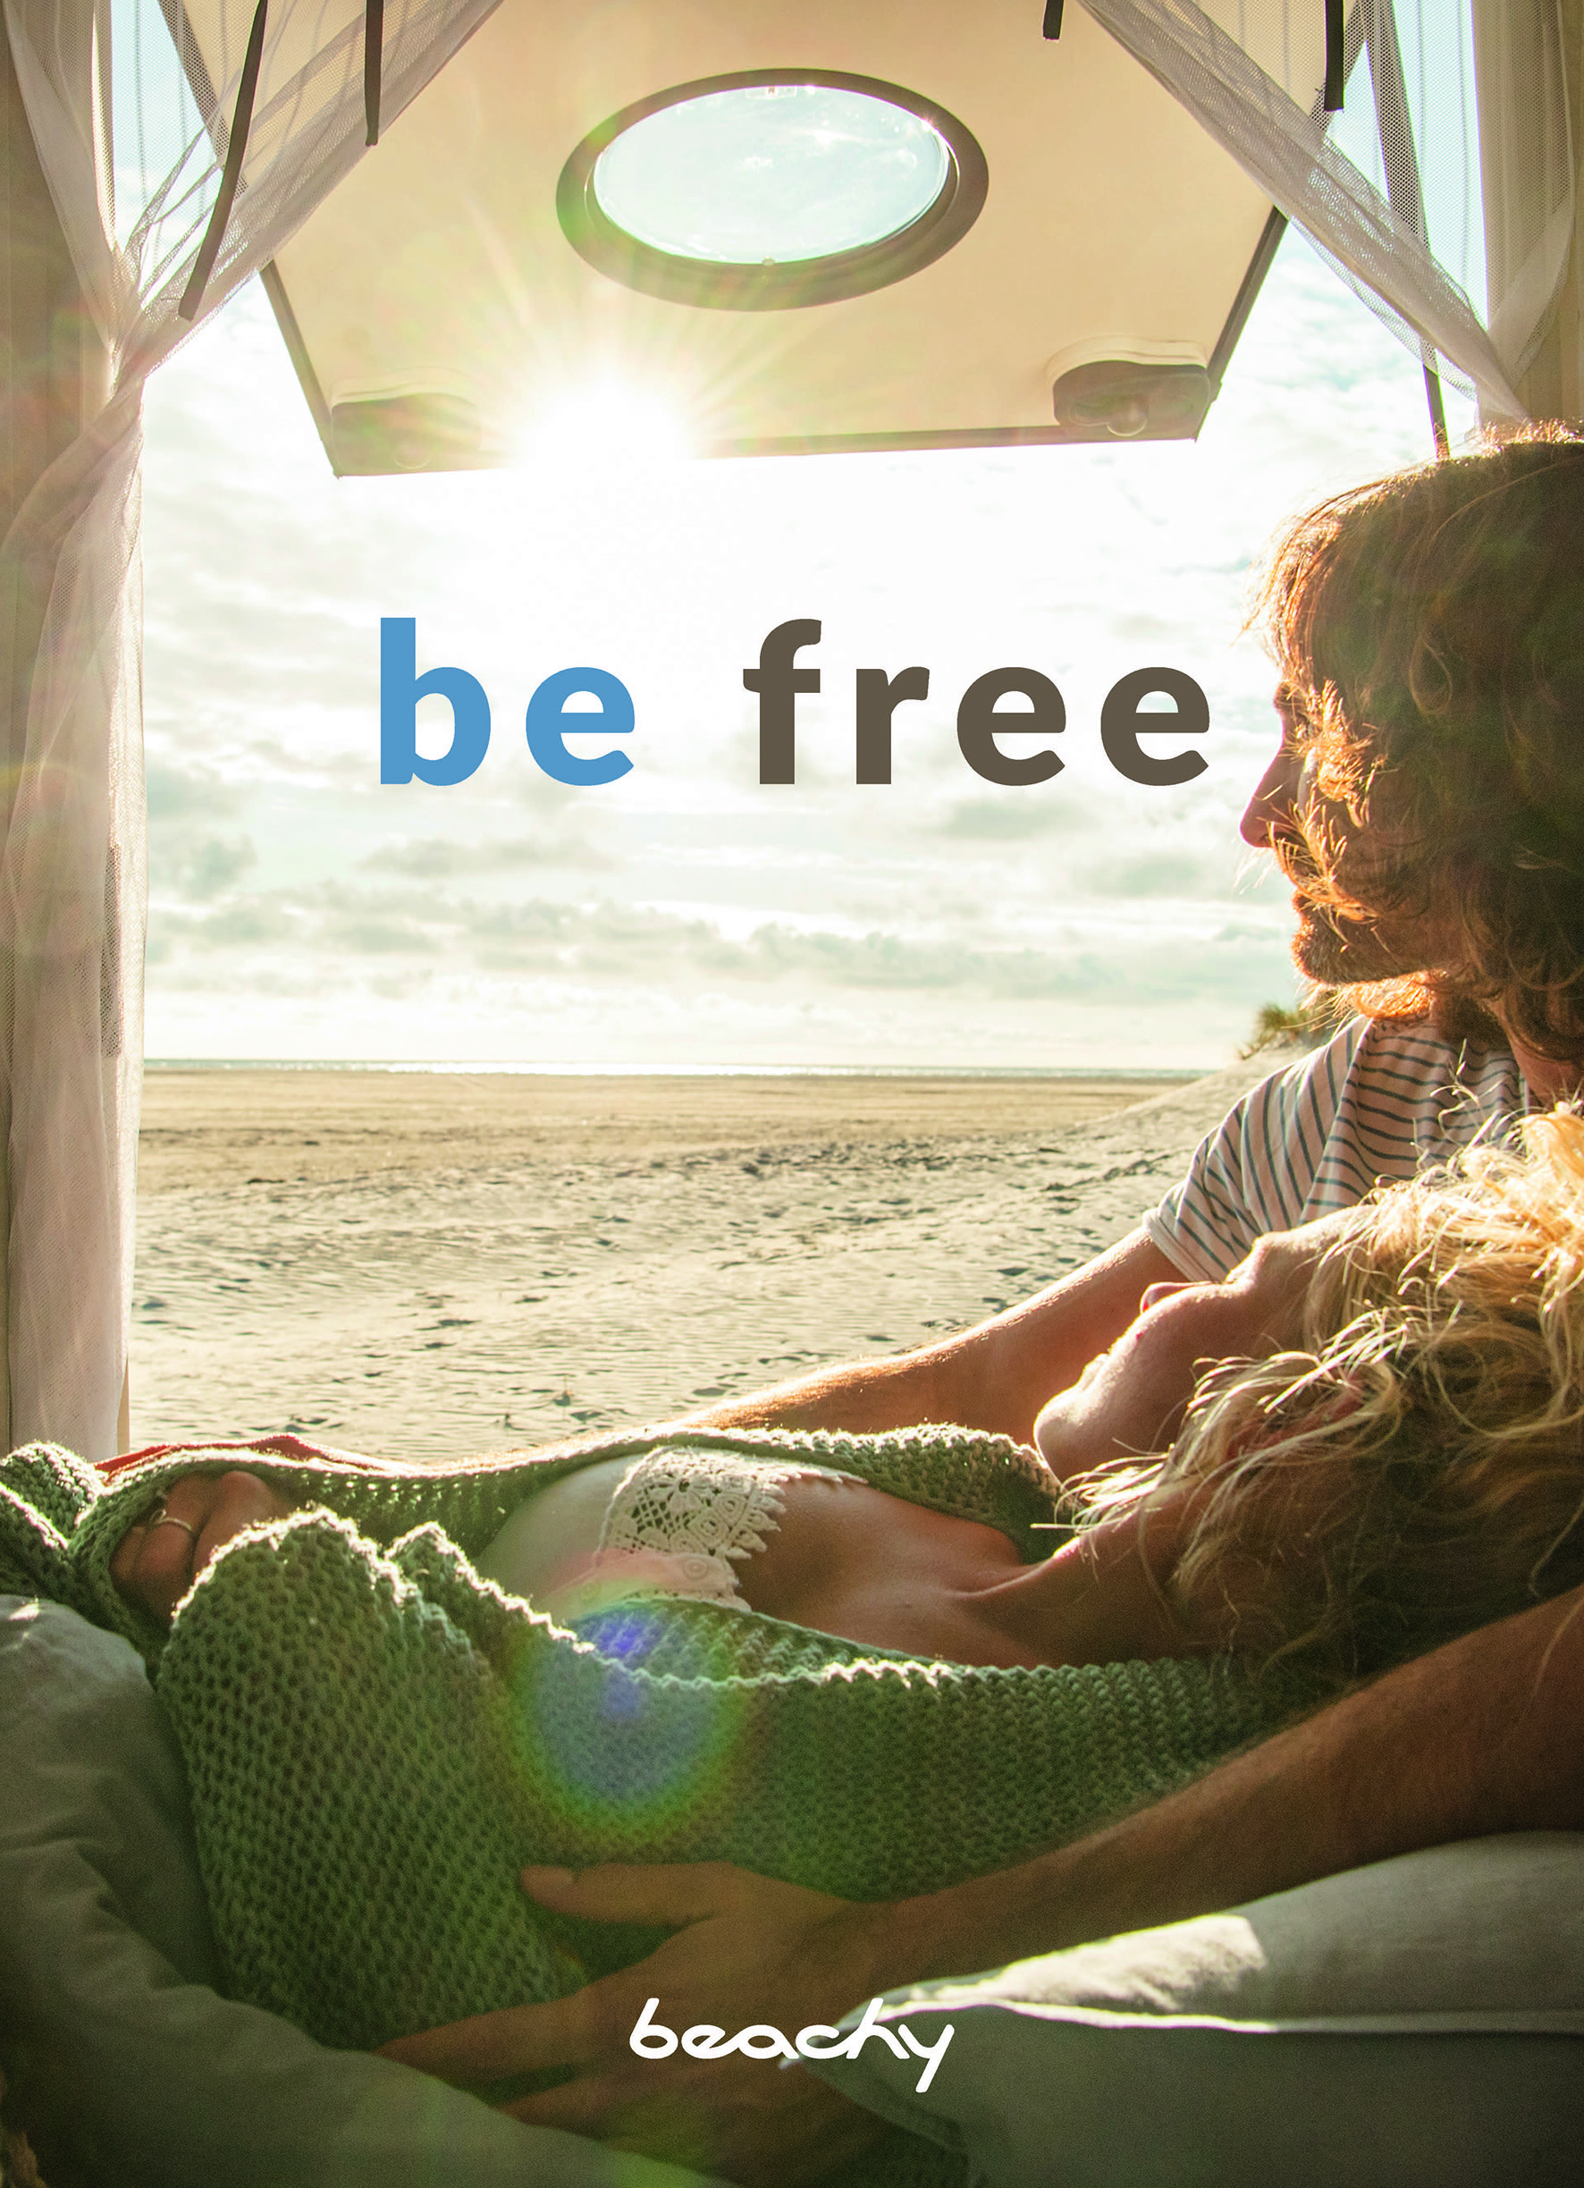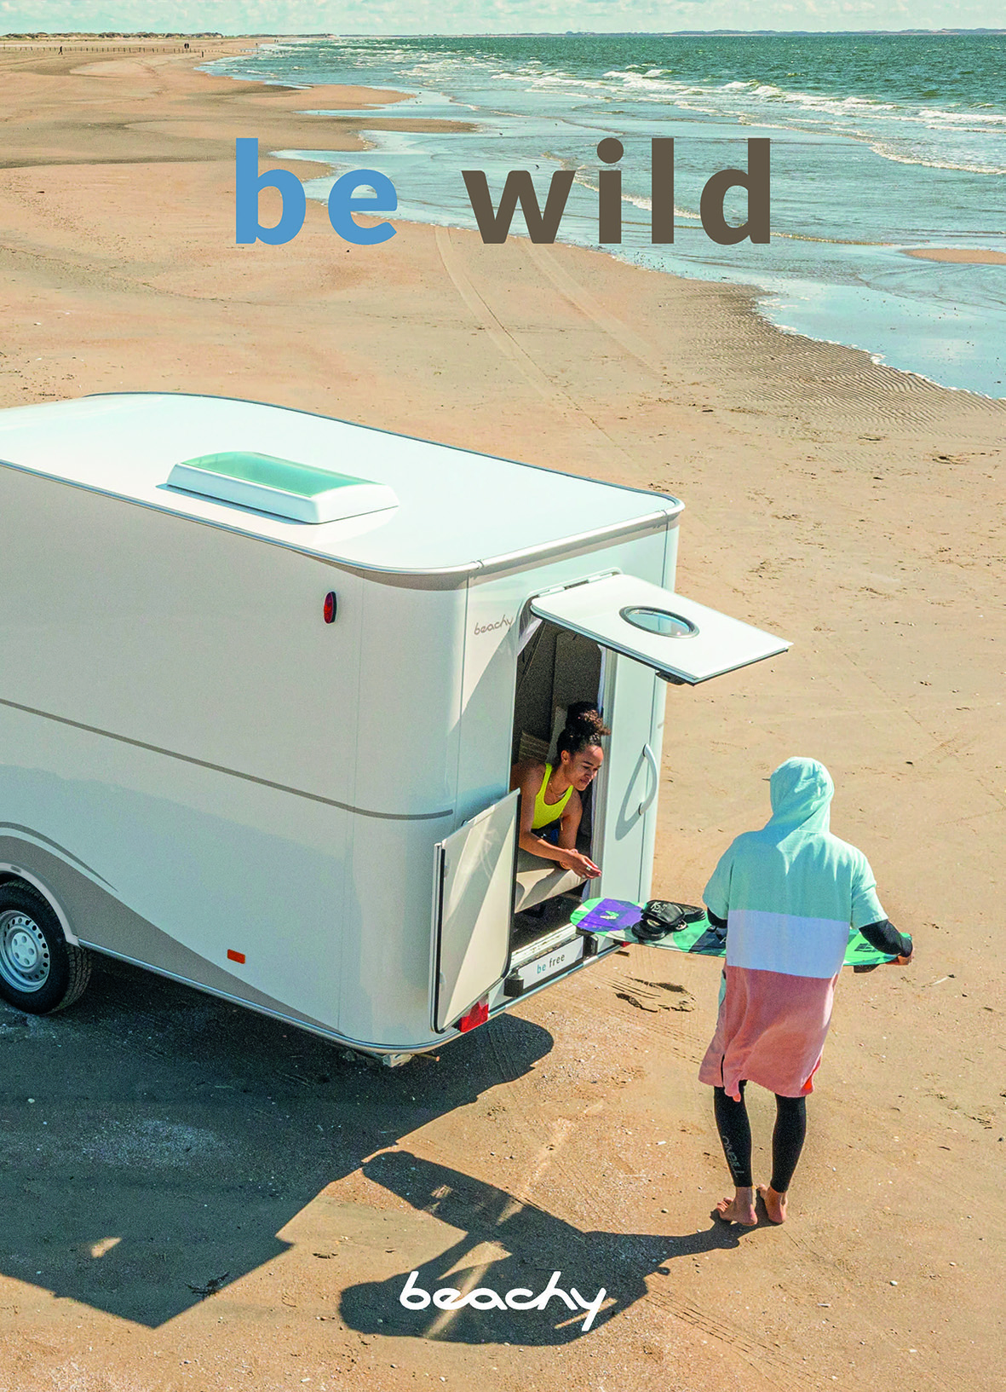
“Be ready”, “be free”, “be wild”: with this PR campaign, the BEACHY speaks to the hearts of its target group.

