HOBBY and Volkswagen Commercial Vehicles lay foundations for long-term collaboration

- HOBBY offers motorhomes based for the first time on the Crafter panel van
- Premiere at the Düsseldorf 2022 Caravan Salon

Hannover, Rendsburg, 19 May 2022 – Volkswagen Commercial Vehicles and motorhome specialists HOBBY have laid the contractual foundation stone for long-term cooperation. The first stage of the cooperation will see HOBBY offering its own motorhome solutions based on Volkswagen Commercial Vehicles’ Crafter panel van before the end of the year. The new vehicles will be on show for the first time at the Caravan Salon this August in Düsseldorf.
Lars Krause, Volkswagen Commercial Vehicles’ Management Board Member for Sales and Marketing: “Over the past several years, we have seen a constant growing trend in respect of our camper vans. That applies not just to our California models, but to the whole industry. ‘Van life’ has become a genuine lifestyle. We are therefore delighted to start our partnership with HOBBY, as we are certain that our Crafter is an ideal base vehicle for their motorhomes.”
“The cooperation with Volkswagen Commercial Vehicles is going to be a game-changer for the HOBBY-Fendt Group and opens up totally new possibilities for us”, says Bernd Löher, Chief Executive of HOBBY. “The Crafter brings with it all the features that our customers are already familiar with from their car and that - especially in the area of safety - they value. For HOBBY it is the ideal time for the strategic expansion of the portfolio and for entering the premium camper van segment, one of the strongest growing categories in the leisure vehicle market”, adds Löher.

Volkswagen Commercial Vehicles
We Transport Success, Freedom and Future
As a leading manufacturer of light commercial vehicles, the Volkswagen Commercial Vehicles brand (VWCV) is reshaping the transportation of goods, services and people in a fundamental and lasting way. Our vehicles transport construction workers, families and adventurers, bread rolls, parcels and surfboards. Every day they help countless people all over the world to do a good job, they operate as mobile workshops and they bring paramedics and police personnel to wherever they are needed. At our sites in Hanover (D), Poznań (PL), Września (PL) and Pacheco (ARG), around 24,000 employees produce the Transporter, Caddy, Crafter and Amarok model lines, and, as of 2022, will be producing the ID. Buzz – the fully electric version of our iconic Bulli. Within the Volkswagen Group, VWCV is also the lead brand for autonomous driving and for mobility offerings such as Mobility-as-a- Service and Transport-as-a-Service - areas in which we are shaping the future of mobility. In this way, the brand is transporting the society of tomorrow with all its requirements for clean, intelligent and sustainable mobility. It is this that Volkswagen Commercial Vehicles stands for with its brand promise: We transport success, freedom and future.

HOBBY - built for life
HOBBY has been producing caravans and motorhomes in the Northern German town of Fockbek for 55 years - reliably, passionately, innovatively. At the traditional location in the heart of Schleswig-Holstein, 1,200 employees produce more than 15,000 leisure vehicles every year. 350 authorised dealers in all countries of Europe as well as sales representatives worldwide are on hand to provide support and advice to Hobby customers. In addition to the Hobby-Wohnwagenwerk Ing. Harald Striewski GmbH, the Hobby group also includes Fendt-Caravan GmbH based in Bavaria, the Lightweight Furniture Specialist Formlight GmbH from North Rhine-Westphalia and the Rendsburger Feuerverzinkerei GmbH.

Picture Cooperation VWCV & HOBBY
Caption: Bernd Löher (HOBBY) and Lars Krause (Volkswagen Commercial Vehicles) lay the foundation for the cooperation of both brands for future motorhomes.
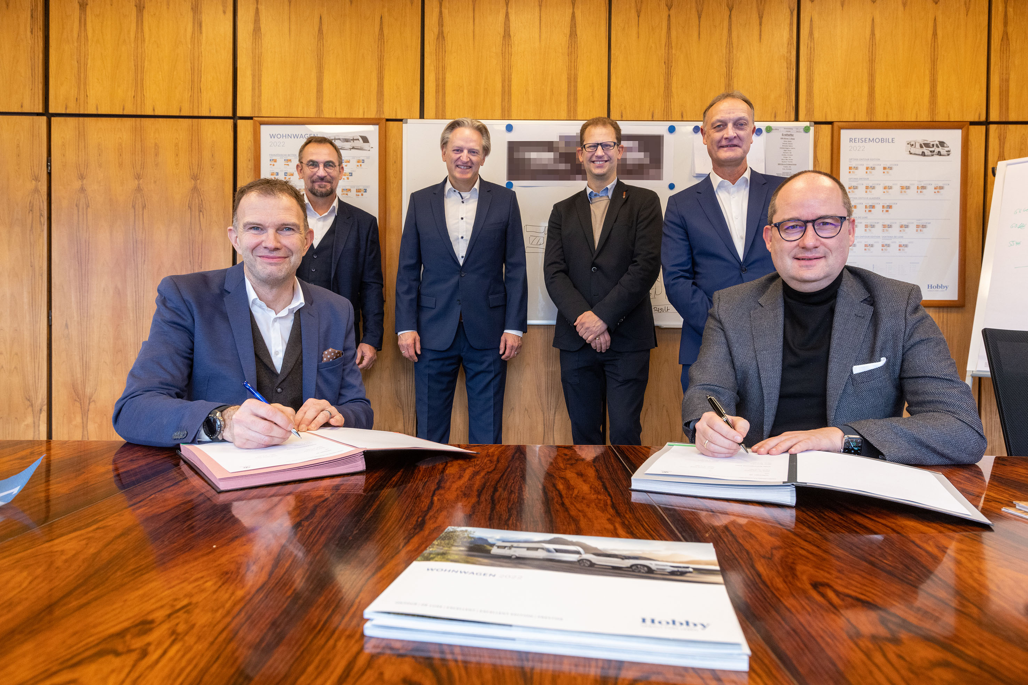
Sedentary left: Bernd Löher, Managing Director Hobby
Sedentary right: Lars Krause, Member of the Board of Volkswagen Commercial Vehicles for Sales and Marketing

Standing from left to right
Holger Schulz, Managing Director Hobby
Thomas Schulz, Head of Target Group Sales, Volkswagen Commercial Vehicles
Alexander Rühland, Head of Product Marketing Motorhomes, Volkswagen Commercial Vehicles
Michael Schmitz, Head of Direct Sales, Volkswagen Commercial Vehicles

Further information is available from the Hobby press office:
presse@hobby-caravan.de or at mediaportal.hobby-caravan.de/en/

