Hobby vans and motorhomes: what the 2023 season has in store
Fockbek, 15 June 2022 – Proven success stories and brand-new vehicles: Hobby kicks off the new season with a mix of bestsellers and new vehicles. The announcement of a new addition to our range of vans is particularly exciting.
Hobby fans will have to wait until the Caravan Salon in Düsseldorf at the end of August, which is where the new Hobby MAXIA VAN will be launched. The details released so far have increased the sense of anticipation. The MAXIA name alone hints at what to expect from the interior of the latest van in the Hobby range. Customers will be familiar with the MAXIA range from our caravan segment, where it stands for the new premium class of Hobby caravans, boasting Scandinavian design, perfectly coordinated colour schemes and that Nordic sense of cosiness. “The ‘hygge’ design will also be found in our MAXIA VAN,” confirms Bernd Löher, Managing Director of Hobby. “It represents a new style of camping, where mobile homes are just as cosy and stylish as people’s own homes.” The MAXIA VAN is built on the VW Crafter. Bernd Löher is well aware that the collaboration with Volkswagen has huge advantages: “Our customers are already familiar with many of the features found in cars; something they truly appreciate, especially when it comes to safety and assistance systems.” More information about the new MAXIA VAN will follow shortly.

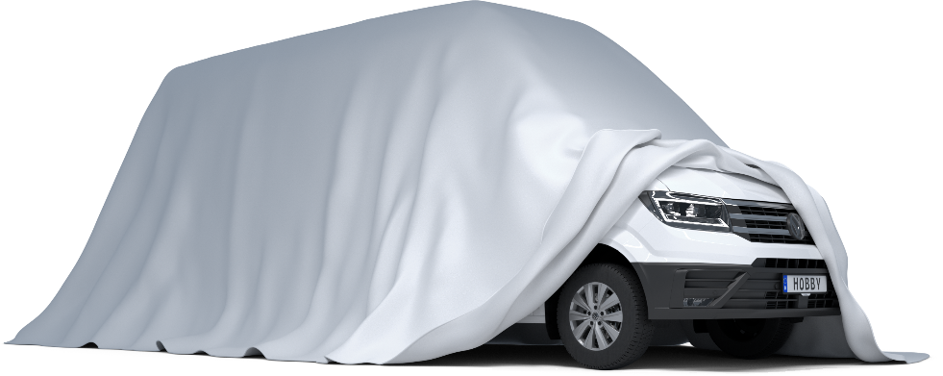
The new MAXIA VAN built on a VW Crafter chassis will be launched in autumn 2022.

TRIED-AND-TESTED CAMPER VAN AT A FAIR PRICE
As before, the tried-and-tested VANTANA ONTOUR EDITION (Citroen chassis) and VANTANA DE LUXE (Fiat chassis) vans will be available with two different layouts at the start of the 2023 season. In addition to the bed being arranged lengthwise (K65 ET) or crosswise (K60 FT) in the vehicle, a choice of three different upholstery/furniture finishes is available. “Both model ranges have lots of fans and the demand for them is still high,” explains Löher. Highlights like HOBBY TOP, the extra-wide panoramic roof vent in the VANTANA DE LUXE, ensure that this is the case. “The unbeatable value for money of all Hobby vehicles is crucial for many customers,” says the Hobby Managing Director. “Lots of high-quality and handy features are included in Hobby vehicles right from the start – at no additional cost.” The entry-level VANTANA ONTOUR EDITION model boasts an extensive range of standard equipment; when it leaves the factory, it comes with an awning, a navigation system including integrated reversing camera and a satellite system including TV, for example.
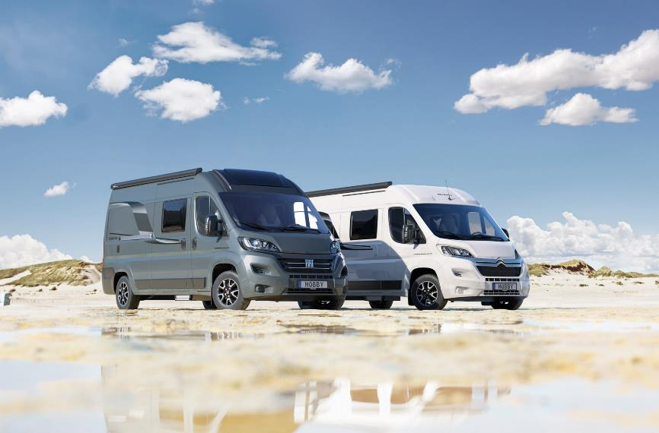
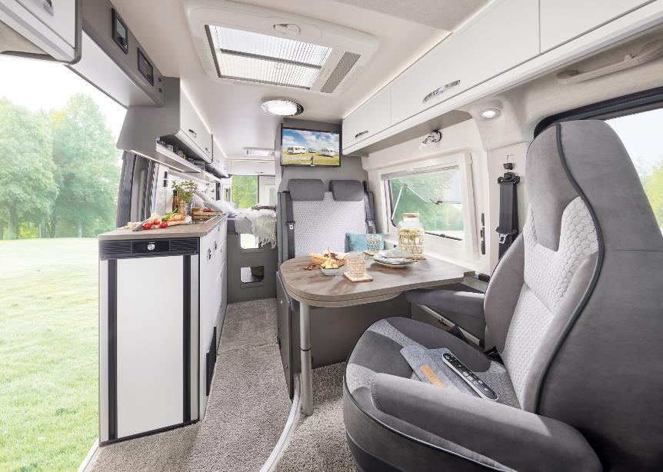
The VANTANA ONTOUR EDITION and VANTANA DE LUXE come with numerous features
The interior design of the VANTANA DE LUXE is based on bright colours and a low-maintenance design.
OPTIMA DE LUXE CONTINUES TO IMPRESS
Last season kicked off with a makeover of the interior design of our motorhome range: the completely redesigned OPTIMA DE LUXE (Fiat chassis) was the first motorhome to feature our Scandinavian “hygge” design. Many customers were immediately won over by the clean lines of the furniture, perfectly coordinated colour schemes and stylish interior. They were equally impressed by the revamped exterior design featuring a new roof scoop and dynamic indicators at the rear. It will come as no surprise then that Hobby has made no changes to the OPTIMA DE LUXE for the launch of the 2023 season. “With 5 layouts, the OPTIMA DE LUXE offers a lot of flexibility for both couples and families,” explains Matthias Schätzle, Head of Motorhome Design at Hobby. “Customers have the choice between a double bed, single beds or a practical drop-down bed, for example.”

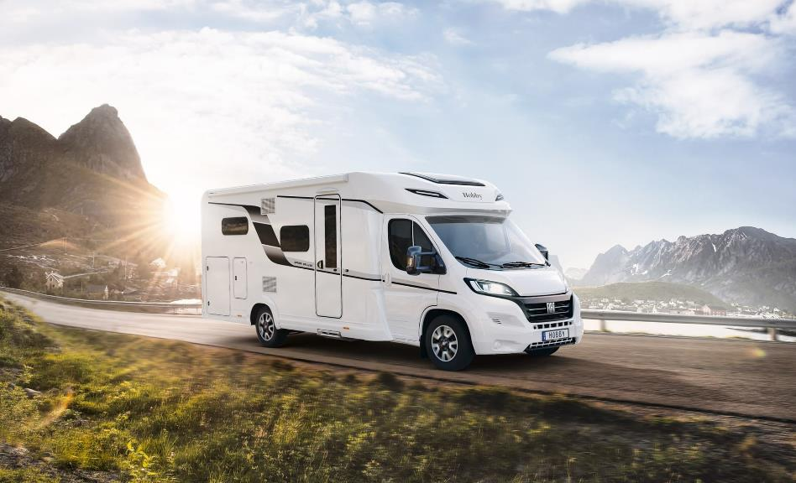
The interior design of the OPTIMA DE LUXE was completely revamped last season.
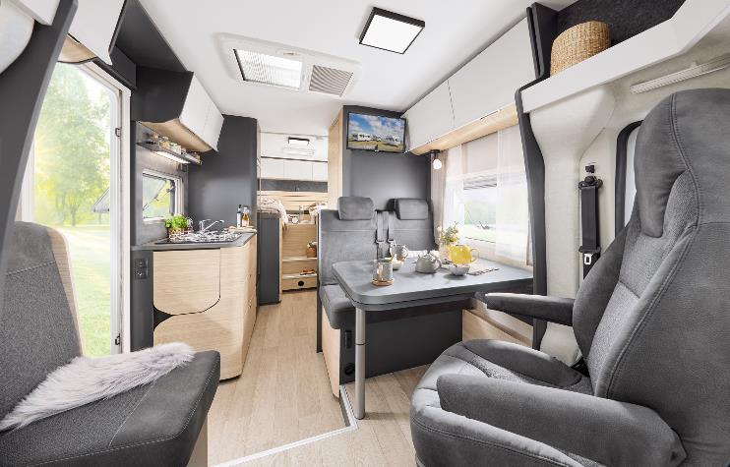
Minimalist, Nordic, clean: the OPTIMA DE LUXE adds a touch of Scandinavian “hygge” to the motorhome.

OPTIMA ONTOUR RANGE REMAINS ON TRACK FOR SUCCESS
Our best-selling motorhome, the OPTIMA ONTOUR EDITION (Citroen chassis), is also unchanged for the new season. When it comes to value for money, the renowned “HobbyKomplett” ALL-INCLUSIVE package – which includes a navigation and satellite system, awning, pleated blinds and many other extras besides – has ensured that the highly manoeuvrable OPTIMA ONTOUR EDITION has taken the top spot for many years now, and will continue to do so this season. “We can see from the order numbers that our range of motorhomes is perfectly geared towards the needs and requirements of our customers,” says Schätzle. “From the entry-level OPTIMA ONTOUR model and compact OPTIMA ONTOUR EDITION to the OPTIMA ONTOUR OVERCAB with storage space galore (all on a Fiat chassis), we have the perfect motorhome for everyone.”
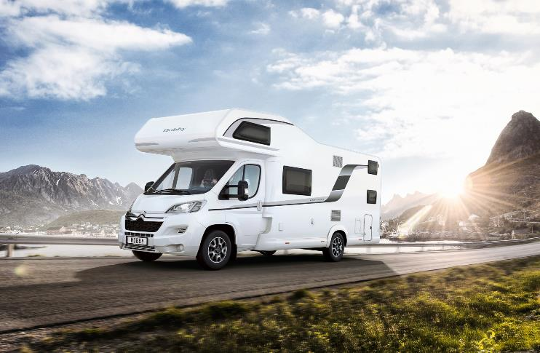
The OPTIMA ONTOUR OVERCAB has been at the top of the league tables where value for money is concerned for years.
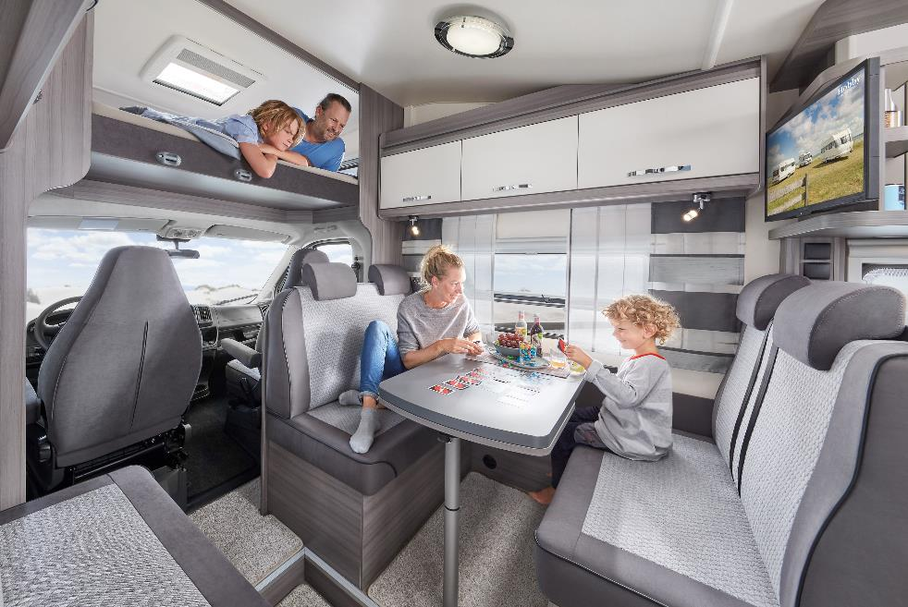
Plenty of room for sleeping and playing in the OPTIMA ONTOUR OVERCAB
Further information is available from the Hobby press office:
presse@hobby-caravan.de or at mediaportal.hobby-caravan.de

