Hobby is launching the 2023 caravan season with a series of new innovations
Fockbek, 15 June 2022 – The highlight is the new MAXIA 585 UL featuring the popular Scandinavian “hygge” design. The design, variety and technology of other model ranges will also be updated.
Modern, minimalist design and a touch of Scandinavian “hygge”: since its launch in summer 2022, the Hobby MAXIA and its two layouts have gone down a storm with many camping fans. The stately MAXIA 660 WQM with its large panoramic front window is still something of a sensation. For the 2023 season, a new layout will be added to the range of luxury class models. With a width of 2.50 metres and clean cabinet fronts, it feels incredibly spacious with a maximum technically permissible laden mass of 1,700 kg. At around 7.69 metres, the MAXIA 585 UL is significantly longer than its smaller brother, the MAXIA 495 UL.

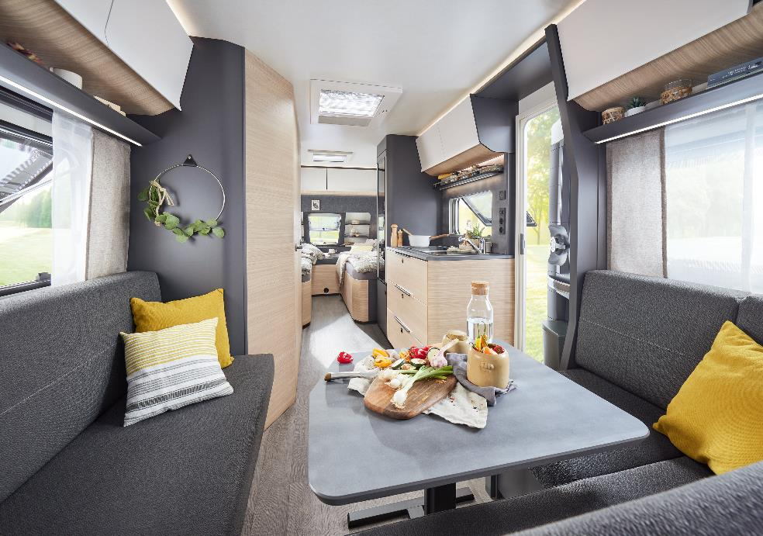
Cosy, yet an impressive 2.50 metres in width: the new MAXIA 585 UL featuring the popular “hygge” design

A large wardrobe and cabinets with a pull-out drawer ensure plenty of additional storage space. The model also features two new corner panels with practical reading lights in the U-shaped seating area for more light in the evening.

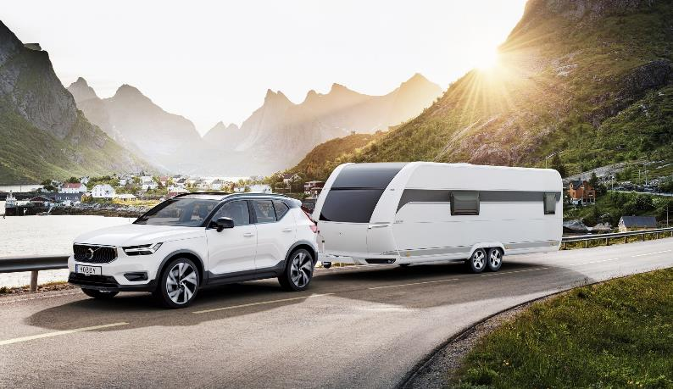
“Hygge” to the max: the MAXIA 660 WQM features a large panoramic front window

NEW FURNITURE FINISH FOR THE EXCELLENT
The choice of furniture finishes for the popular EXCELLENT model range will be updated for the 2023 season. The modern anthracite-coloured wood finish featuring light units has been borrowed from the EXCELLENT EDITION and can now be found in the EXCELLENT model range too. “The fresh, welcoming design is extremely popular with our customers,” says Bernd Löher, Managing Director of Hobby. “People want their mobile homes to be just as stylish as their own homes. We want to satisfy this demand with our vehicles.” The EXCELLENT EDITION is also gaining some new layouts. From the 2023 season onwards, the model range will be available in 10 layouts. Families will be interested to know that four layouts come with children’s beds. The EXCELLENT EDITION 650 KMFe even has a completely separate children’s room with a seating area and table at the rear, where there is room for the kids to draw and play. The adult and children’s areas are separated by a curtain.
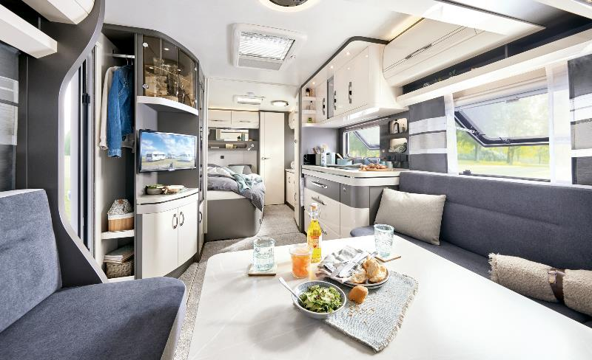
The EXCELLENT 560 WFU featuring the new furniture finish
NEW UPHOLSTERY COMBINATION FOR THE PRESTIGE
The new upholstery design in the PRESTIGE is also modern and welcoming. The plain, pale grey upholstery combination with a sleek grey decorative curtain makes the PRESITGE feel particularly cosy. By using Vivalife fabrics, Hobby has opted for an extremely sustainable material. The fabrics are made of upcycled fibres and are fully recyclable. They can be easily cleaned using a damp cloth and soft brush.
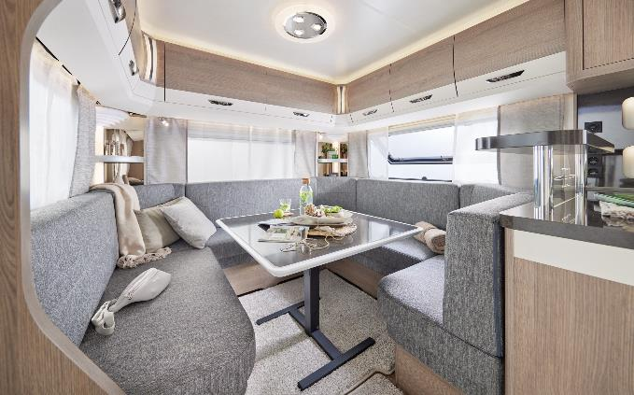
The new Vivalife fabrics in the PRESTIGE are made of upcycled fibres, which are easy to clean.

KITCHEN HIGHLIGHTS FOR 2023
In addition to all the major updates, all Hobby caravans will also feature a new hob/sink combination from the 2023 season onwards. “In addition to design, the focus here is clearly on functionality,” explains Dirk Gottwald, Head of Caravan Design at Hobby. “The hob and sink are separate, but both can be covered with black glass panels. This not only looks good, but also keeps out dust while providing an additional work surface and storage space.”
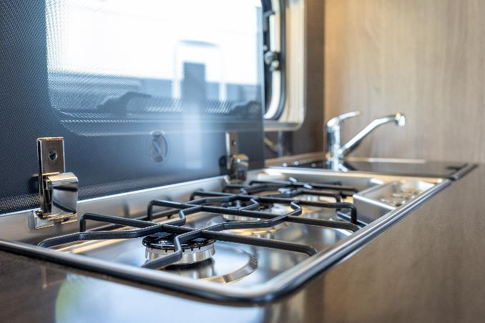
The hob/sink combination with black glass panels is new for the 2023 season
From the 2023 season onwards, almost all caravans with a Super Slim Tower refrigerator will be fitted with a double-hinged, 130-litre absorption refrigerator with a removable 12-litre freezer compartment. This is a step forward in terms of convenience, as the contents of the refrigerator can be easily accessed from both sides. The MAXIA 660 WQM even comes with a 157-litre compressor refrigerator with an 18-litre freezer compartment as standard
.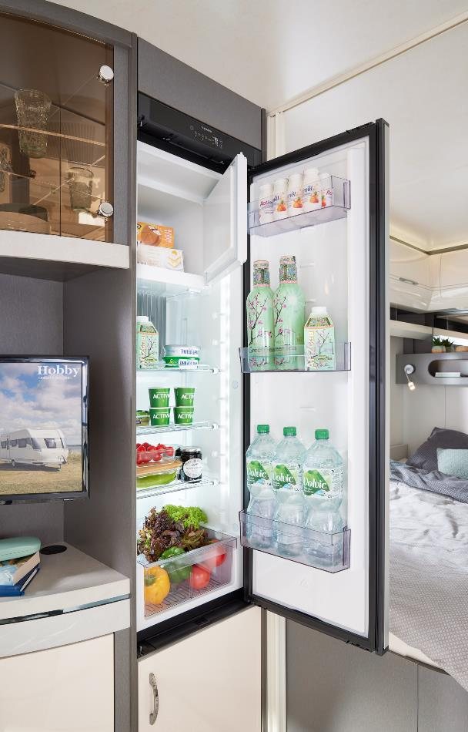
Spacious and convenient: the new 130-litre absorption refrigerator can be opened from both sides.

All Hobby caravans and motorhomes can be seen in person at the CARAVAN SALON in Düsseldorf from 26 August to 4 September 2022, and at your Hobby dealership in the near future.
Further information is available from the Hobby press office:
presse@hobby-caravan.de or at mediaportal.hobby-caravan.de

