The new HOBBY MAXIA 585 UL: Scandinavian living for up to 4 people
Fockbek, 28 July 2022 – Scandinavian design and smart features: the MAXIA 585 UL is the latest addition to the Hobby caravan family. Like all models in the MAXIA range, it features an open-plan design, warm colours, natural materials and a healthy helping of “hygge”.
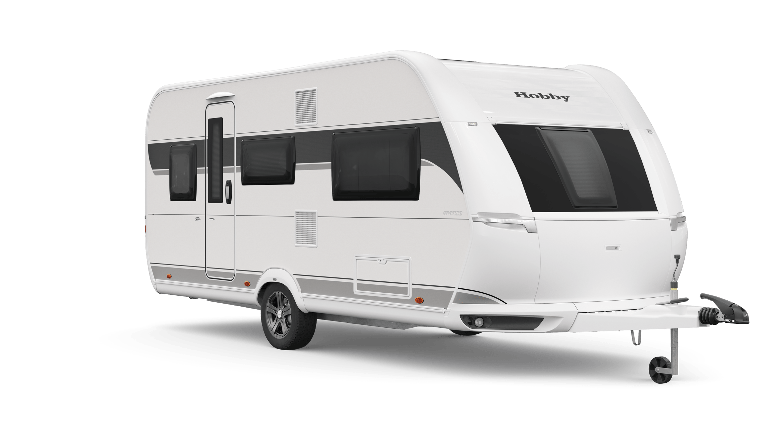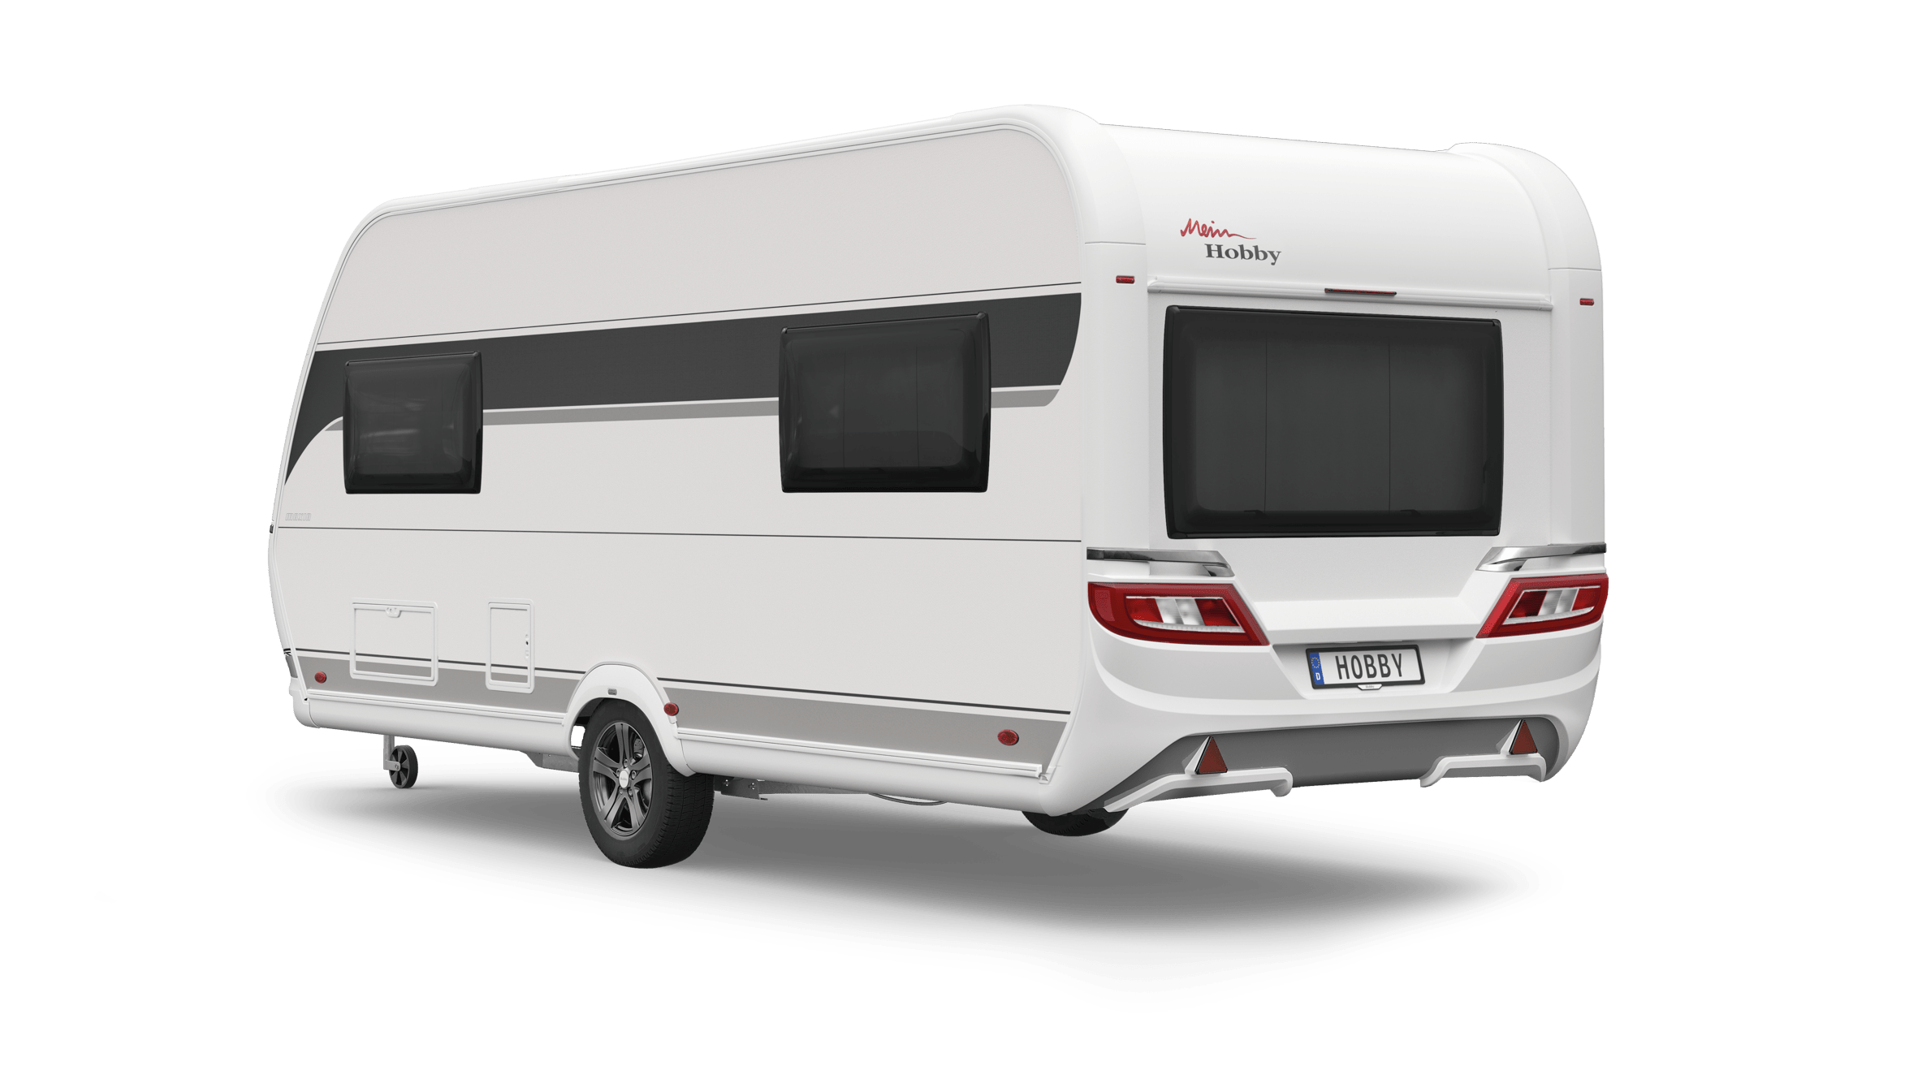
Timeless design, oneness with nature and a sense of cosiness – the typical Scandinavian feeling of “hygge” is the new motto of the MAXIA model range. “The success of the MAXIA models shows that our customers attach great importance to cosiness and design in addition to quality,” says Bernd Löher, Managing Director of Hobby. “We are continuing on this path with the new MAXIA 585 UL and expanding our MAXIA range.” With a width of 2.50 m and a length of 7.69 m, the MAXIA 585 UL is slightly longer than its smaller brother, the MAXIA 495 UL (L: 7.20 m / W: 2.30 m). Inside, both models are characterised by the modern furniture design with clean cabinet fronts and an open feel.

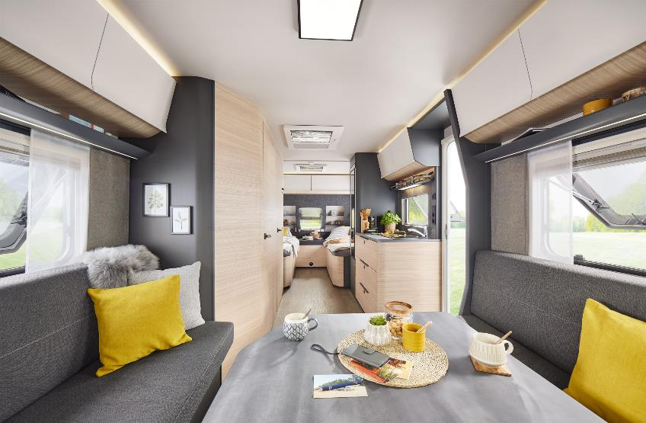
Modern furniture design, clean cabinet fronts and an open feel in the MAXIA 585 UL.

A COMFORTABLE AND COSY SPACE
There are two comfortable single beds with cold foam mattresses at the front of the 585 UL, which can be joined together with the help of a handy bed extension. This creates an extra-large sleeping space across the entire width of the vehicle.
The heart and soul of the new layout is the large U-shaped seating area at the rear. During the day, the whole family can get together here to enjoy a meal or relax. At night, the seating area can be converted into two extra berths in just a few simple steps. The ambient lighting above the wall units and under the seating area creates an exceptionally cosy atmosphere.

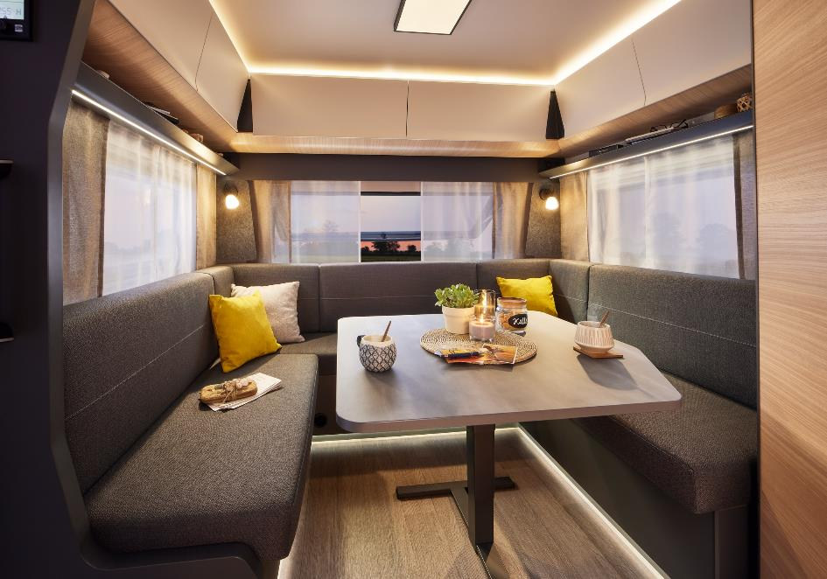
The ambient lighting in the MAXIA 585 UL creates a cosy atmosphere in the evenings.

A KITCHEN THAT COMBINES DESIGN WITH FUNCTION
In the wide side kitchen with a large work surface and the new 3-burner hob/sink combination there is a 133-litre refrigerator with a 12-litre freezer compartment. A spice rack, several power sockets, bright LED lighting and extra-large drawers will get the hearts of amateur cooks leaping for joy.

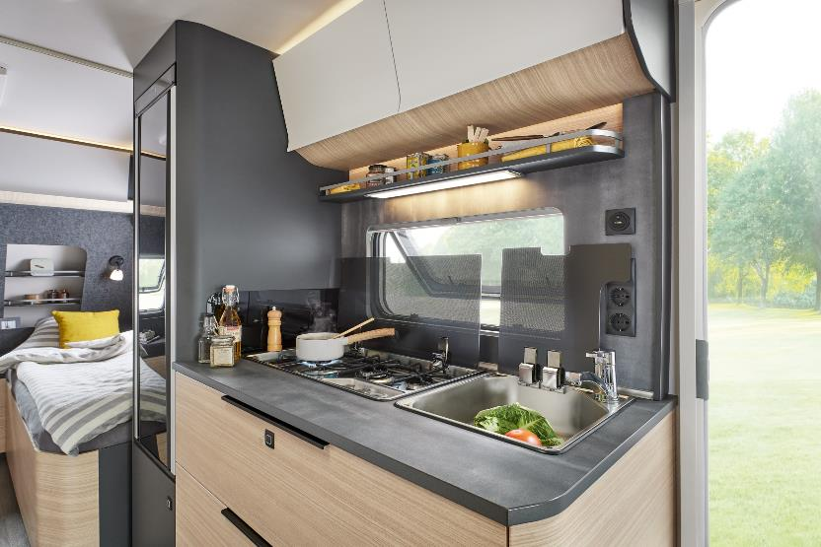
The wide side kitchen with a large work surface and the new 3-burner hob/sink combination.

GENEROUS STORAGE SPACE AND PLENTY OF ROOM FOR YOUR PERSONAL CARE
There’s room for all of the family’s holiday clothes in the large wardrobe. Food and other holiday items can be stored on several levels in the additional storage cupboard with a pull-out drawer. The compact washroom on the driver’s side makes effective use of the available space. The toilet can be rotated, which creates lots of space and an impressive amount of elbow room. The rooflight can be opened and provides natural light as well as excellent ventilation for the washroom.
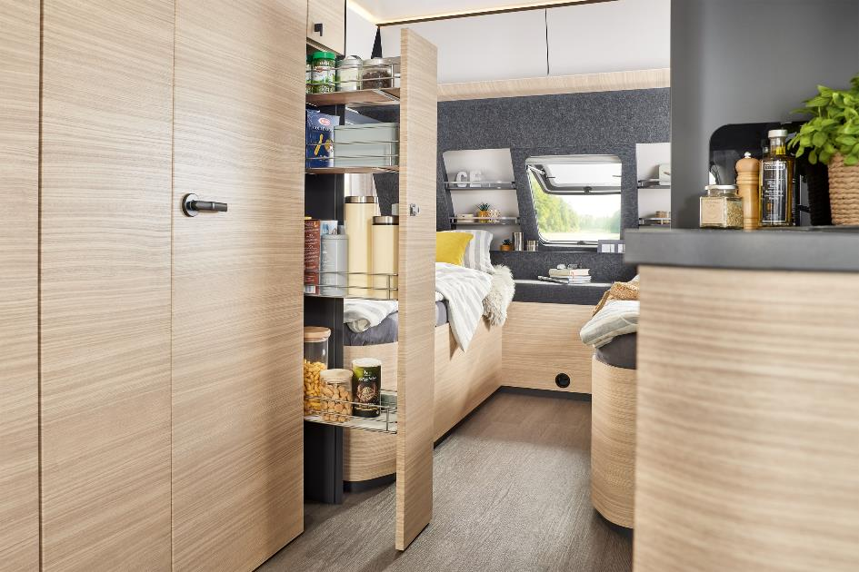
The handy pull-out drawer creates lots of storage space in a small area.

SMART ON-BOARD CONTROL SYSTEM INCLUDED
Like all Hobby caravans, the MAXIA 585 UL comes with the HobbyConnect on-board control system as standard. The free HobbyConnect app gives you access to lots of different features. Using a smartphone or tablet computer, the light settings and air conditioning can be controlled, or the battery status and water tank levels checked, for example.
EVERYTHING YOU NEED – INSIDE AND OUT
The MAXIA 585 UL is available to order in Germany at prices starting from 36,440 euros. Thanks to the “HobbyKomplett” ALL-INCLUSIVE package, the latest Hobby caravan is also equipped with everything that’s needed for a great holiday as standard. Typical of Hobby, it represents unbeatable value for money without any extra costs or expensive optional packages.
The MAXIA 585 UL can be seen in person at the CARAVAN SALON in Düsseldorf from 26 August to 4 September 2022, and at your Hobby dealership in the near future.
Further information is available from the Hobby press office:
presse@hobby-caravan.de or at mediaportal.hobby-caravan.de

