THE NEW HOBBY MAXIA VAN:
SCANDINAVIAN LIVING
MEETS PRECISION GERMAN ENGINEERING
Fockbek, 12 August 2022 – Hobby’s MAXIA VAN combines Scandinavian flair and cosiness with state-of-the-art bodywork and vehicle technology “Made in Germany”. Powerful, comfortable and brimming with smart features, this van will transform any camping holiday into a premium, van life experience.
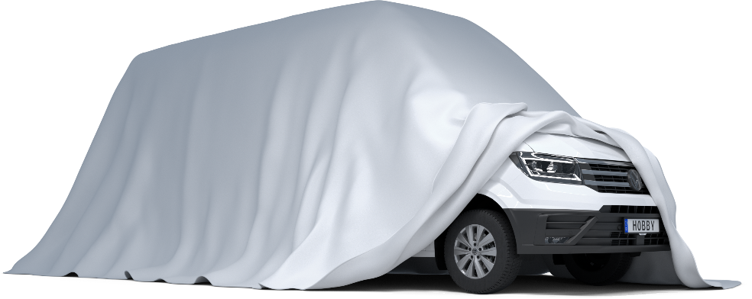

Nature and technology, timeless and modern, cosy yet space-saving – in impressive fashion, the Hobby MAXIA range proves that supposed opposites are sometimes the perfect match for one another. In addition to its clean and elegant design, the new MAXIA VAN built on a VW Crafter chassis is also characterised by its high-performance vehicle technology.

“With the MAXIA VAN, we’re catering to customers for whom travel and driving dynamics are of paramount importance, but who don’t want to make any compromises where style and comfort are concerned,” says Hobby Managing Director Bernd Löher regarding the latest addition to the popular MAXIA range.

HOME IS WHERE THE HEART IS – WITH A VIEW OF THE OPEN ROAD
Light walnut wood, graphite grey wall units, white overhead cabinets and the flair of the open-plan design; the elegant interior of the MAXIA VAN is a dream come true for anyone who’s fallen in love with the simple Scandinavian design style. The grey, V-Flex, felt-effect lining for the roof and side walls as well as the modern cabinet doors also contribute to this feeling of cosiness. What’s more, thanks to the super-high roof, the van also boasts a comfortable interior headroom of 2 m.
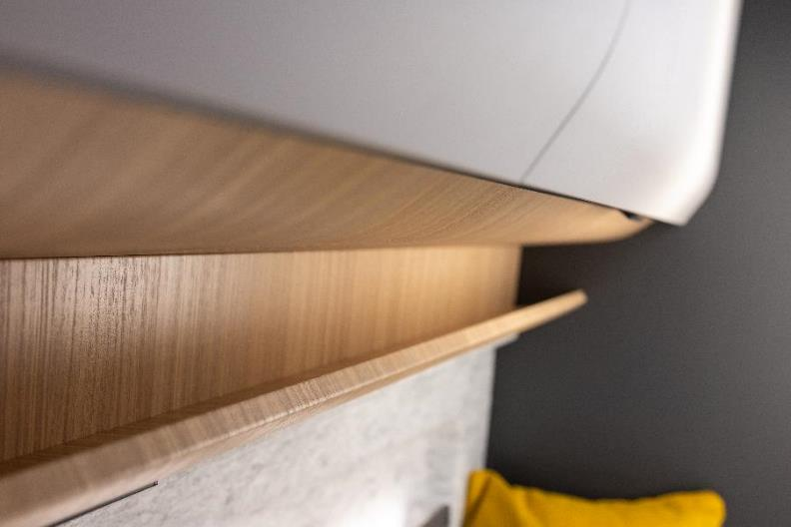
Light walnut wood, graphite grey wall units, white overhead cabinets and the flair of the open-plan design.
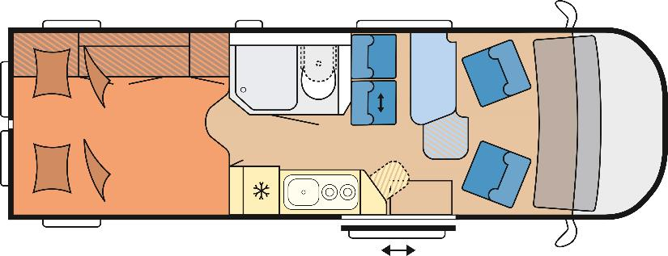
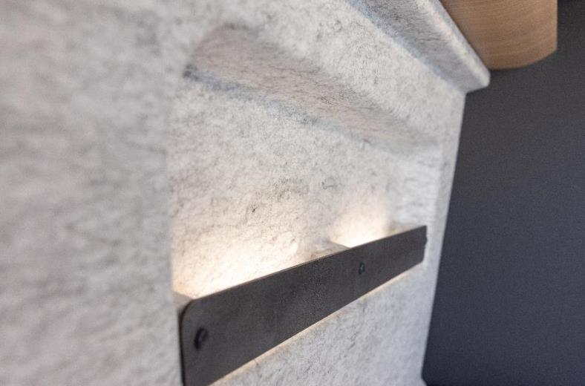
The grey, V-Flex, felt-effect lining for the roof and side walls as well as the modern cabinet doors also contribute to this feeling of cosiness.

“Our customers very much appreciate a design that features clean lines, modern styles and warm colour schemes,” says Löher. “As a North German motorhome and caravan manufacturer, we naturally have a high affinity for Scandinavia as well as the feeling of “hygge” that’s typical of the MAXIA range, and which we are now also introducing into the van segment with our MAXIA VAN. Because our customers want a vehicle that’s just as comfortable and cosy as their own home.”

Plenty of storage space and the compact washroom with an integrated shower and toilet ensure convenience. In addition to practical cabinets with storage space for the on-board technology, drawers and compartments, the multifunctional rear section of the VAN also has room for the two pull-out, 11-kg gas bottles. The well-designed kitchen units, such as the 90-litre compressor refrigerator, the hob/sink combination with a 2-burner hob and electric ignition, are also sure to impress. The kitchen also includes a fold-out worktop extension and kitchen drawers with push lock and soft-close mechanisms. Another feature is the slide-out bench seat, which can not only be moved forwards and sideways, but is also extremely ergonomic and equipped with three-point seat belts.
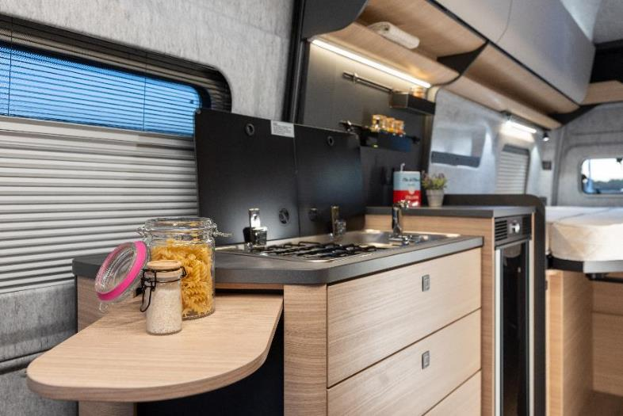
The well-designed kitchen units, such as the 90-litre compressor refrigerator, the hob/sink combination with a 2-burner hob and electric ignition.

Thanks to the ambient lighting, an efficient TRUMA Combi 6 heating system and highly effective Cellofoam insulation made of up to 60% recycled fibres, a cold foam mattress and GOODSIDE slatted frame, it’s still cosy at night and in winter. This is true of all three berths, because in addition to the two single beds measuring an incredible 2 m in length, there’s another overnight solution for young campers in the cab of the MAXIA VAN. With a maximum technically permissible laden mass of 3.5 t and the extra-large sleeping space at the rear, the MAXIA VAN is perfectly tailored to the needs of couples. With approval for 4 people, an increase in load capacity to 3.85 t is an option. The van is just over 2 m wide and 6.8 m long in total.

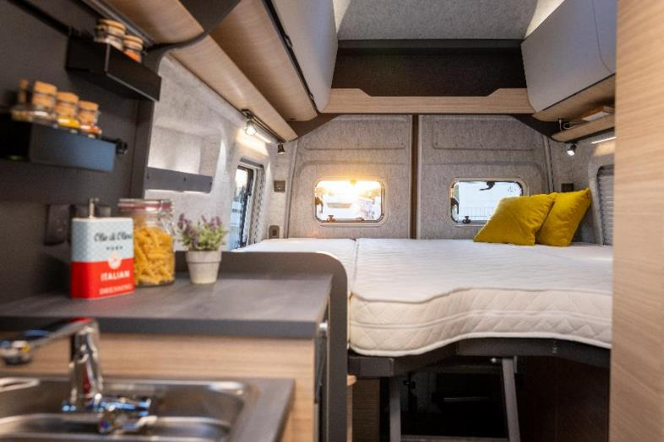

“HYGGE” MEETS HIGH-TECH: THE MAXIA VAN’S MULTIMEDIA PACKAGE
“Composition Colour”, Volkswagen’s very own radio system with TFT display, four speakers, Bluetooth and two USB-C ports, is just as much a part of the extensive multimedia package as Car-Net App-Connect and the interface for connecting with smartphones.
And for those who couldn’t cope without being able to stream their favourite series or the opportunity to do a bit of work while on the road, the Hobby MAXIA VAN has its own mobile Internet connection thanks to CAMPERNET LTE.

HOBBY AND VW: THE PERFECT MATCH
Performance, quality and attention to detail are the things that Hobby and Volkswagen share in common – and the reason why both companies are so loved in Europe (and beyond). It’s also the reason why Hobby is using the VW Crafter (2.0 l TDI) as the base vehicle for the first van in its MAXIA range. 177 hp, 8-speed automatic transmission and start/stop technology are all included on board, as is the latest vehicle safety technology. As a result, the MAXIA VAN comes with a comprehensive range of driving assistance systems as standard, including fatigue detection, a reversing camera, lane departure warning system (“Lane Assist”), traffic monitoring system, adaptive cruise control (ACC) up to 160 km/h including speed limiter, as well as light and rain sensors.
“At the end of the day, from our point of view, it’s also the combination of many different things that make the vehicle so special,” summarises Hobby Managing Director Löher. “Driving, safety, design and comfort. The high-quality interior and the VW Crafter chassis make the MAXIA VAN a luxury class model in the van segment.”
The MAXIA VAN will be celebrating its official launch at the CARAVAN SALON in Düsseldorf from 26 August to 4 September 2022 and available at a Hobby dealership near you from the 4th quarter onwards.

Further information is available from the Hobby press office:
presse@hobby-caravan.de or at mediaportal.hobby-caravan.de

