Caravan Salon 2022: HOBBY presents the MAXIA VAN and the BEACHY AIR study.
Fockbek/Düsseldorf, 26 August 2022 – North-German caravan and mobile home manufacturer Hobby will feature at Caravan Salon in Düsseldorf where it will showcase a host of new developments, popular best sellers, and a surprising concept – all with a generous helping of “hygge”. The MAXIA product range will take centre stage with its modern Scandinavian design, its premium MAXIA VAN camper and the BEACHY AIR study as an added surprise.

The MAXIA VAN was the most eagerly anticipated new development presented by Hobby at their press conference at this year’s Caravan Salon in Düsseldorf. The VW Crafter base vehicle, in particular, has generated plenty of attention. It marks the first step in a new collaboration between Hobby and Volkswagen. In addition to the convenience of the same safety and assistance systems that can be found in cars, the MAXIA VAN boasts a powerful 177 hp engine with an 8-speed automatic transmission – in addition to a unique design.

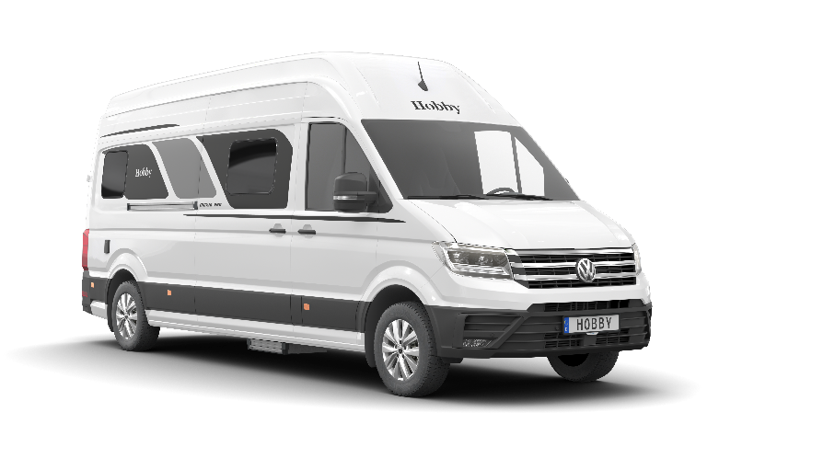
The new MAXIA VAN with VW-Crafter chassis.
With a maximum technically permissible mass of 3.5 tons, the MAXIA VAN has been designed for use by two people when on the road. This is reflected in the layout which features two single beds in the rear, a side kitchen and a washroom. For those who wish to travel in a group of four, the vehicle’s load capacity can optionally be increased to 3.85 tons. With the MAXIA VAN, Hobby has positioned itself in the premium van segment. This is also evidenced by the interior furnishings. Beautifully coordinated colours and thoughtfully designed furniture appeal to people who also truly appreciate modern comforts in a mobile home.

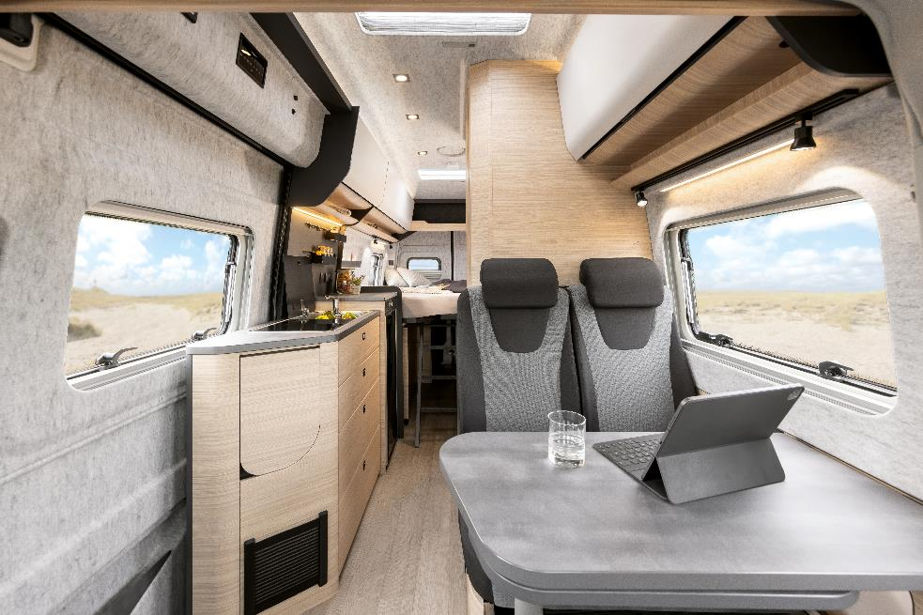
The scandinavian “hygge” interior design of the MAXIA VAN.

Light walnut wood, graphite grey wall units, white overhead cabinets and an open-plan design; the elegant interior of the MAXIA VAN is a dream come true for anyone who has fallen in love with the simple aesthetic of Scandinavian design. The grey, V-Flex, felt-effect lining for the roof and side walls as well as the modern cabinet doors also contribute to this feeling of cosiness. What’s more, despite having a double floor, the van boasts a comfortable interior headroom of 2 metres thanks to the super high roof.

Numerous clever storage solutions and the compact washroom with an integrated shower and toilet provide even more convenience. In addition to practical cabinets with storage space for the on-board technology, drawers and compartments, the multifunctional rear section of the van also has enough room for the two pull-out, 11-kg gas bottles.

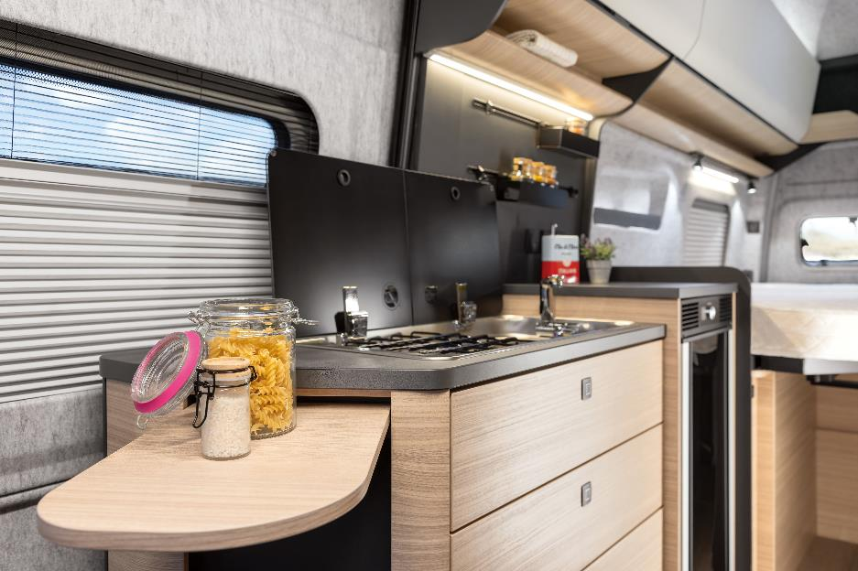
The well-designed kitchen units, such as the 90-litre compressor refrigerator, the hob/sink combination with a 2-burner hob and electric ignition.
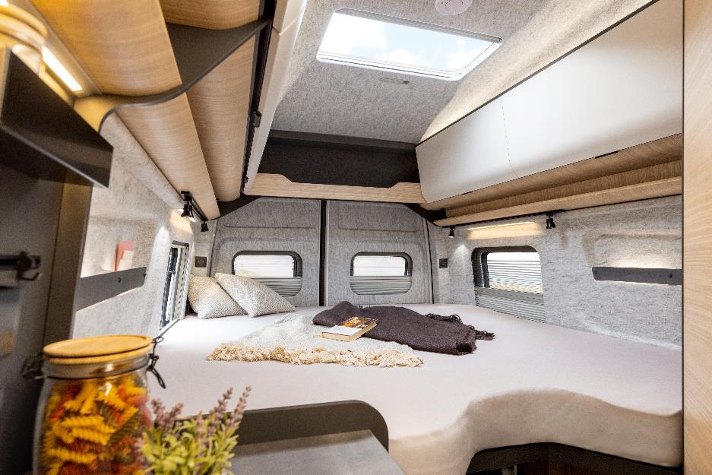
The super high roof of the VW Crafter provides a generous feeling of space in the MAXIA VAN.
Thanks to the ambient lighting, an efficient TRUMA Combi 6 heating system, highly effective Cellofoam insulation made of up to 60% recycled fibres, a cold foam mattress and GOODSIDE slatted frame, cosy nights are guaranteed – even in winter. With a choice of three different paint finishes, the MAXIA VAN also offers scope for you to express some of your personality in the exterior design.

The MAXIA VAN 680 ET, with Hobby’s trademark ALL-INCLUSIVE package, is available to order now at your local dealership, with prices starting at 89.750 Euro, and delivery expected from spring 2023.

HOBBY motorhomes and caravans
Alongside the MAXIA VAN that HOBBY is presenting at Caravan Salon in Düsseldorf, the MAXIA range will also feature a new caravan. Say hello to the newest member of the MAXIA family – the MAXIA 585 UL.

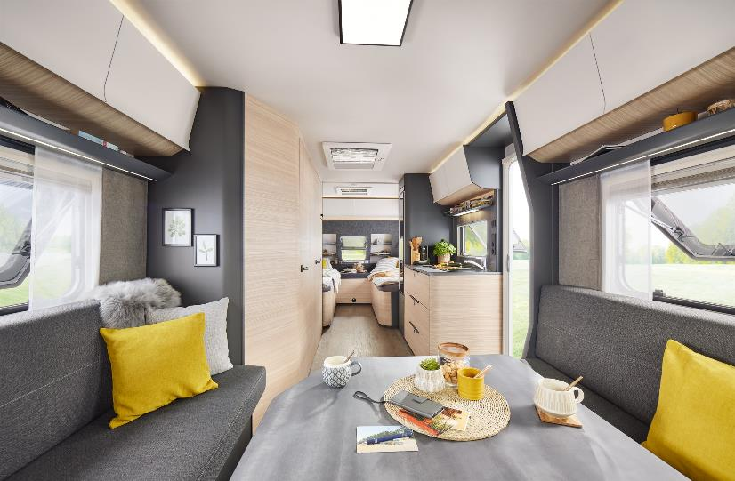
Modern furniture design, clean cabinet fronts and an open feel in the MAXIA 585 UL.
The entire caravan portfolio has been carefully refined for the 2023 season, with new layouts in some cases and a number of improvements to the equipment package.

For the new season, the well-established VANTANA vans and OPTIMA motorhomes feature the same models as the previous year, albeit with a few minor adjustments to the details.
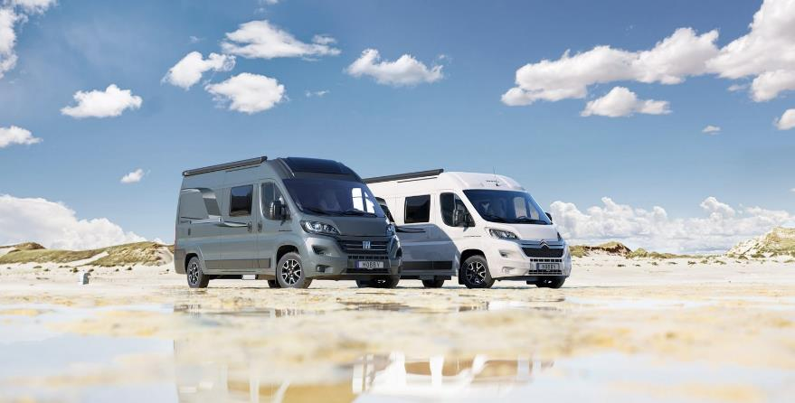
The VANTANA ONTOUR EDITION and VANTANA DE LUXE come with numerous features.
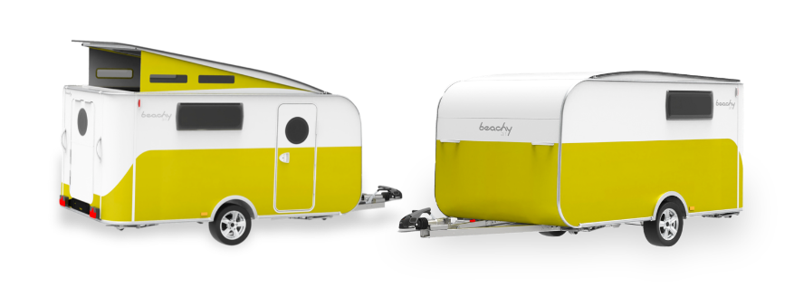
However, HOBBY saved the biggest reveal of all until the opening day of Caravan Salon. Alongside the MAXIA VAN, HOBBY presented the BEACHY AIR lightweight design study as a surprise at its press conference.
The lightweight study BEACHY AIR by Hobby.
The complete press releases for the BEACHY AIR, MAXIA VAN, MAXIA 585 UL and all motorhome and caravan news for 2023, along with full details and pictures, can be found on the Hobby press portal: https://mediaportal.hobby-caravan.de/pressemitteilungen/
Further information is available from the Hobby press office:
presse@hobby-caravan.de or at mediaportal.hobby-caravan.de

