HOBBY BEACHY AIR STUDY: A CARAVAN FOR THE FUTURE
Fockbek, 26 August 2022 – What will camping holidays look like in the future? This is a question that Hobby, the north German manufacturer of caravans and motorhomes, is asking itself. The caravan industry is in need of fresh and innovative ideas. The BEACHY AIR study in lightweight construction is one of them.

Camping holidays allow us to embrace nature. Anywhere, at any age, at any time. Simply, flexibly and with ease. How that could look in the future will be presented by Hobby with the BEACHY AIR study at the Caravan Salon in Düsseldorf.
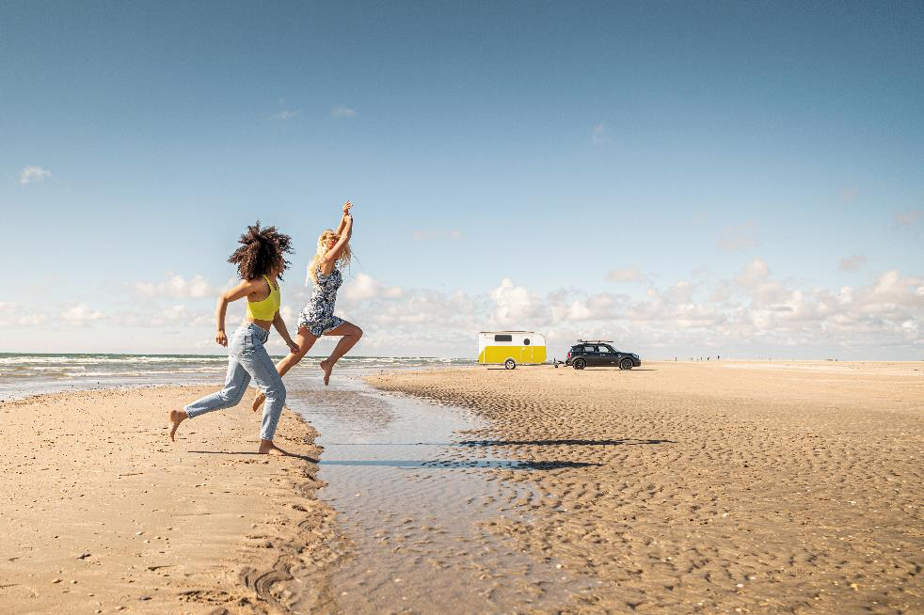
The idea: a caravan that is so lightweight and aerodynamic that it can also be towed by electric vehicles and with a category B driving licence. “The BEACHY AIR showcases cutting-edge technology with a focus on lightweight construction and functionality”, said Hobby Managing Director Bernd Löher about the latest innovation project from his company. “We wanted to achieve an unladen weight of less than 500 kg in order to develop the perfect caravan for the age of electric mobility. And what could be more fitting than the logical continuation of the BEACHY idea, namely to build simple, clever and stylish vehicles in
a beach house look”, added Löher.

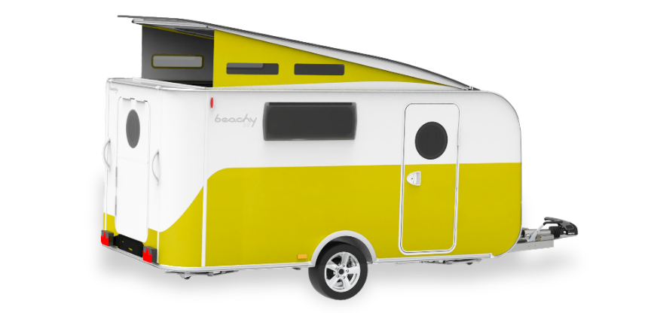
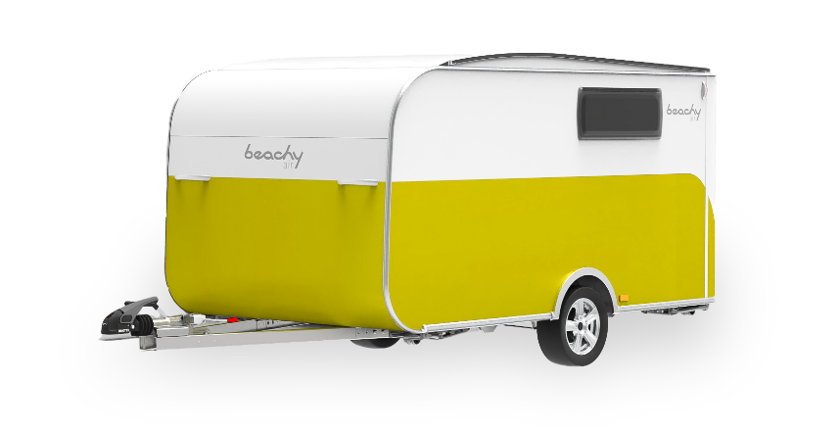
The new BEACHY AIR study in lightweight construction by Hobby.

THE BODY: COMPACT. SIMPLE. EXTRAORDINARY.
With a body length of approximately 3.5 metres and an overall height of approximately 2 metres, the BEACHY AIR looks quite compact at first. The clever pop-up roof, however, makes it possible to increase the height to 2.15 metres. And the removable kitchen unit takes flexibility to the next level – especially when the weather is nice and everything can be easily relocated outdoors. The convenient folding high desk can also be used as an additional work surface for the kitchen or provide office space for working on the go.
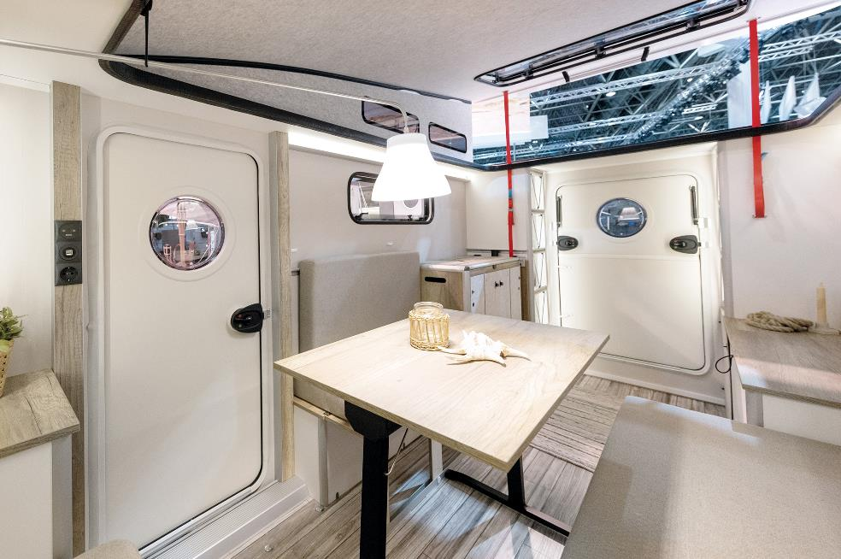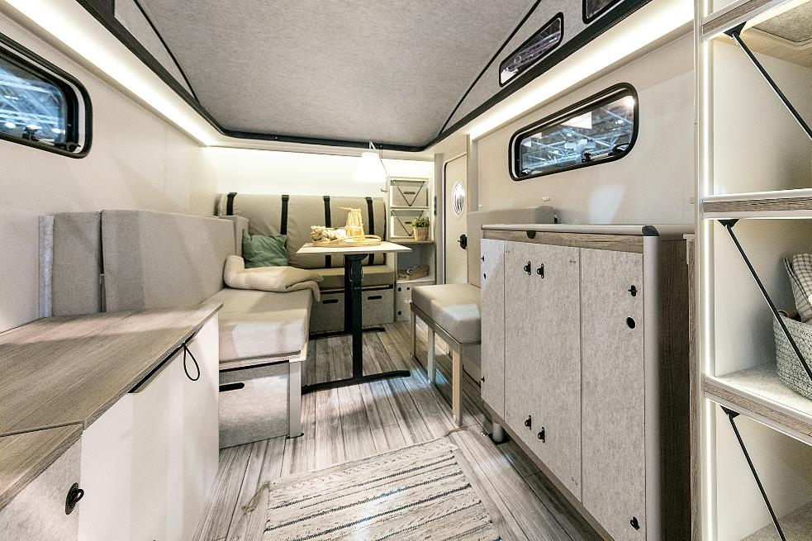
The BEACHY AIR at the Caravan Salon 2022.
Thanks to its modular build, the BEACHY AIR provides a generous sense of space in a very small area. In just a few simple steps, the L-shaped lounge seating area can be converted into a bed measuring 2 x 1.40 metres. A cold foam mattress topper that also serves as a backrest ensures a perfect night’s sleep. Crafted to make the most of lightweight construction, the furniture design features bright and
natural colours for that authentic BEACHY feeling.

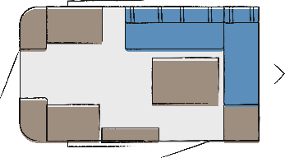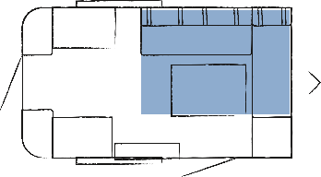
Day and night floor plans of the BEACHY AIR

LOW WEIGHT, HIGH IMPACT – VISION MEETS REALISM
With the study, Hobby has overcome one of the current limitations faced by many electric vehicles: Thanks to the low weight of the BEACHY AIR, it is not only possible to significantly increase the range for travel, but also the spectrum of vehicles that can tow the caravan. The lightweight caravan is made feasible by its innovative monocoque construction and various lightweight components. This special construction greatly reduces weight without affecting stability or safety.
A SUSTAINABLE FUTURE REQUIRES TEAMWORK
To turn future-oriented projects like the BEACHY AIR into reality, strong partnerships on equal footing are necessary. For example, Vöhringer GmbH & Co KG developed the lightweight construction materials, while Knott GmbH contributed the ultra-lightweight chassis. The vehicle concept and prototype build of the BEACHY AIR were implemented by the development agency Ross Design GmbH. Anne Halskov of the Danish design agency PENATOS was once again responsible for the interior of the BEACHY AIR.
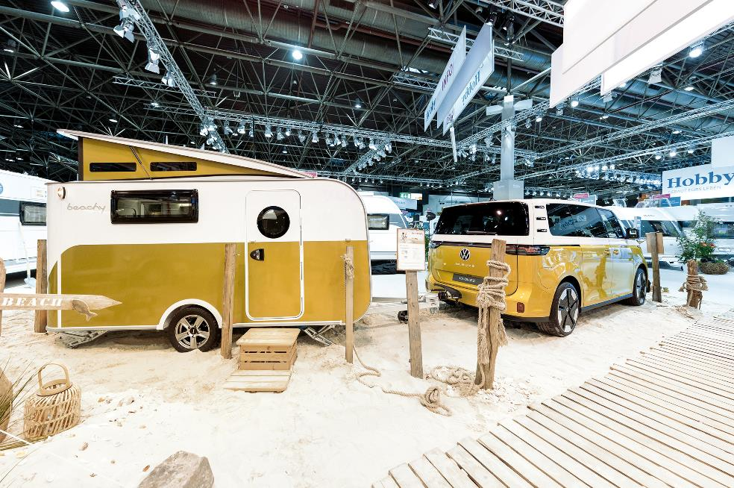
Hobby will be presenting the new BEACHY AIR study in connection with a VW ID. Buzz van for the first time at the Caravan Salon 2022 in Düsseldorf to demonstrate what is possible in the field of electromobility and caravanning. When and in what form the study will enter serial production has currently been left open by Hobby.
Further information is available from the Hobby press office:
presse@hobby-caravan.de or at mediaportal.hobby-caravan.de

