Built for life. And all that is yet to come: Hobby’s new family caravan MAXIA 595 KML
Fockbek, 09 January 2023 – Right on time for the CMT in Stuttgart, Hobby has announced a new layout in the popular MAXIA caravan range. The MAXIA 595 KML offers berths for up to five people (seven per optional features) and a brand-new children’s bed area. The real stand-out feature: exactly how the multifunctional children’s bed area is used is up to families to decide for themselves.
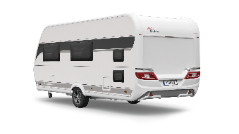
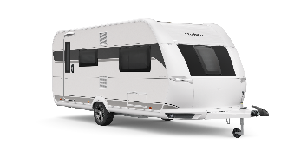

Berths for up to three children
Able to adapt to all circumstances and travel plans, the children’s bed area of the MAXIA 595 KML offers more than nine different potential uses. There is room for up to three bunk beds, each with a load-bearing capacity of 100 kg, in the multifunctional rear area.
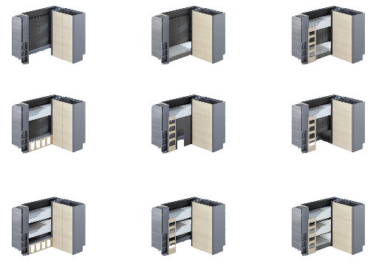

Thanks to a click-to-connect system with roll-up bed slats and mattresses, the comfortable upper beds that each measure 76 x 200 cm can easily be assembled and disassembled. The bottom bed is made up of three upholstered cushions and a topper to create a bed measuring 73 x 200 cm.
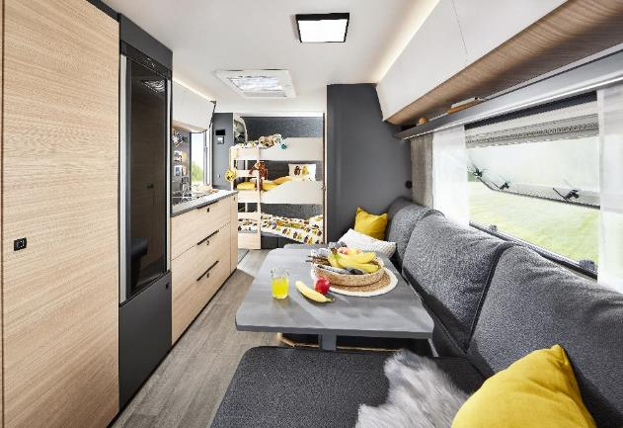
Rear view of the MAXIA 595 KML with the multifunctional children’s bed area.

During the day, the cushions can be converted into a cosy seating area that is also an inviting place to play. The dimpled structure of the form fleece underside ensures good air circulation, even in winter. The two lower beds have one side window each. The top bed provides an unobstructed view of the star-studded sky through a rooflight. A good night’s rest is ensured by the fly screen and pleated blackout blinds. LED reading lights on all levels provide pleasant light for reading. Thanks to a dimming function and integrated USB A/C ports, they simultaneously serve as night lights and as a source of power. Plenty of additional storage space is provided by the shelf that is built into foot end of the beds. Its practical storage boxes are waiting to hold clothes, toys and cuddly companions.

MORE THAN A CHILDREN’S BED AREA
Sleep, play, organise: the children’s bed area in the MAXIA 595 KML is as multifaceted as family life itself. The core element of the multifunctional concept is the perforated back panel. It ensures that warmth is evenly distributed among all the bed levels. At the same time, the holes can be used to mount various accessories – such as mesh pockets and elastic cords. And enough space for two adults and another child.
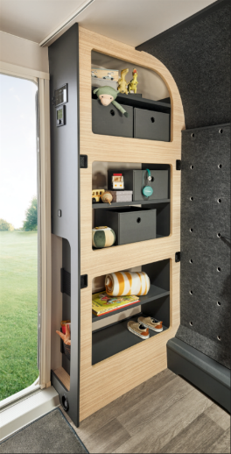
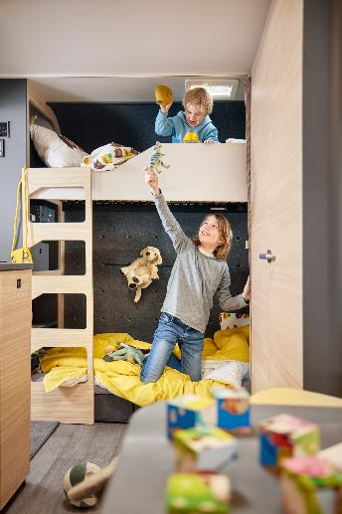
The multifunctional children’s bed area of the MAXIA 595 KML

The removable ladder makes it easy and comfortable even for little feet to reach the upper beds. When the lower area is not being used as a bed or play area, the ladder serves as a guard to secure the luggage stored behind it. As an alternative, it offers a cosy retreat with a cushion for four-legged friends. “Multifunctional use is the fundamental idea behind the MAXIA 595 KML” explained Christoph Semkow, Project Manager of MAXIA development. “This caravan can be used by families for a lifetime. From the first child to the third, for when a friend comes along on holiday or when some of the kids stay at home, but the family dog joins the crew. And even without the bunk beds, the area can be used as flexible storage space. We’re working on additional components for just that – such as shelving systems that, like all of our accessories, can easily be mounted on the wall.”

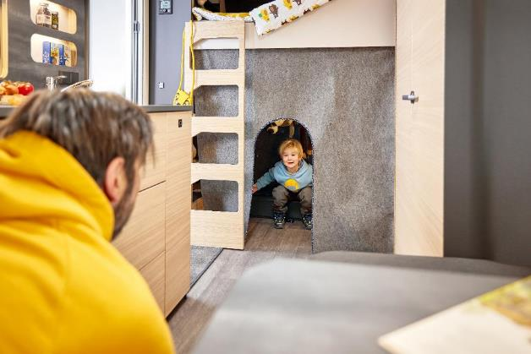
Daytime situation in the childrens’s bed area of the MAXIA 595 KML

Large family bed
Along the same lines as the new children’s bed area, the berths for adults are also multifunctional. An extension can be used to convert the two tried-and-tested single beds into a cosy family bed that is approximately 2.20 m wide – enough room to give little visitors a place to cuddle at night.

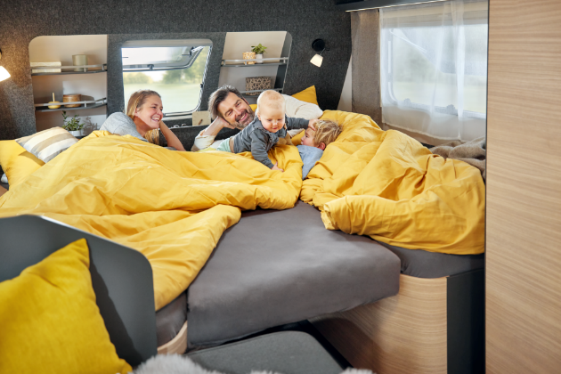
The cozy family bed with optional bed extension

Cosy living and dining area
As is the case with all vehicles in the MAXIA range, the MAXIA 595 KML is not just about functionality. The open-plan concept with Scandinavian furniture design embodies tiny house charm. Its stylish yet durable felt-effect surfaces and natural materials create a modern atmosphere. The middle of the caravan is home to a spacious wardrobe, a large seating and dining area as well as the kitchen and bathroom. The family seating area can also be converted into an additional berth. So the MAXIA 595 KML comes with up to three bunk beds, a large family bed and the converted seating area - to thus on proud seven sleep possibilities.
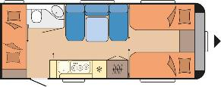
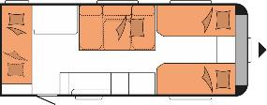

Day and night layout of the MAXIA 595 KML

Premiere at the CMT Stuttgart
With the new MAXIA 595 KML, Hobby has gone above and beyond when it comes to meeting all of the requirements of a family caravan. Designed in the popular “hygge” style of the MAXIA range, the caravan combines the best of what the familiar MAXIA layouts have to offer with a new multifunctional children’s bed concept. Showcased for the first time at the CMT in Stuttgart from 14 to 22 January 2023, the MAXIA 595 KML will be delivered to the first customers at the beginning of summer 2023.

The MAXIA 595 KML will celebrate its official premiere during a CMT press conference at 11:30 am on 13 January 2023 at the Hobby stand in Hall 5, and we would like to cordially invite you to the event.

Further information is available from the Hobby press office:
presse@hobby-caravan.de or at mediaportal.hobby-caravan.de

