Ready to hit the road from day one:
Overview of Hobby vehicles for the 2024 season
Fockbek, 01 august 2023 – Hobby has completely revamped the exterior design of all its caravans for the 2024 season. A number of changes have also been made inside: new wood finishes, modern designs and lighting concepts have dramatically rejuvenated the appearance. As we enter the new season, you can expect to find all the usual features and equipment in our motorhomes and vans.

Hobby caravans – Built for everyone
Flowing lines, stylish rear lights and handles that blend in seamlessly with the front section: Hobby caravans have been given a striking makeover for the start of the 2024 season. In addition to the revamped exterior design with new flush windows, popular features such as the stand-on drawbar cover, the stylish access holes to the heavy-duty supports for the crank handle and the integrated awning rail remain unchanged.
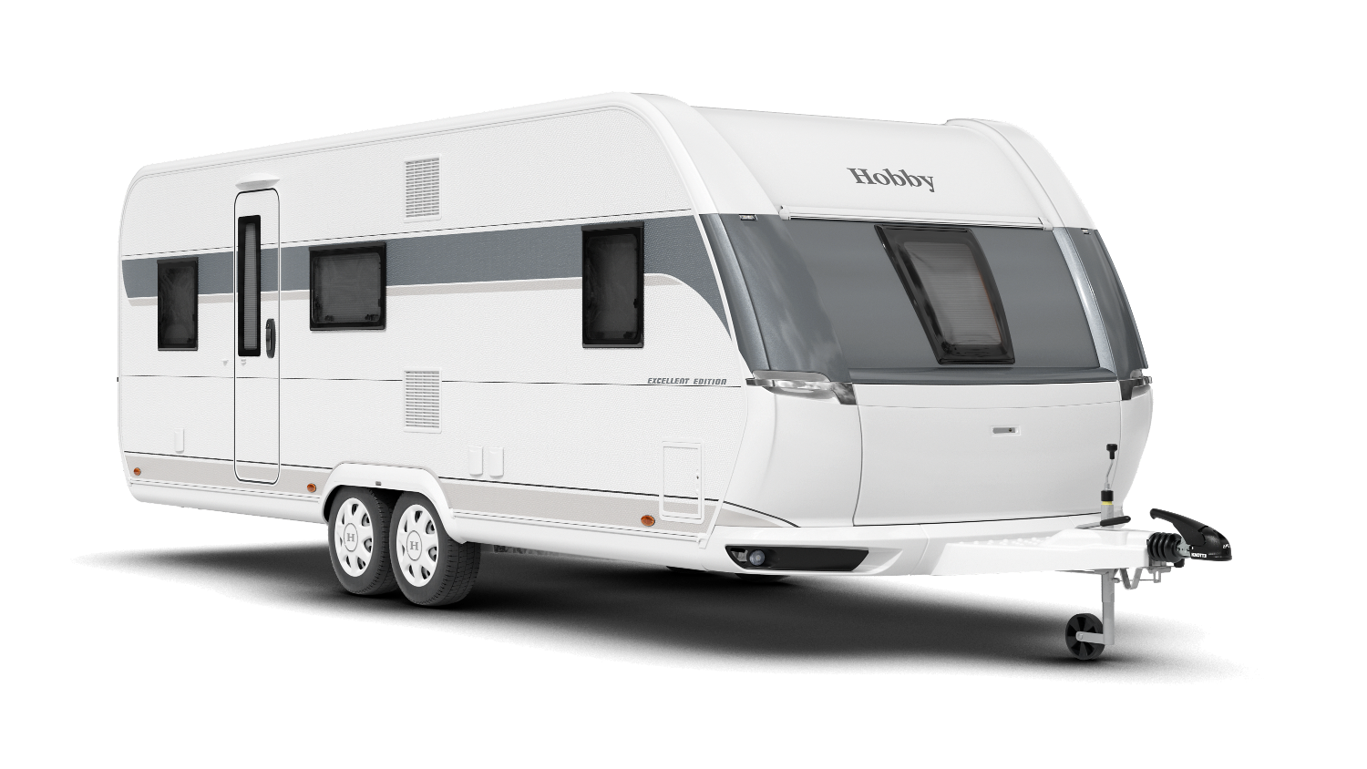
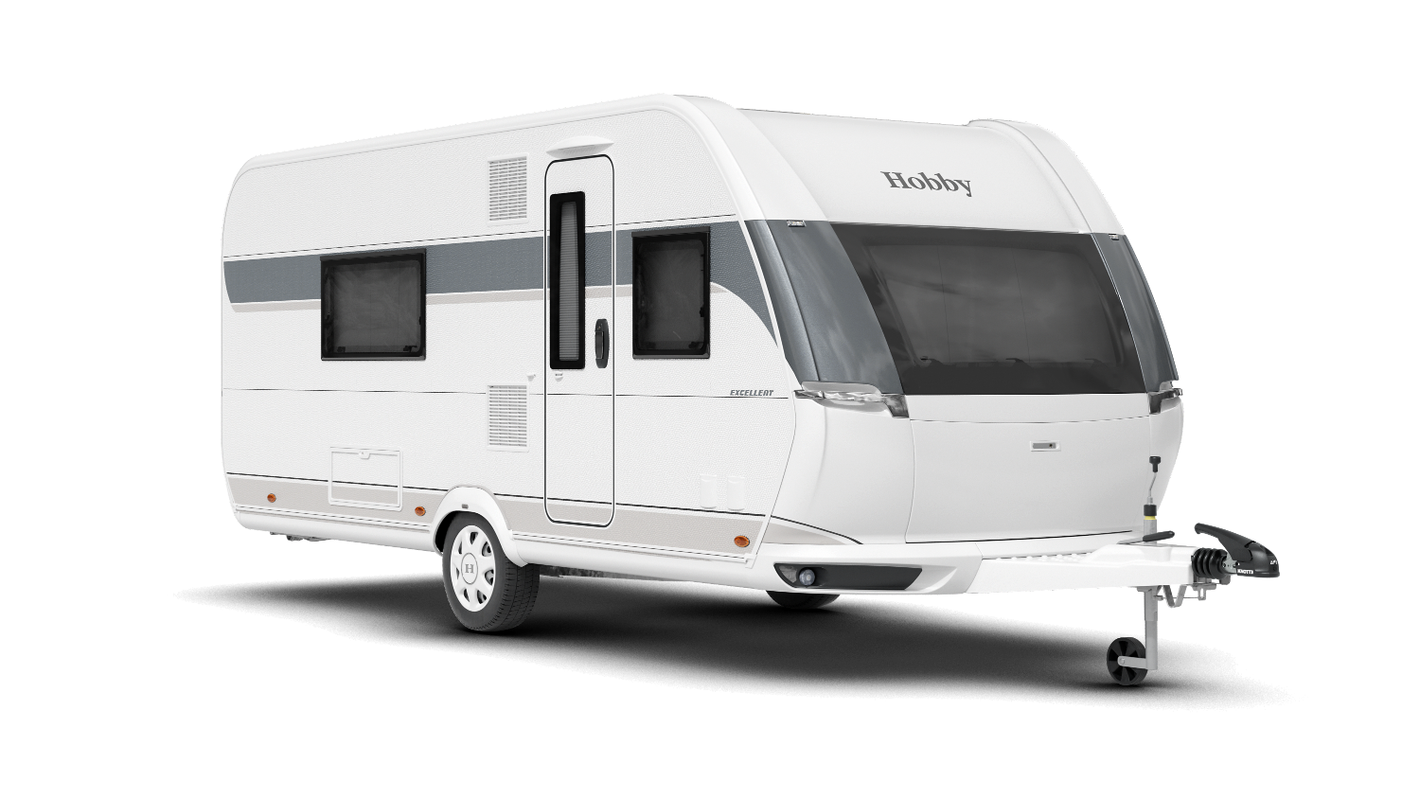

The new exterior design of the EXCELLENT 495 WFB and EXCELLENT EDITION 650 KMFe

The interior is also far more modern. Almost all of the model ranges now have new upholstery and a new furniture design. Only the MAXIA models have not been changed on the inside, as they already feature our popular Scandinavian “hygge” look.
With 49 caravan layouts in seven different model ranges, Hobby will continue to offer the usual variety of models in the 2024 season. The entry-level ONTOUR model starts at 20,310 euros, which includes the “HOBBYKOMPLETT” ALL-INCLUSIVE PACKAGE, like all Hobby vehicles. “The things that our target groups want have changed significantly,” says Thomas Neubert, Product Manager at Hobby. “On the one hand, we’re responding to these demands with our revamped interior and exterior design, while also ensuring that we design vehicles for very different target groups. This includes the Hobby sub-brand beachy, which has a minimalist and open beach house vibe. Thanks to its retro charm and three different models, the beachy caravan has already developed a huge fan base in just two years,” explains Neubert.
“With our ONTOUR model range, we offer young families and couples a comfortable entry-level caravan class with three models containing single beds, one double bed or a double bed and a bunk bed for children.”
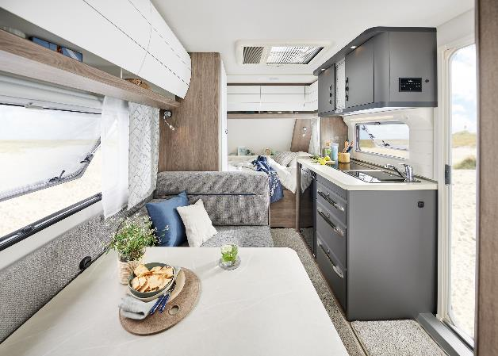
ONTOUR 390 SF: The comfortable entry-level class

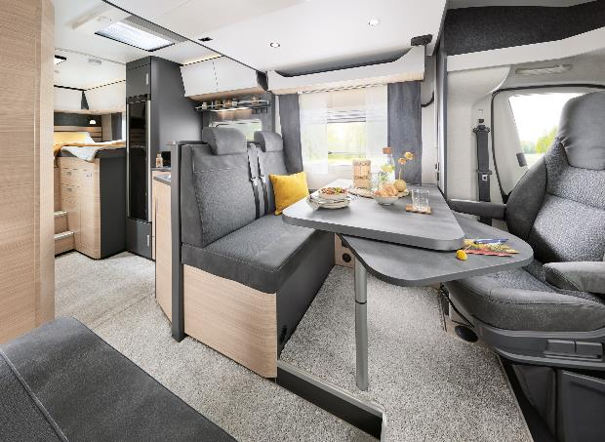
With lots of children’s bed configurations, the DE LUXE is perfect for families and boasts the widest variety of models with 14 different layouts. Thanks to the manually-operated drop-down bed above the U-shaped seating area, the DE LUXE 515 UHK has a total of seven berths. Our caravans in the EXCELLENT and EXCELLENT EDITION model ranges appeal to holidaymakers with exacting demands, which include large rear washrooms, even more storage space and an open feeling of space. The PRESTIGE and MAXIA luxury class model ranges leave nothing to be desired. “The layouts featuring large couch seating areas are especially popular in our PRESTIGE caravans,” explains Neubert. The MAXIA model range is available in three layouts. It is particularly popular on account of its modern, Scandinavian interior design. The MAXIA 595 KML featuring a multifunctional children’s bed area has been available to pre-order since last winter and is now available from dealers.
Top-quality design featuring our Nordic “hygge” look in the OPTIMA DE LUXE T75 HGE

“In just a few simple steps, up to three children’s beds can be installed and removed here,” explains Thomas Neubert. “This means that you can create a play den, a children’s seating area, a place for your four-legged friends or more space for luggage, depending on what you need.”

Variety of motorhomes in four model ranges
In the motorhome segment, Hobby has 15 models for the 2024 season, starting at 69,270 euros. The company offers a range of vehicles for different target groups in this segment, too. While the OPTIMA ONTOUR has layouts for families and couples, and comes ready to hit the road for first-timers, the OPTIMA ONTOUR EDITION is significantly more compact, making it perfect for winding roads and city trips. Thanks to the “HOBBYKOMPLETT” ALL-INCLUSIVE PACKAGE, the OPTIMA ONTOUR EDITION comes pre-fitted with a navigation system/reversing camera, a satellite/TV combination, a roof vent in the cab and a fly screen. The OPTIMA OVERCAB is the perfect model for anyone who values extra storage space and berths. The models in the OPTIMA DE LUXE luxury class of motorhomes boast top-quality design featuring our Nordic “hygge” look, which is reminiscent of the caravans in our MAXIA model range.

Vans: from compact to spacious
In the van segment, the new, luxury-class MAXIA VAN is now available. Thanks to its modern, Scandinavian interior design with coordinated colour schemes and minimalist furniture, this camper van is also in a league of its own. “What’s more, thanks to its VW Crafter chassis and assistance systems found in VW cars, the MAXIA VAN is a supremely smooth ride,” adds Thomas Neubert.
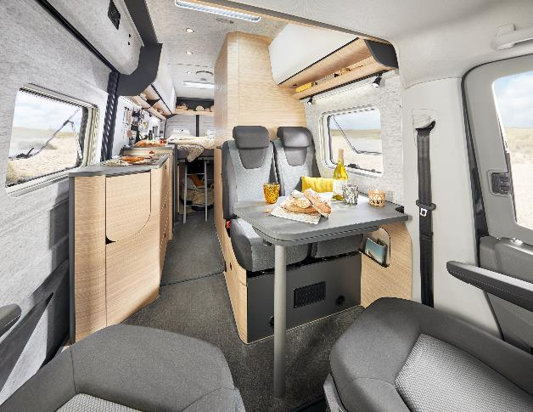
Modern Scandinavian interior design in the MAXIA VAN 680 ET

The vans in the VANTANA model range, including the entry-level VANTANA ONTOUR EDITION and the VANTANA DE LUXE – which has a panoramic roof vent and a whole host of other extras – will continue to be part of our range. They all come ready to hit the road, starting at 63,500 euros.

“HOBBYKOMPLETT” ALL-INCLUSIVE PACKAGE: one price, all you need, all included

“Whether you’re looking for an entry-level, mid-range or luxury-class vehicle, all Hobby vehicles are ready to hit the road from day one and come equipped with everything you need for a great holiday when they leave our factory,” says Neubert. “Depending on the model, this includes technical features like a navigation system/reversing camera and the smart on-board control system HOBBYCONNECT, as well as fly screens, rooflights, ambient lighting and comfortable mattresses. Unlike the rest of the industry, there are no compulsory add-ons or hidden costs with us.”

More pictures and information about the models for the 2024 season can be found online right now at hobby-caravan.de/en, or come and see them for yourself at the Caravan Salon in Düsseldorf from 25 August to 3 September 2023.

Further information is available from the Hobby press office:
presse@hobby-caravan.de or at mediaportal.hobby-caravan.de

