Hobby vans: Ready for the new season
Fockbek, 03 august 2023 – Whether you’re looking for an entry-level, mid-range or luxury-class van, Hobby has you covered with three different model ranges. The vehicle manufacturer is sticking to tried-and-tested recipes for success for the 2024 season.
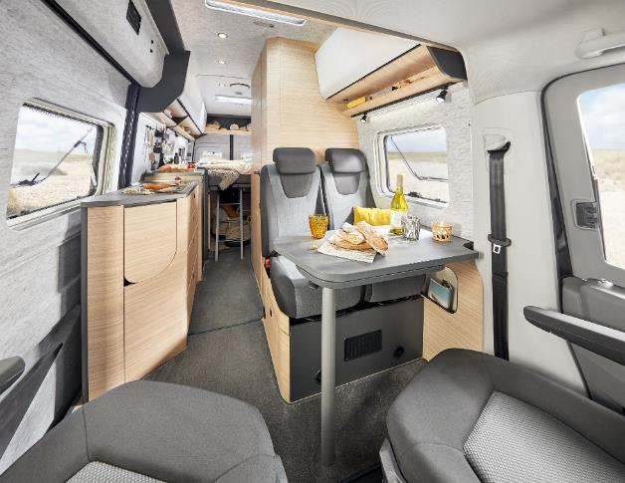
“We started a revolution with our MAXIA VAN last season,” says Bernd Löher, Managing Director of Hobby. “It’s the first model range to be built on a VW Crafter chassis. And the first van to feature our “hygge” design.” Minimalist Scandinavian-style furniture, coordinated colour schemes and premium materials – that’s what “hygge” means to Hobby. The interior design, which has already been tried and tested in various caravan and motorhome model ranges, is a hit. “People are wowed as soon as they enter the MAXIA VAN,” says Bernd Löher. “Many compare the vehicle to a stylish holiday home.”
Minimalist Scandinavian-style furniture in the MAXIA VAN 680 ET

A smooth ride meets design
“Assistance systems commonly found in VW cars ensure a really smooth ride and a high level of safety,” says Bernd Löher. “Thanks to the 177 hp engine and 8-speed automatic transmission, even challenging stretches of road are nothing to worry about.” In addition to practical cabinets with storage space for the on-board technology, drawers and compartments, the multifunctional rear section of the van also has enough room for two pull-out, 11-kg gas bottles.
The light walnut wood, graphite grey wall units, white wall units with modern doors, as well as the grey, V-Flex, felt-effect lining for the roof and side walls contribute to the open feel of the MAXIA VAN.
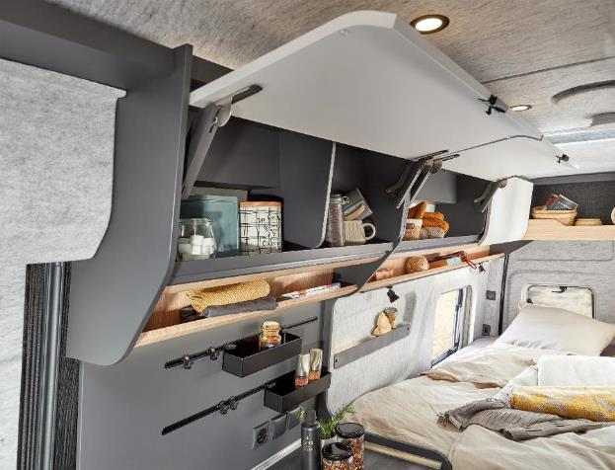
White wall units with modern doors and the grey, V-Flex, felt-effect lining in the MAXIA VAN 680 ET

Thanks to the super-high roof, the van also boasts a comfortable interior headroom of two metres. Other highlights include the double floor, the comfortable, two-metre-long beds with a GOODSIDE slatted frame, a large 90-litre compressor refrigerator and a modern compact washroom with a shower.
Fitted with all the equipment you could ever need, the MAXIA VAN is now available from many Hobby dealers starting at €89,750.
Entry-level van with all the bells and whistles
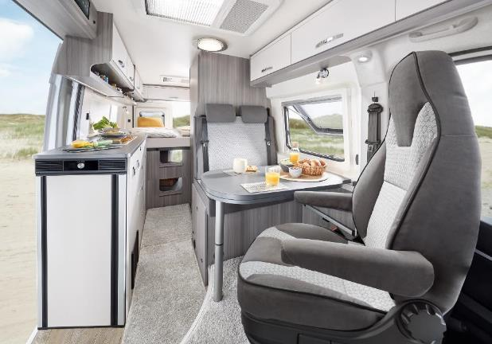
While the MAXIA VAN is primarily aimed at couples with exacting demands where design and ride comfort are concerned, the Hobby range also includes an entry-level model – the VANTANA ONTOUR EDITION, starting at €63,500. The model comes with a wide array of features and equipment, everything you need for a great holiday.
Wide array of features and equipment in the VANTANA ONTOUR EDITION K65 ET

Like all Hobby vehicles, many extras are already included right from the start thanks to the “HOBBYKOMPLETT” ALL-INCLUSIVE PACKAGE. This includes a navigation system, a satellite system and TV, as well as a large refrigerator and premium mattresses. Customers have a choice between two layouts built on a CITROËN chassis with the bed arranged crosswise or lengthwise. Both versions have two extra, optional berths in the seating area and cab. Other highlights include a large, double-hinged refrigerator in the entrance area, premium mattresses on a folding GOODSIDE slatted frame system, as well as a highly practical compact washroom.

A touch more luxury
With a panoramic roof vent, 16-inch alloy rims and cosy ambient lighting, the VANTANA DE LUXE offers customers even more features and extra comfort. “This model range is targeted at those who want a little extra and who attach importance to special features, like the three special paint finishes Expedition Grey, Lanzarote Grey and Black Metallic, as well as romantic mood lighting,” says Bernd Löher. The VANTANA DE LUXE is available in two layouts with the bed arranged crosswise or lengthwise. Both versions are built on the tried-and-tested FIAT DUCATO chassis.

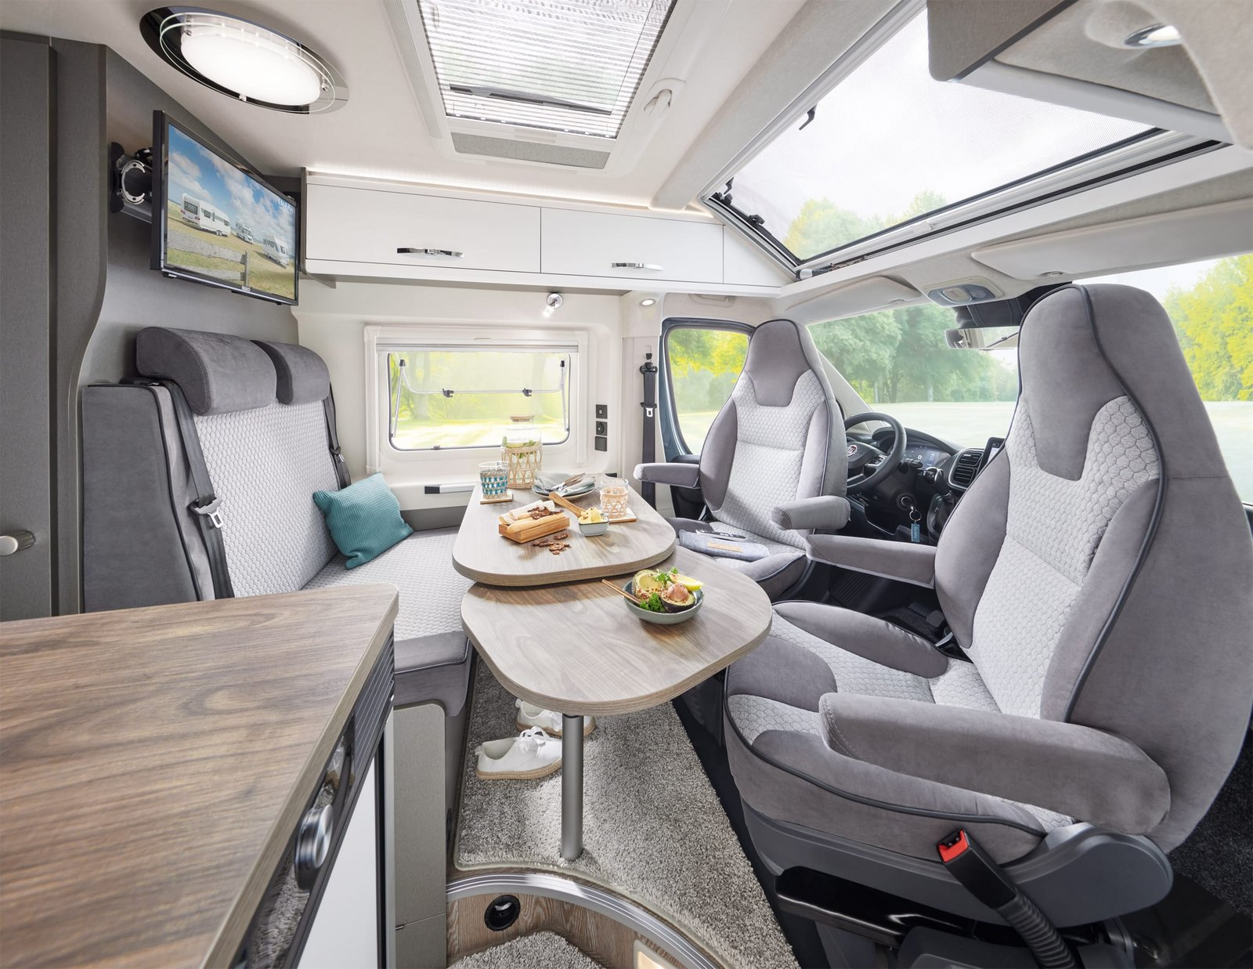
The seating area in the VANTANA DE LUXE K65 ET

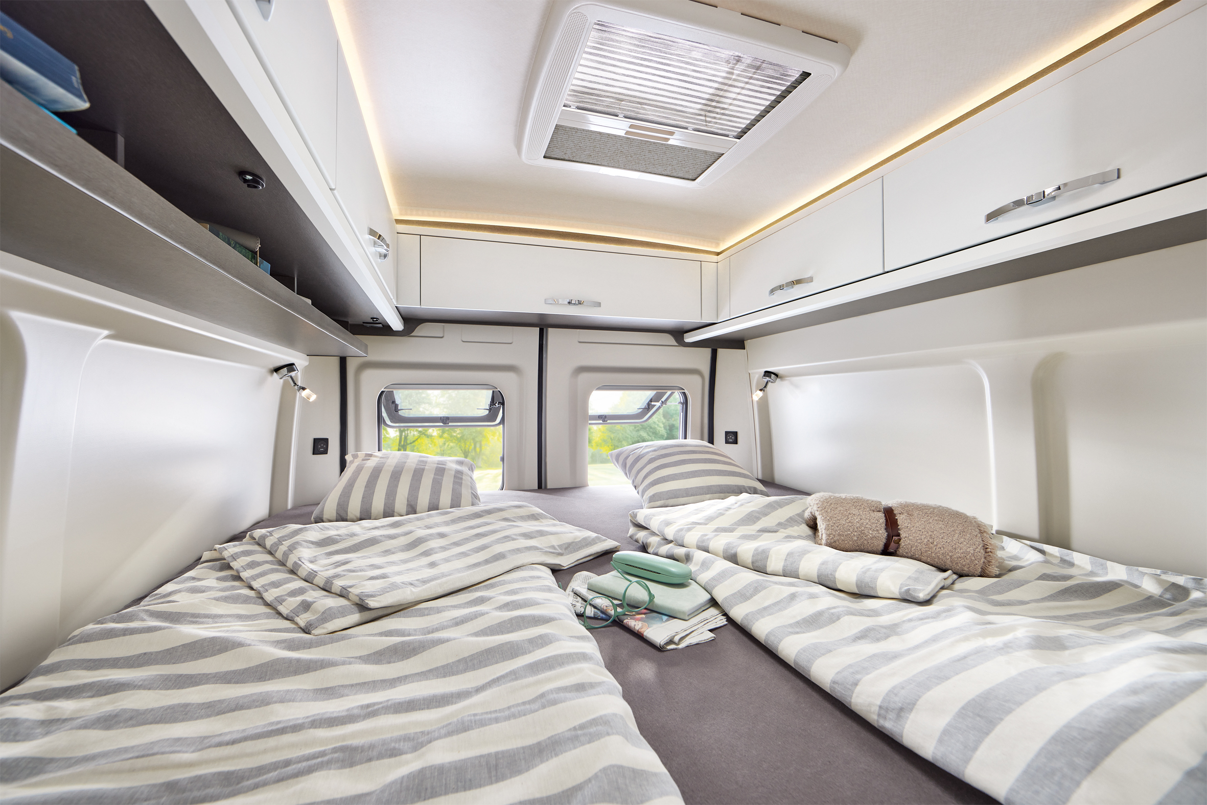
The cosy single beds in the VANTANA DE LUXE K65 ET

More pictures and information about the models for the 2024 season can be found online right now at hobby-caravan.de/en, or come and see them for yourself at the Caravan Salon in Düsseldorf from 25 August to 3 September 2023.

Further information is available from the Hobby press office:
presse@hobby-caravan.de or at mediaportal.hobby-caravan.de

