Built for everyone: Hobby is aiming for variety with its OPTIMA motorhomes
Fockbek, 04 august 2023 – Motorhome holidays for everyone: what Hobby means by that is a wide choice of vehicles to satisfy everyone’s needs. The tried-and-tested OPTIMA range will continue to be a hit in the 2024 season. It includes models for couples and families with up to seven berths, ranging from entry-level models to luxury-class motorhomes.
“There’s no such thing as THE typical camper any more,” says Thomas Neubert, Product Manager at Hobby. Our customers come from different age groups and have very different demands when it comes to motorhomes. For us, this means that we have to cater to a wide variety of different tastes and needs. It starts with the size of the vehicle – do you choose a compact van, a versatile semi-integrated motorhome, or a large family vehicle with an overcab? For most people, the sleeping arrangements are the next thing to consider. There are different layouts within each of the vehicle model ranges – they might have single beds, drop-down beds or double beds, for example. Then it’s time to consider the finer details: our customers might ask themselves if a lot of space in the kitchen is important to them. Do they need a large washroom or is a compact solution sufficient when they go camping? There are large garages for those who take a lot of equipment and luggage with them on their holidays. Of course, the interior is also important – so, do they choose a more simple or elegant design, or go for a clean Scandinavian look?”
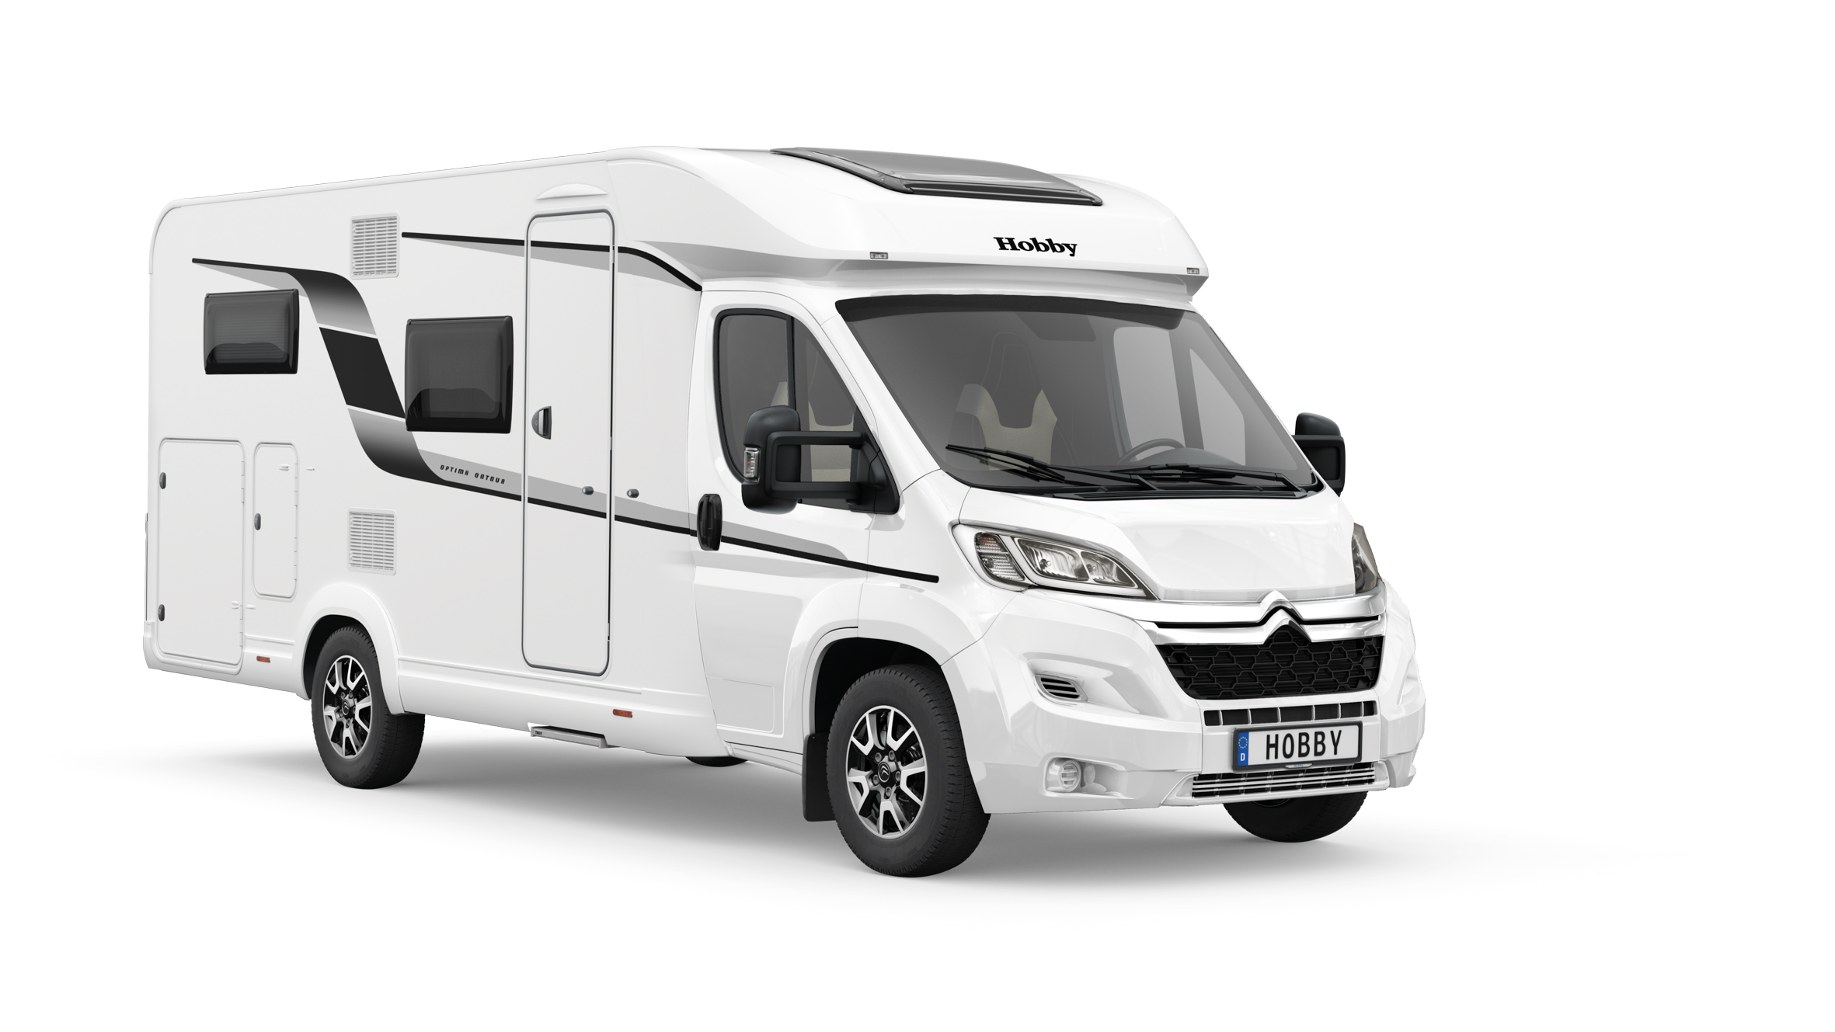
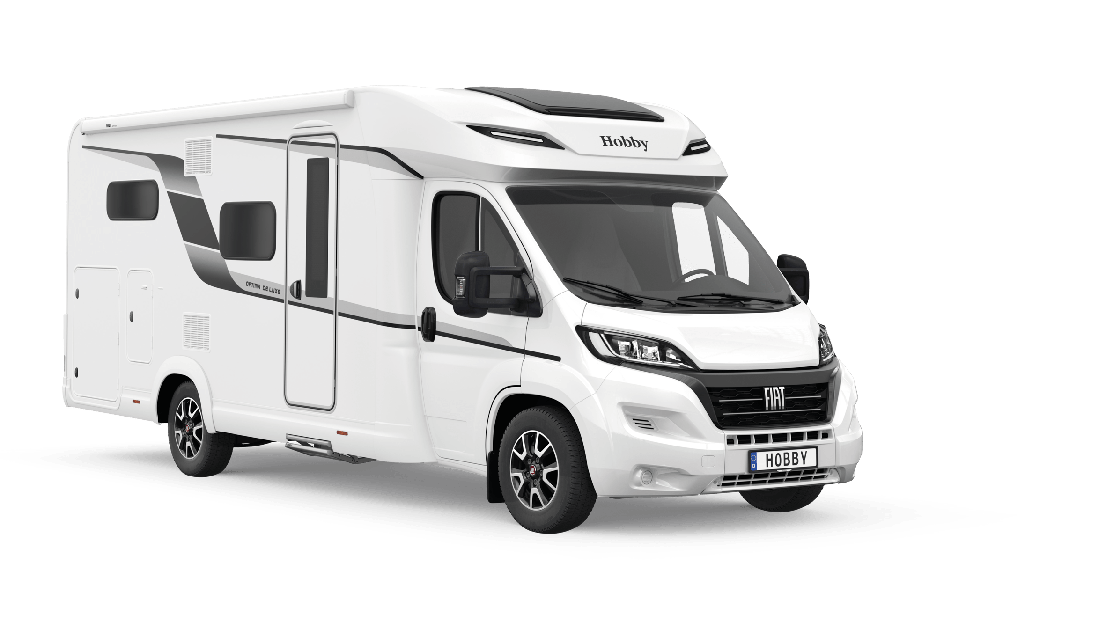

New exterior design for the OPTIMA ONTOUR T65 GE and OPTIMA DE LUXE T65 GE
Hobby OPTIMA ONTOUR – Built for flexibility
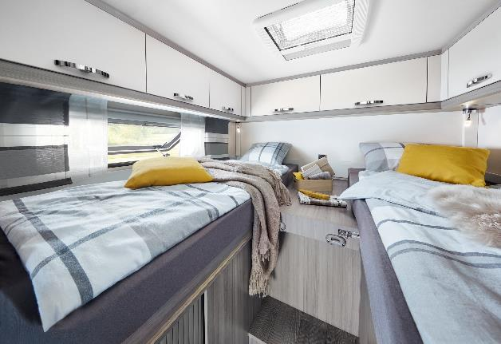
The OPTIMA ONTOUR is one of the most popular, classic motorhomes in the Hobby range. With six layouts and starting at 69,270 euros, the model range built on a CITROËN chassis offers couples and families flexibility. The OPTIMA ONTOUR T65 HKM can sleep up to seven people with a bunk bed, drop-down bed and mattress in the cab. The OPTIMA ONTOUR T65 GE is focused on comfort with beds that are easy to get into, as well as a large rear garage.
The single beds in the OPTIMA ONTOUR are easy to get into

For those who value having lots of space in the bathroom, the OPTIMA ONTOUR T70 F boasts an extra-large rear washroom.
“Like all our vehicles, the OPTIMA ONTOUR has everything you need for a great holiday on board, right from the start,” says Thomas Neubert. “Our customers love the “HOBBYKOMPLETT” ALL-INCLUSIVE PACKAGE. Our motorhomes are ready to hit the road as soon as they leave the factory, without any hidden costs or compulsory add-ons.”

Compact and spacious – OPTIMA ONTOUR EDITION
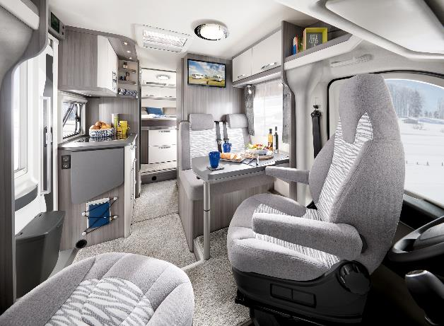
Hobby has developed the OPTIMA ONTOUR EDITION for those who prefer a more compact motorhome. Measuring just 2.23 m in width, the motorhome built on a CITROËN chassis also performs brilliantly on winding roads and in cities. The model range is available in two layouts with single beds or one island bed. One other huge advantage is the wide array of special features and equipment. For example, a navigation system/reversing camera, satellite/TV combination, roof vent in the cab and fly screen are included in the price at no extra charge, starting at €72,920.
Wide array of features and equipment in the OPTIMA ONTOUR EDITION V65 GQ

The two Hobby OPTIMA OVERCAB models offer families a huge amount of extra room with up to seven berths and ample storage space.

OPTIMA DE LUXE – Stylish luxury class
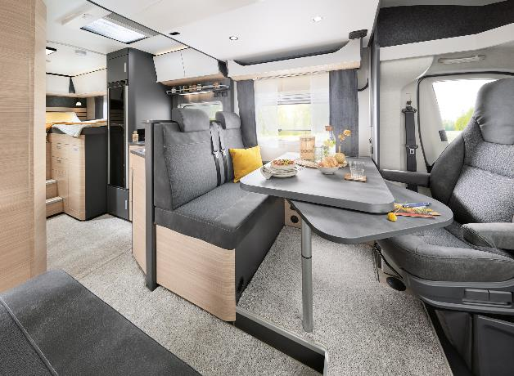
The design of the OPTIMA DE LUXE will remain unchanged in 2024 on the tried-and-tested FIAT chassis. With its Scandinavian “hygge” look and perfectly coordinated colour schemes, this Hobby model range meets the needs of those who expect perfection when travelling. “It’s all about aesthetics and premium materials,” says Thomas Neubert. “Requirements that were deemed less important ten years ago are now right at the top of many people’s wish lists. The OPTIMA DE LUXE is especially popular with fans of interior design.”
Scandinavian “hygge” look and coordinated colour schemes in the OPTIMA DE LUXE T75 HGE

Starting at €89,830, five models provide solutions for a variety of travel scenarios and requirements. They include designs that are focused on convenience and comfort when travelling, such as the open-plan bathroom in the OPTIMA DE LUXE T70 GE. The bathroom can be partitioned off from the living area with a dividing door. This creates a washroom that spans the entire width of the vehicle, directly connected to the sleeping area.

More pictures and information about the models for the 2024 season can be found online right now at hobby-caravan.de/en, or come and see them for yourself at the Caravan Salon in Düsseldorf from 25 August to 3 September 2023.

Further information is available from the Hobby press office:
presse@hobby-caravan.de or at mediaportal.hobby-caravan.de

