The new mid-range comfort class:
Hobby EXCELLENT and EXCELLENT EDITION
Fockbek, 09 august 2023 – Travel with all the mod cons: no one who spends several weeks a year travelling in a caravan is interested in making compromises, even when on holiday. That’s why the Hobby EXCELLENT and EXCELLENT EDITION model ranges exist. They’re starting the 2024 season with a new exterior design and stylish interior accents. The perfect choice for those looking for the middle ground between an entry-level and luxury-class caravan.

Built for quality time – The EXCELLENT
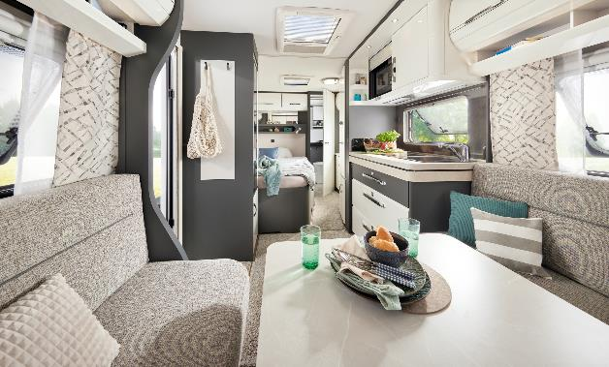
For couples who want an elegant, fresh start after many years of travelling in the family caravan or who want their first purchase to be a comfortably appointed, mid-range caravan, the EXCELLENT offers five different layouts starting at 26,720 euros. With a width of between 2.30 and 2.50 m, both smaller and larger models are available. The EXCELLENT also offers a lot of flexibility when it comes to the choice of berths, the kitchen area and the position of the washroom. For those who attach importance to having lots of space in the bathroom, for example, the EXCELLENT 495 WFB, EXCELLENT 540 WFU and EXCELLENT 560 WFU models all have a large rear washroom that spans the entire width of the vehicle.
Cosy atmosphere in the EXCELLENT 495 WFB
The compact EXCELLENT 460 SL features a lovely rear kitchen and single beds. With up to four berths, some layouts even have enough room for the grandchildren or guests to tag along. Thanks to its large corner kitchen and couch seating area, there is plenty of room in the EXCELLENT 560 FC for people to cook and eat meals together, and enjoy games evenings.

Ready to hit the road right from the start
For the 2024 season, the living area in the EXCELLENT has been given a fresh, elegant revamp with white high-gloss wall units, illuminated designer shelves and indirect strip lighting. The exterior design has also been updated for the new season. Like all Hobby caravans, the EXCELLENT is ready to hit the road right from the start and equipped with everything that makes your holiday the best time of the year thanks to the “HOBBYKOMPLETT” ALL-INCLUSIVE PACKAGE. Unlike the rest of the industry, there are no optional packages or compulsory add-ons with Hobby.
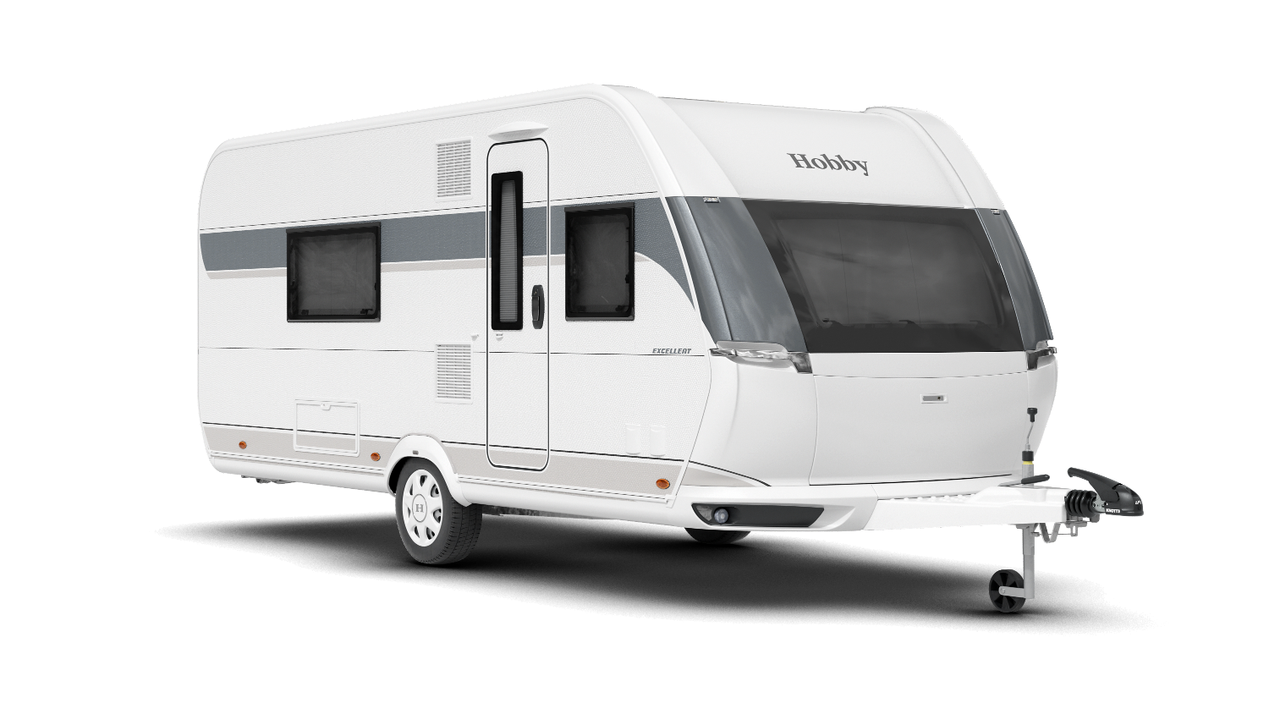
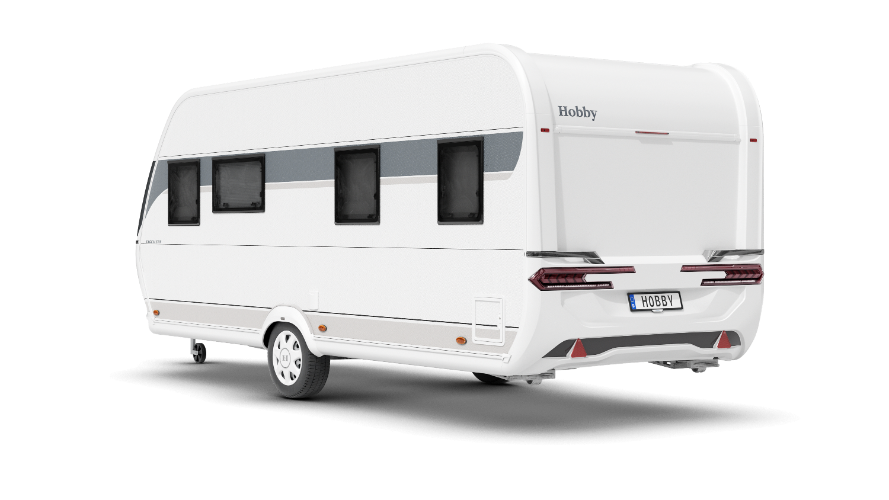

New exterior design of the EXCELLENT 495 WFB

EXCELLENT EDITION – Stylish with plenty of storage space
As you’d expect, the EXCELLENT EDITION will still be just as stylish in the upcoming season. Despite the similar names, all of the models are completely separate model ranges. The EXCELLENT EDITION, for example, is primarily aimed at families and couples who love minimalist design and want an open feel without sacrificing on storage space. Featuring a large island bed, you’re guaranteed a great night’s sleep in the EXCELLENT EDITION 540 UFf. Slightly modified wall units and a light-coloured upholstery combination will ensure the habitation area looks even brighter and more airy in the 2024 season.
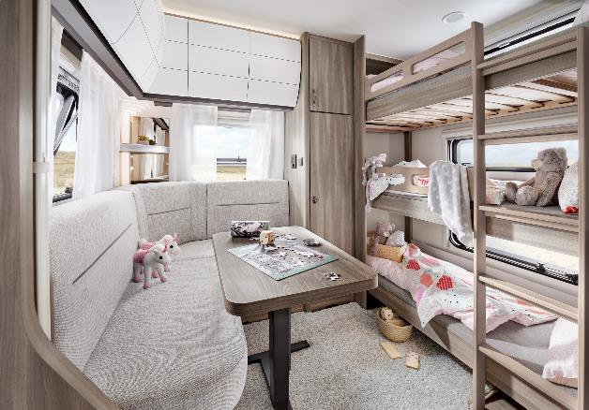
Four of the ten layouts are aimed at families with young and older children. The EXCELLENT EDITION 650 KMFe even has a children’s room with its own seating area and table.
Children’s room with seating area and table in the EXCELLENT EDITION 650 KMFe

Starting at 26,600 euros, the EXCELLENT EDITION is also ready to hit the road when it’s delivered and equipped with a whole host of handy features thanks to the “HOBBYKOMPLETT” ALL-INCLUSIVE PACKAGE. Five models come with an efficient TRUMA Combi 6 heating system as standard.

New exterior design for both model ranges
Like the EXCELLENT, the EXCELLENT EDITION will also feature a revamped exterior design for the 2024 season. Flowing lines and a harmonious overall appearance are the things that Hobby has focused on. The chrome-plated manoeuvring handles, aerodynamic front section and new, stylish rear lights are just some of the eye-catching features.
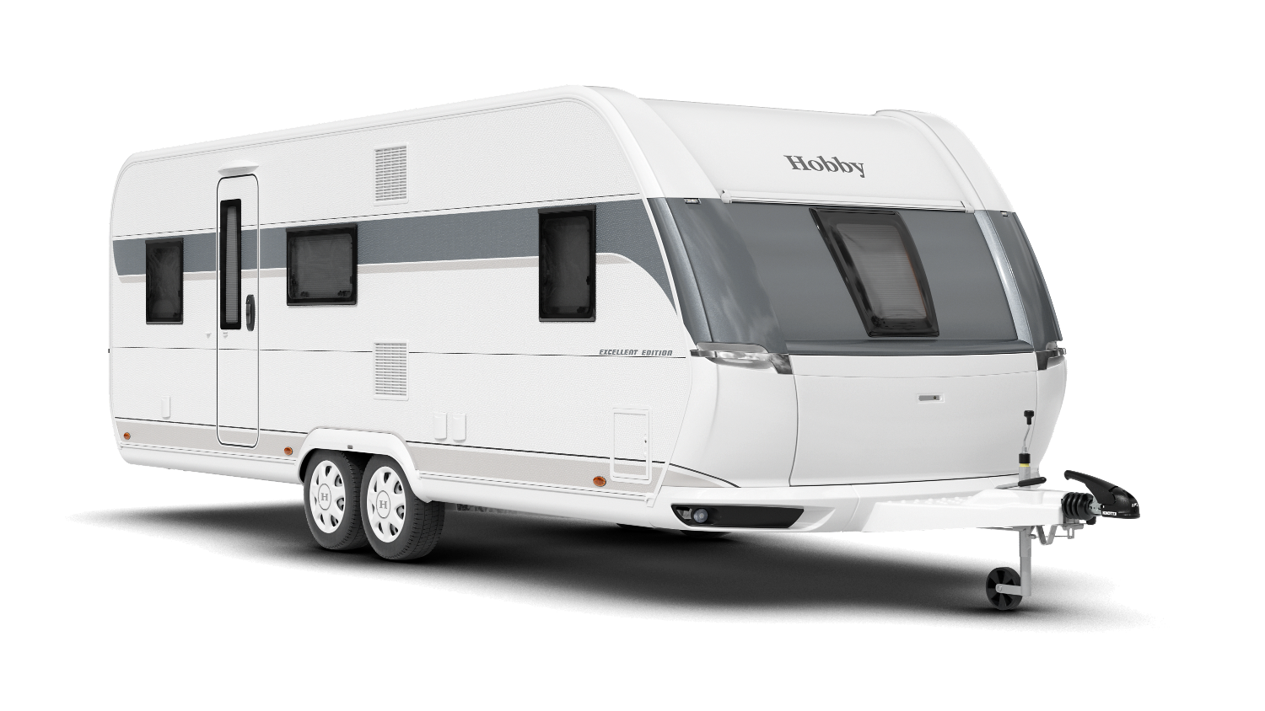
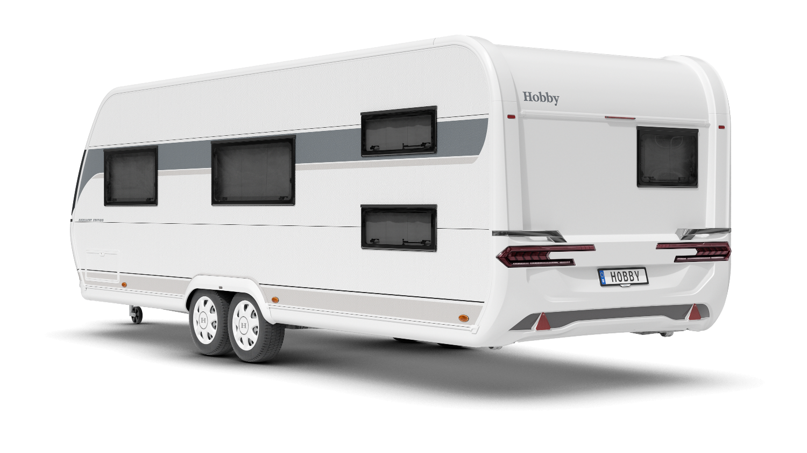

New exterior design of the EXCELLENT EDITION 650 KMFe

More pictures and information about the models for the 2024 season can be found online right now at hobby-caravan.de/en, or come and see them for yourself at the Caravan Salon in Düsseldorf from 25 August to 3 September 2023.

Further information is available from the Hobby press office:
presse@hobby-caravan.de or at mediaportal.hobby-caravan.de

