Updates to our luxury class:
What’s new in the Hobby PRESTIGE and MAXIA
Fockbek, 11 august 2023 – The Hobby PRESTIGE and MAXIA model ranges are luxury-class caravans that can give luxurious holiday apartments a run for their money when it comes to both design and comfort. Both model ranges are suitable for use in winter and perfect for large families with up to seven berths. The new 595 KML model of the MAXIA model range offers an extraordinary level of flexibility.

New look for the PRESTIGE
Featuring a dark oak decor with high-gloss white accents, glossy stone-effect worktops and tabletops, as well as stylish upholstery combinations, the PRESTIGE has a completely new look for the 2024 season. The stylish ambient lighting contributes to the luxurious feel of the living area. Extra-large wall units ensure that no objects are left lying around to spoil the harmonious look.
Four layouts boast a large couch U-shaped seating area, as well as L-shaped kitchens. The heated coat rack in the entrance area makes it clear that the PRESTIGE is built to meet the highest standards.
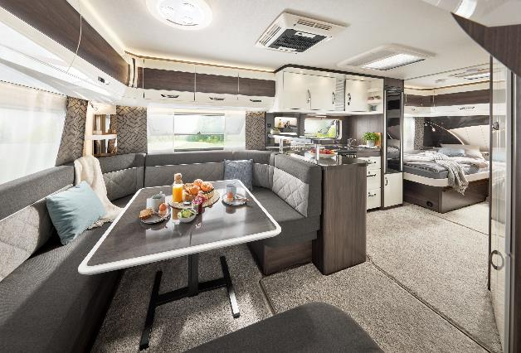
Luxurious living area in the PRESTIGE 620 CL
Bonus for winter campers
Starting at €34,500, eleven individual PRESTIGE layout solutions offer the flexibility needed to satisfy a variety of requirements. As part of the “HOBBYKOMPLETT” ALL-INCLUSIVE PACKAGE, all models are equipped with an efficient heating system, as well as the best heat insulation and body technology. This means that even freezing temperatures will not cause you any problems when camping during the winter. Optional extras like the ALDE hot water underfloor heating in seven models will keep you extra cosy, if you so desire.
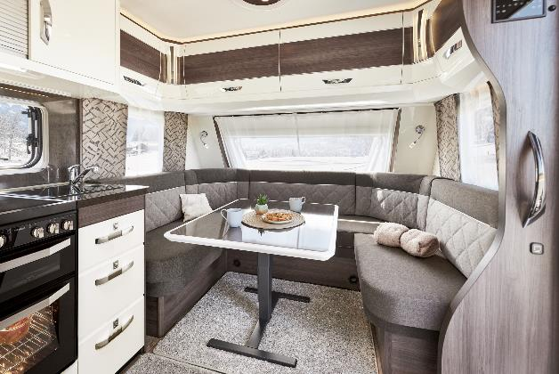
Cosy U-shaped seating area in the PRESTIGE 560 WLU

New family layout for the MAXIA
With its Scandinavian “hygge” design, the MAXIA continues to build on the success of the previous season. Minimalist design, natural colours and Nordic cosiness remain the hallmarks of the popular luxury-class model range. The panoramic window in the kitchen at the front of the MAXIA 660 WQM is one of the model range’s many impressive extra features.
The new MAXIA 595 KML family layout has been available to pre-order since last winter and is now available from dealers.
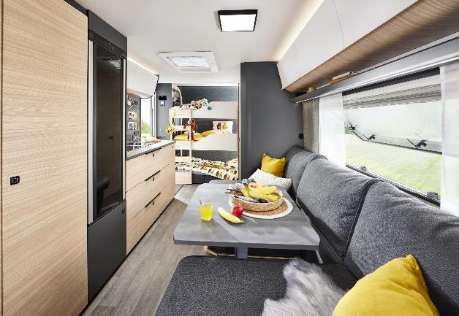
The multifunctional children’s bed area in the latter can be used in more than nine different ways: up to three children’s beds can be installed and removed again in just a few simple steps. A play den, a child Family-friendly layout in the MAXIA 595 KML
ren’s seating area, a bolthole for your four-legged friends or more space for your luggage can be created just as easily. The caravans in the MAXIA model range are also suitable for use in winter and come ready to hit the road with the “HOBBYKOMPLETT” ALL-INCLUSIVE PACKAGE starting at €37,900.

New exterior design for all caravans
Hobby is giving all of its caravans a new exterior design for the 2024 season. Chrome-plated manoeuvring handles, an aerodynamic front section and stylish rear lights give the PRESTIGE and MAXIA a sporty appearance. The PRESTIGE is available in the Slate Grey paint finish, while the MAXIA is available in Anthracite.

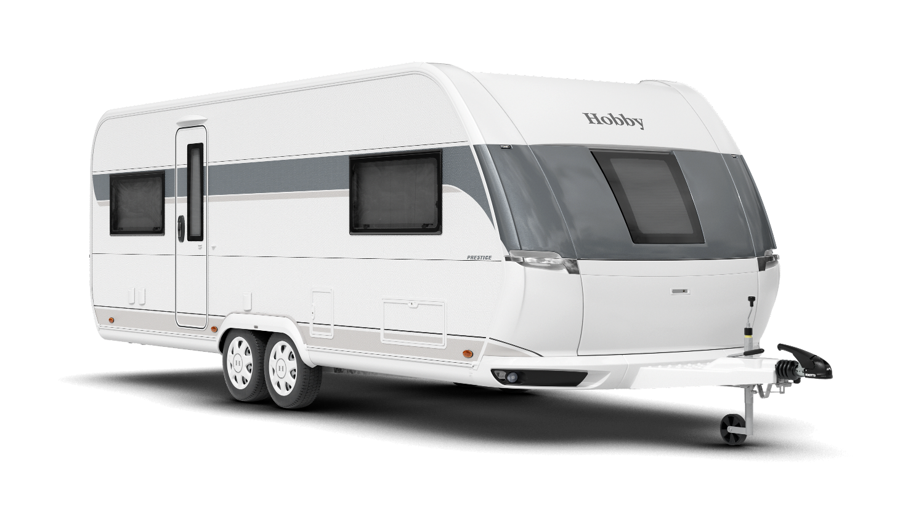
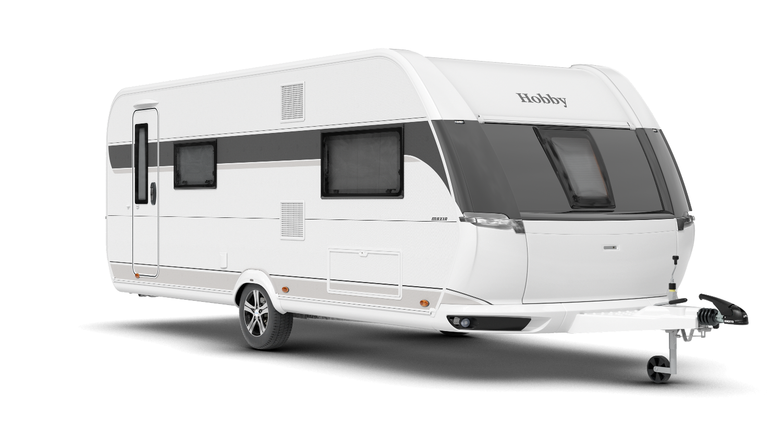

New exterior design of the PRESTIGE 620 CL and MAXIA 595 KML

More pictures and information about the models for the 2024 season can be found online right now at hobby-caravan.de/en, or come and see them for yourself at the Caravan Salon in Düsseldorf from 25 August to 3 September 2023.

Further information is available from the Hobby press office:
presse@hobby-caravan.de or at mediaportal.hobby-caravan.de

