The new MAXIA VAN 680 DT with multifunctional face-to-face sleeping/seating area
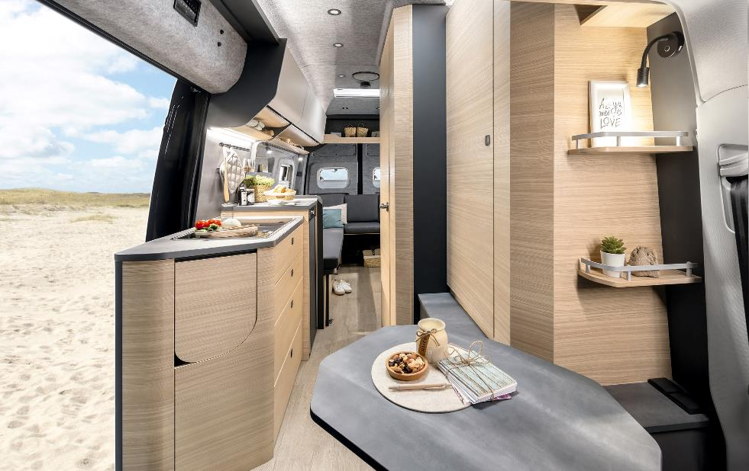
Fockbek, 09 January 2024 – Hobby presents the second layout of the MAXIA VAN built on a VW Crafter chassis at the CMT in Stuttgart.

Alone or as a couple, the MAXIA VAN 680 DT will make you feel at home, whatever your situation

BUILT FOR LIFE
It is as versatile as life itself: sometimes relaxing, sometimes exciting, but always ready for change. The new MAXIA VAN 680 DT encapsulates the cosy “hygge” flair that Hobby fans will be familiar with and appreciate from the MAXIA VAN 680 ET. Its particularly spacious interior and slick design featuring light walnut wood and the grey V-Flex felt-effect lining leave plenty of room for creativity.

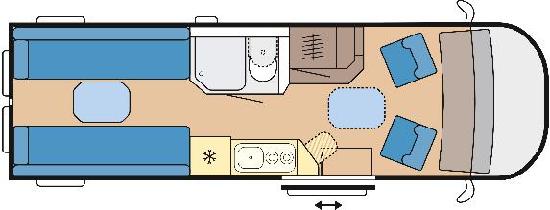
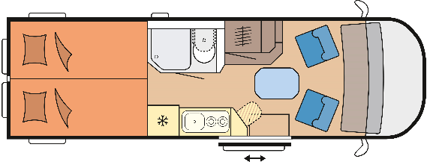
The layout of the new MAXIA VAN 680 DT – Day and night-time configuration

SPECIAL FEATURES
Weighing under 3.5 tonnes and with a payload of over 300 kg, the MAXIA VAN 680 DT is ready to go, whatever the situation – be it for extended summer holidays, doing a bit of work on the road, or spontaneous trips to snowy destinations. Thanks to the ambient lighting, the powerful TRUMA Combi D 6 diesel-powered heater, a double floor and the highly efficient Cellofoam insulation made of up to 60% recycled fibres, it remains cosy even at night and in winter. Road safety, comfort and performance are all standard features of the two-seater vehicle thanks to the wide range of assistance systems, an 8-speed automatic transmission and a 177 hp engine. Interior features such as the kitchen and shower room meet the high standards for which the MAXIA model range is renowned. The 90-litre compressor refrigerator as well as the hob/sink combination with a 2-burner hob and electric ignition are also sure to impress. Thanks to the super-high roof, the van also boasts a comfortable interior headroom of two metres.

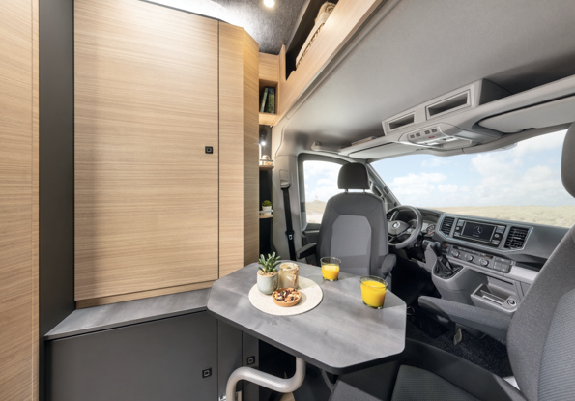
Seating area at the front of the MAXIA VAN 680 DT with a large wardrobe

THE LAYOUT OF THE MAXIA VAN 680 DT
The latest Hobby van has a seating area at the front for two people and a large cabinet.
It has lighting inside and can be adapted to suit individual requirements with either a clothes rail or two shelves. The swivelling pedestal table is always wherever you need it, whether at the front in the cab or at the rear between the bench seats.
When the table is not in use, it can be easily stowed away in the double floor, which comes as standard.

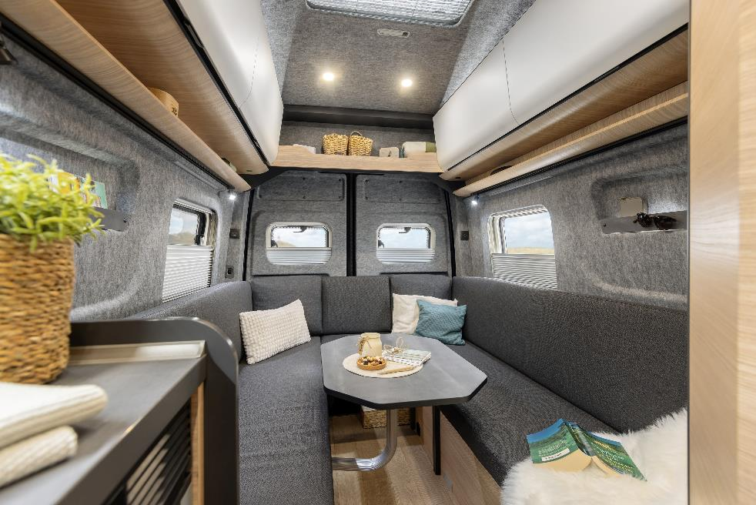
Cosy U-shaped seating area in the MAXIA VAN 680 DT

The heart and soul of the new vehicle is the area at the rear: the multifunctional rear is a seating and sleeping area in one and can be adapted to whatever you plan to do on the road in just a few simple steps. A mobile workspace in a face-to-face seating area during the day, the cosy U-shaped seating area for enjoying dinner together in the evening, and either single beds or a double bed measuring 2 m in length for a well-deserved rest at night. A 3-layer upholstery/slatted frame system with an additional mattress topper makes the bed extra comfortable. Thanks to the adjustable seats, the relax position with inclined backrest makes it a comfortable spot to rest your legs. During the day, the toppers can be transformed into cosy cushions by placing them inside a cover.

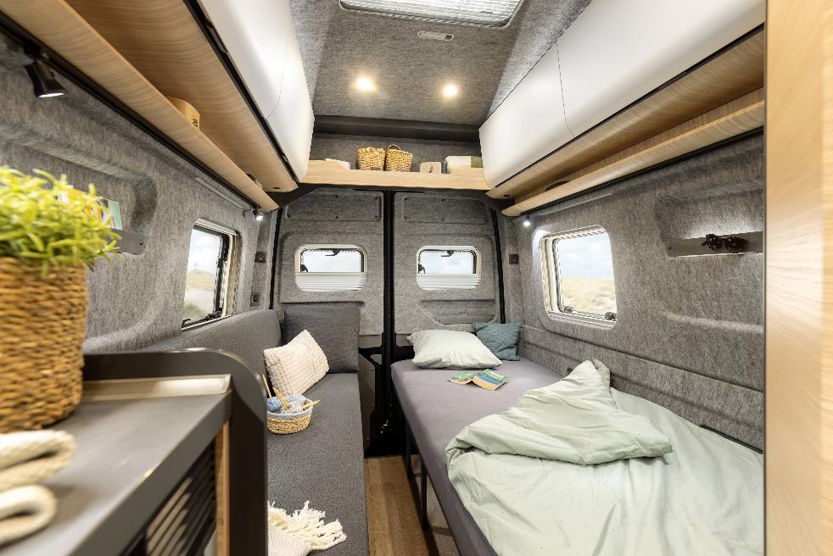
With just one bed and a bench seat, depending on your needs – the multifunctional rear section of the MAXIA VAN 680 DT

Alone or as a couple, the MAXIA VAN 680 DT will make you feel at home, whatever your situation. Hobby will be presenting the new MAXIA VAN 680 DT for the first time at the CMT in Stuttgart from 13-21 January 2024. The first models will be available from dealers in the spring starting from 89,750 euros.

Further information is available from the Hobby press office:
presse@hobby-caravan.de or at mediaportal.hobby-caravan.de

More images attached/available in the media portal:

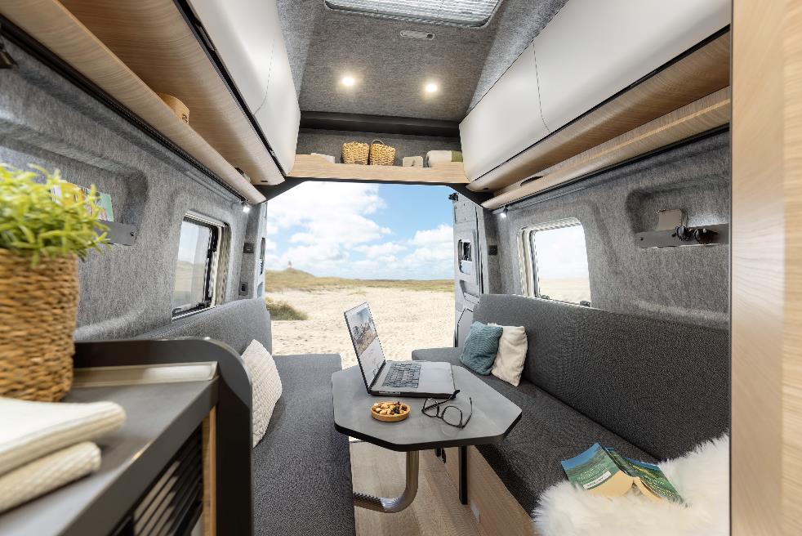

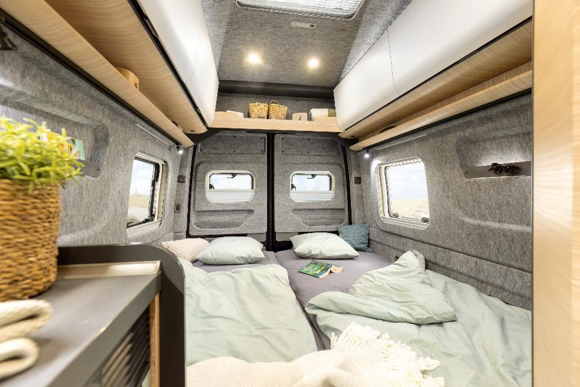
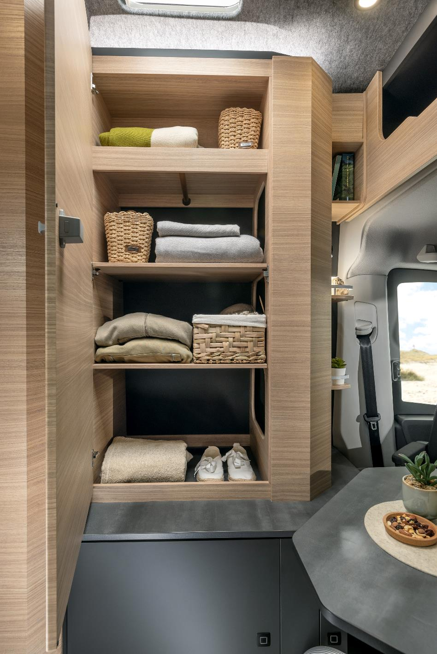
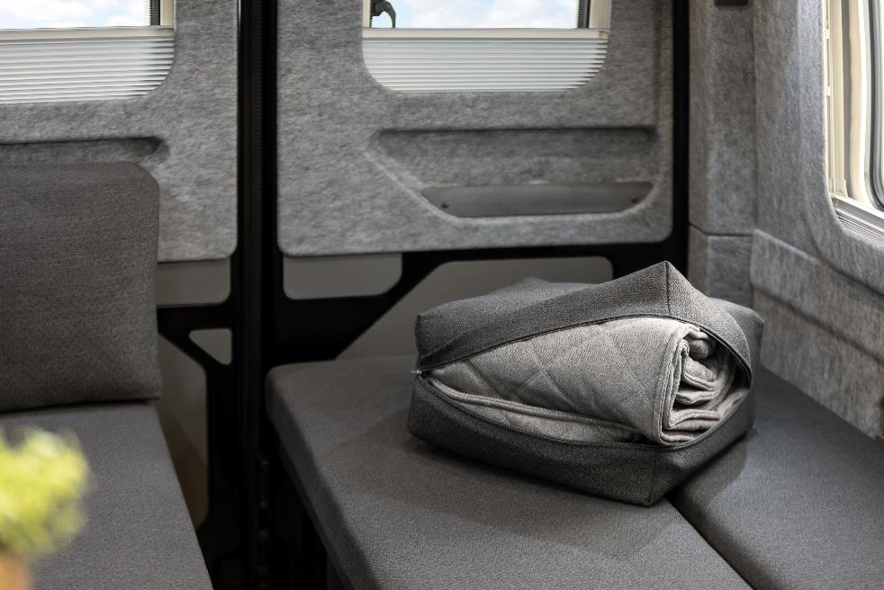

The multifunctional rear section
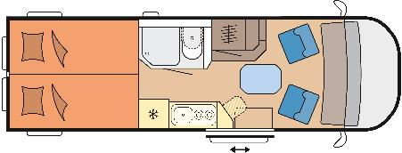
2 longitudinal beds
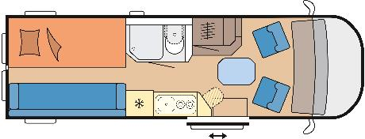
1 bed + bench seat
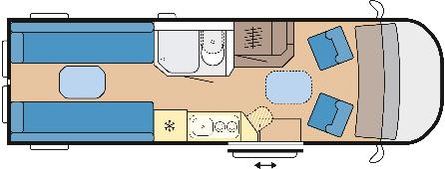
Face-to-Face seating area
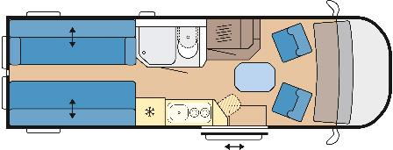
Relax position with inclined backrest thanks to the adjustable seat
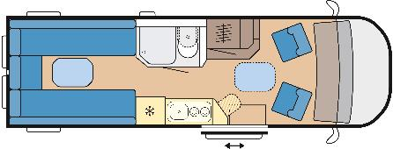
U-shaped seating area

