Premiere at the CMT in Stuttgart: The OPTIMA ONTOUR EDITION is now available as a new FIAT EDITION
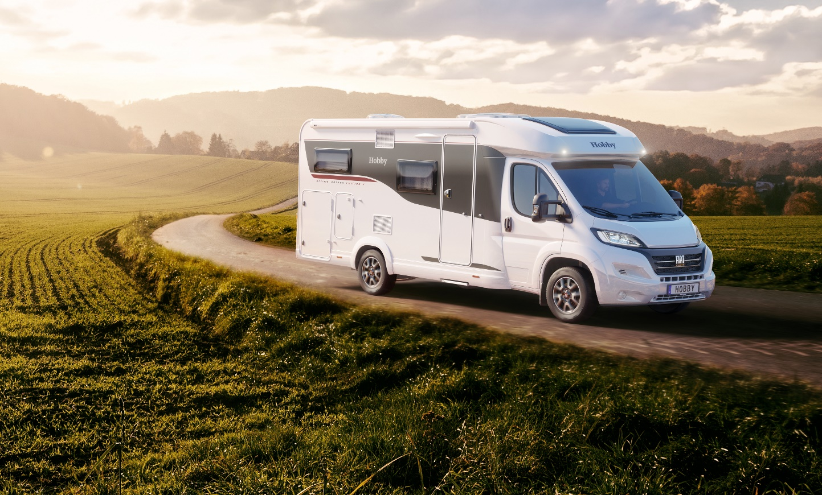
Fockbek, 12. january 2024 – A new year and a new limited special edition from Hobby: The compact OPTIMA ONTOUR EDITION F is built on a Fiat chassis and is ready for any adventure with the renowned “HobbyKomplett” ALL-INCLUSIVE package. However, as a special edition, it has even more to offer and comes with many extras worth over €11,000 included.
The OPTIMA ONTOUR EDITION F with new dynamic edition exterior panelling.

The edition model is based on the well-known layout of the Optima Ontour Edition V65 GE and is incredibly spacious, boasting a wide range of features and equipment, with plenty of room for everything you need on the road. The special edition is now also built on the popular Fiat Ducato chassis with a powerful 140 hp engine and comes with many features that ensure a supremely comfortable ride: original Fiat alloy rims, a leather steering wheel and gearstick, automatic air conditioning and much more besides.
The latest addition is particularly inviting not only on account of its dynamic Edition decals on the exterior, but also thanks to its electric entry step in front of the extra-wide habitation entrance door. The interior has also received a complete makeover. Instead of soft shades of grey, the Edition F features grey upholstery and the cosy Copenhagen/Piquet furniture finish. Thanks to the clever use of space, the compact motorhome has lots of storage space and a payload of 561 kg. This allows campers to take everything with them, without having to worry about every last kilo.
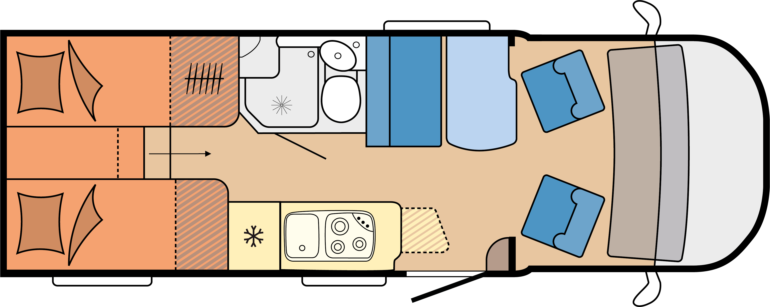
The layout of the new OPTIMA ONTOUR EDITION F

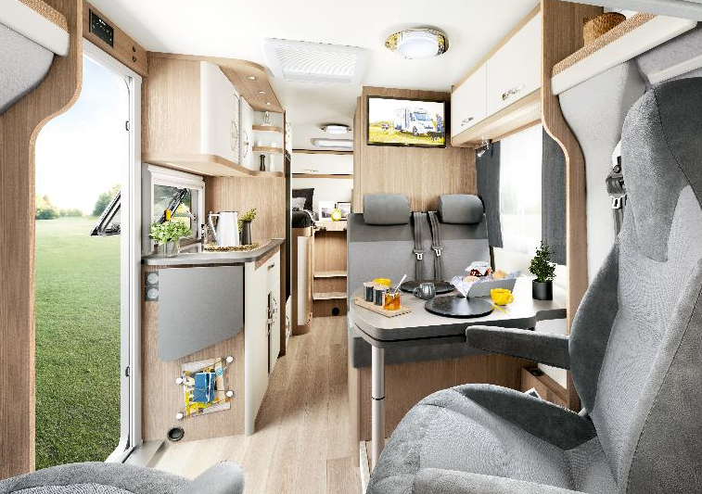
The OPTIMA ONTOUR EDITION F impresses with its spaciousness and plenty of room for everything you need when travelling.

“HobbyKomplett” ALL-INCLUSIVE package leaves nothing to be desired
Thanks to its premium on-board technology and wide array of features and equipment, the OPTIMA ONTOUR EDITION F is ready to hit the road from day one – whether for a spontaneous city break or an extended holiday adventure. As a special edition, even more features are included: the integrated PIONEER navigation system, reversing camera and Wi-Fi media centre as well as the TV combination consisting of a satellite system, LED flat screen TV, tuner, receiver and DVD player mean that the OPTIMA ONTOUR EDITION F has almost everything on board when it leaves the factory almost fully equipped with many extras worth over €11,000 included. It leaves nothing to be desired for discerning campers and represents outstanding value for money.

Live the good life on the road
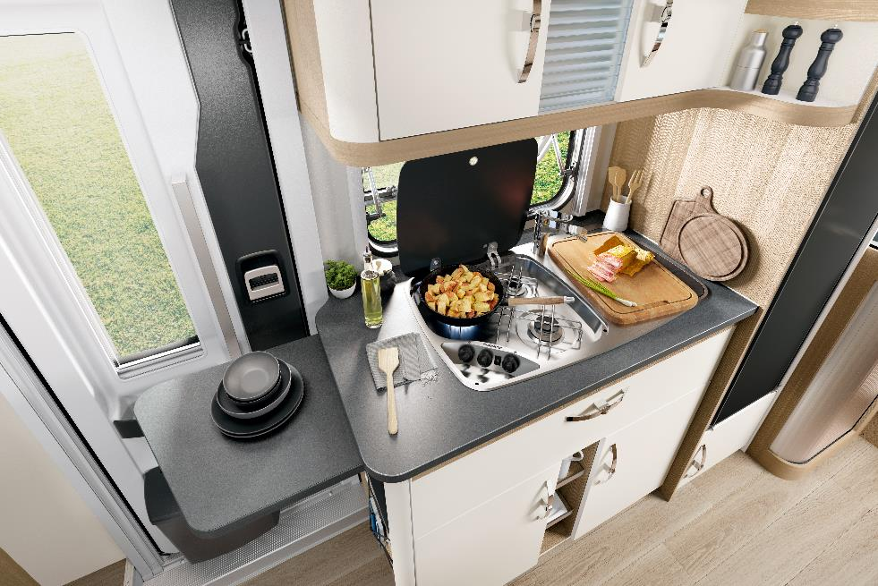
The 4 m-wide and up to 2.5 m-deep THULE OMNISTOR awning is also included on board from the get-go. For its width of 2.23 m, the OPTIMA ONTOUR EDITION F is surprisingly spacious. Whether there are two or four of you, there is room for everyone in the cosy seating area thanks to the practical table and pull-out extension. To ensure you have everything you need on the road, the OPTIMA ONTOUR EDITION F comes with a versatile kitchen with plenty of storage space for supplies, a 133-litre refrigerator and a handy work surface extension. There is space for two gas bottles in the gas locker, while the gas bottle pull-out shelf makes it incredibly easy to replace them.
Thanks to the practical work surface extension and ample storage space, travellers don't have to do without anything.

Get a good night’s sleep and start the day right

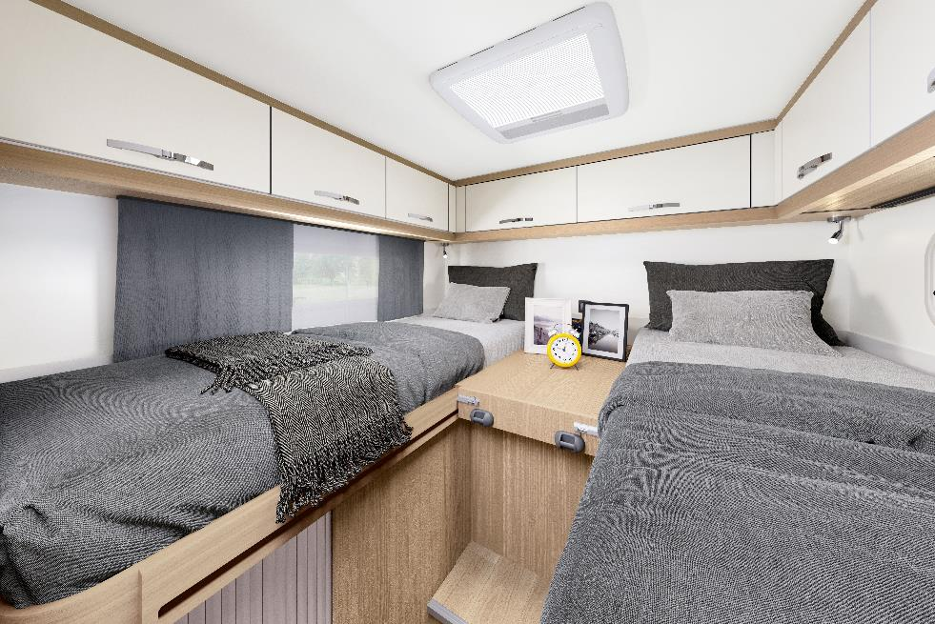
The GOODSIDE® slatted frame system with three adjustable firmness levels and the cold foam mattresses which provide lumbar support ensure you get the best night’s sleep. Using the bed extension with additional cushion supplied as standard, the two single beds can quickly be made into an extra-large, cosy sleeping space.
The two single beds with back-friendly cold foam mattresses ensure a relaxing night's sleep.

Enjoying a shower in the morning in the spacious bathroom with a rotating toilet and rooflight for optimal ventilation is the perfect way to start the day.
Hobby fans will get the opportunity to see and explore the new OPTIMA ONTOUR EDITION F at the CMT in Stuttgart from 13 to 21 January 2024.

The first models will be available from dealers in the spring 2024.

Further information is available from the Hobby press office:
presse@hobby-caravan.de or at mediaportal.hobby-caravan.de

More pictures in the attachment/media portal:
