THE HOBBY MAXIA T: A LITTLE MORE OF EVERYTHING

Fockbek, 28 August 2024. The MAXIA T model range is a new addition to Hobby’s line-up. The “T” indicates a semi-integrated design from the well-known caravan and motorhome manufacturer based in Schleswig-Holstein. These three layouts, stretching from 7.10 m to 7.40 m in length, provide a comfortable mobile home for up to five people. The standard 180 hp engine with automatic transmission effortlessly powers the 4.4-tonne FIAT chassis along winding roads. The Scandinavian-inspired interior and the sleek exterior with bronze accents seamlessly reflect Hobby’s current design language.
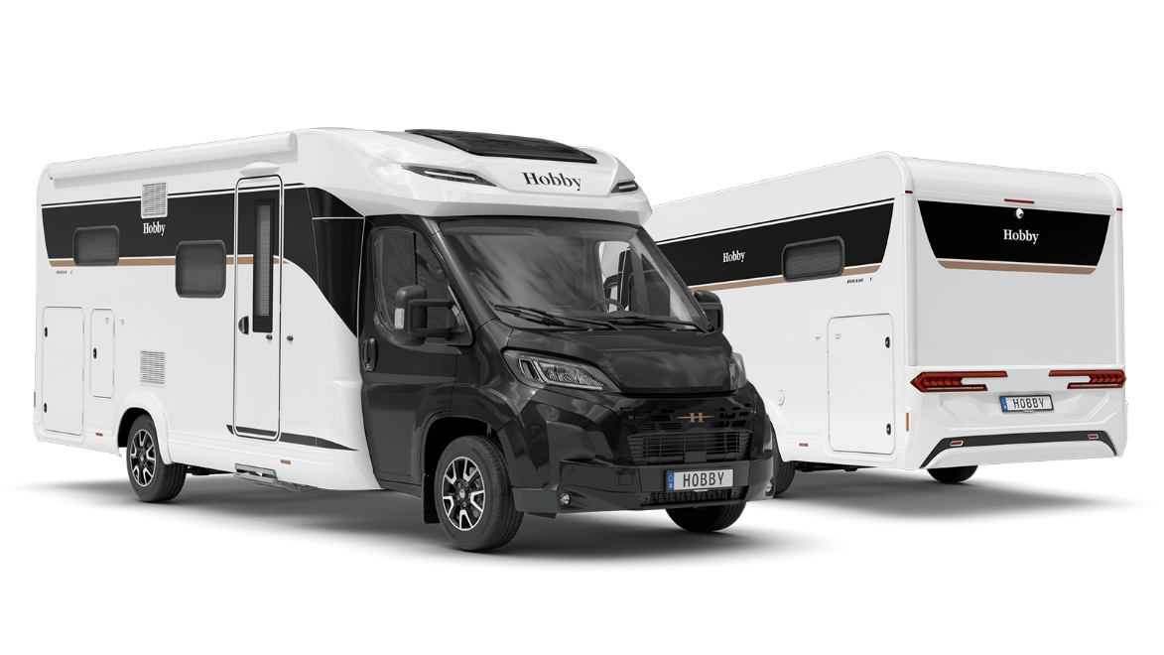
PLENTY OF ROOM FOR EVERYONE: HOBBY’S LONGEST SEMI-INTEGRATED MODEL
The MAXIA T model range is a true masterpiece of space-efficient design. With lengths of 7.10 m for the MAXIA T 710 GE and 7.40 m for the MAXIA T 740 WE and MAXIA T 740 WF, these models are the longest in Hobby’s semi-integrated range. This extra length translates into enhanced comfort. With up to five berths, a 133-litre compressor refrigerator, a three-burner gas-on-glass hob and five additional power sockets, the MAXIA T model range clearly stands out from other semi-integrated motorhomes. The black chassis cowl and bronze accents, new rear lights and stylish roof vents, the 180 hp engine with automatic transmission, tilting double-glazed tinted framed windows, a cosy cab seating area and the Scandinavian interior with soft felt-look elements and ambient lighting all enhance this vehicle’s exclusive appearance, inside and out. For the safety of all passengers, the MAXIA T comes with a comprehensive Safety Package that includes advanced assistance systems such as automatic braking, a lane departure warning system and traffic sign recognition, as well as a steering wheel with integrated controls. The list of standard equipment also includes Hobby’s Lounge Package, which adds electronically adjustable air conditioning with a pollen filter, wireless smartphone charging and a 7” TFT colour display for digital instrumentation – for maximum comfort and convenience while on the road. Optionally, thermal curtains with footwell insulation for the cab can be factory-installed in any of the three layouts.
The MAXIA T 710 GE is designed to welcome campers with two single beds and the option for three additional berths. This model boasts a cleverly designed rear storage area, featuring a lowered rear, XPS heat insulation, insulated and heated rear garages with tie-down rails and eyelets, 12V/230V power sockets and a second garage door with gas springs on the driver’s side. This thoughtful design ensures that all travel gear can be securely and efficiently stored, making the MAXIA T ready for any adventure, no matter the season.
The MAXIA T 740 WE and MAXIA T 740 WF layouts are 30 cm longer, providing enough room for an extremely spacious washroom with a separate shower at the rear of the vehicle. This luxurious bathroom includes a shower screen, a shower column with fittings and compartments, a mirror cabinet and an extendable washing line. If you prefer a double bed, look no further than the MAXIA T 740 WF, while those who favour single beds will be right at home in the MAXIA T 740 WE. Both models feature a seating area at the front, which is separated from the rest of the vehicle by a corner kitchen. At night, the seating area can be converted into two additional berths.
All motorhomes come with the HOBBYKOMPLETT ALL-INCLUSIVE package as standard, which includes blackout blinds and fly screens for all windows, a fly screen for the habitation entrance door, the GOODSIDE® slatted frame system, XPS heat insulation, stylish alloy rims and a gas bottle pull-out shelf for 2 x 11-kg bottles.
The MAXIA T model range is ideal for camping enthusiasts who refuse to compromise on the comfort of a spacious home and want to explore the world in their cosy semi-integrated vehicle, no matter the season. The MAXIA T is available from €84,780.

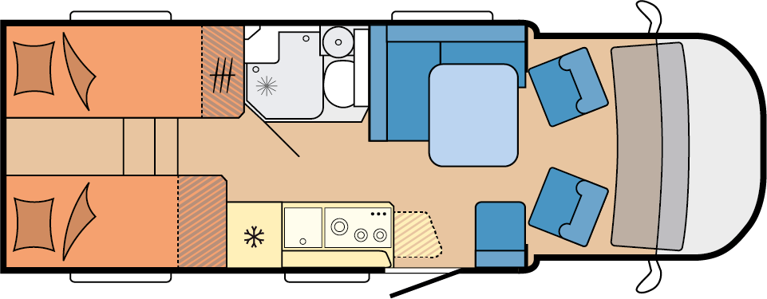

MAXIA T 710 GE
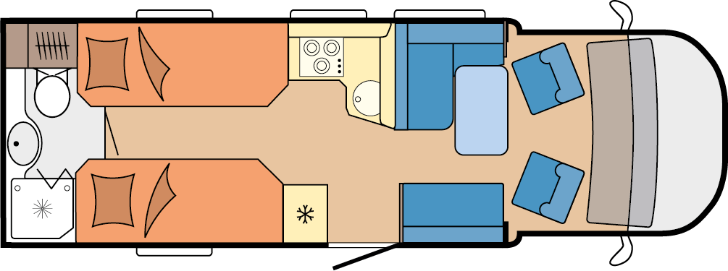

MAXIA T 740 WE

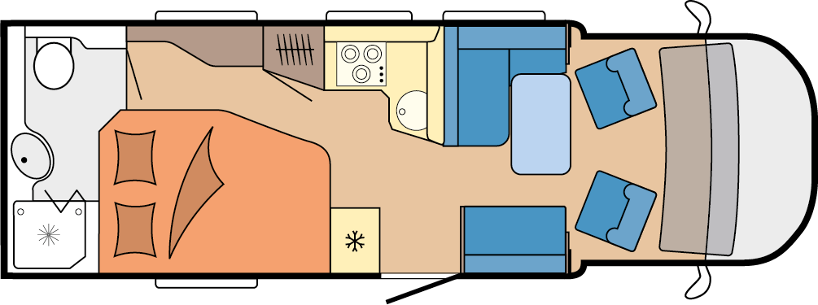

MAXIA T 740 WF

More pictures and information about the models for the 2025 season can be found online at hobby-caravan.de/en, or come and see them for yourself at the Caravan Salon in Düsseldorf from 30 August to 8 September 2024.

Further information is available from the Hobby press office:
presse@hobby-caravan.de or at mediaportal.hobby-caravan.de/en

