THE HOBBY ONTOUR C AND ONTOUR T: COMPACT, VERSATILE AND SPACIOUS

Fockbek, 28 August 2024. Hobby’s newest entry-level motorhomes include the semi-integrated ONTOUR C, with a width of 2.23 m on a new CITROËN chassis, and the 17 cm-wider Fiat-based ONTOUR T. The new ONTOUR model range comes with a 140 hp engine as standard, with the option of an 8-speed automatic transmission. With various sleeping configurations and spacious seating areas, these motorhomes guarantee enjoyable travels no matter the weather.

MASTER EVERY ROAD IN THE COMPACT ONTOUR C
The streamlined ONTOUR C series, built on a 3.5-tonne CITROËN chassis, excels in navigating winding roads or busy city streets. With its narrow width – just 2.23 m – it handles tight streets and sharp mountain curves with ease. Features such as a leather steering wheel with control panel, fog lights with cornering lights, the TECHNO TRIM dashboard and advanced assistance systems – including an automatic braking system, a lane departure warning system, traffic sign recognition, adaptive cruise control and Trailer Stability Assist – ensure a pleasurable drive throughout your journey. The modern exterior design, accentuated by blue stripes, new Hobby rear lights and sleek roof vents, pairs perfectly with the high-quality interior fit and finish – “Copenhagen” wood decor, “Piquet” white cabinet fronts and anthracite-coloured fittings – completing the Scandinavian ambience inside the vehicle. Despite its compact dimensions, camping enthusiasts can look forward to a good night’s sleep in the 7.00 m-long ONTOUR C models. The ONTOUR C 700 GQ features a 1.40 m-wide island bed, ensuring ample space for relaxation. What’s more, the island bed is accessible from three sides for added convenience. For those who prefer single beds, the 20 cm-shorter ONTOUR C 680 GE offers single beds measuring 1.93 x 0.76 m and 1.85 x 0.76 m. They can also be combined to create a full-width sleeping area if desired.
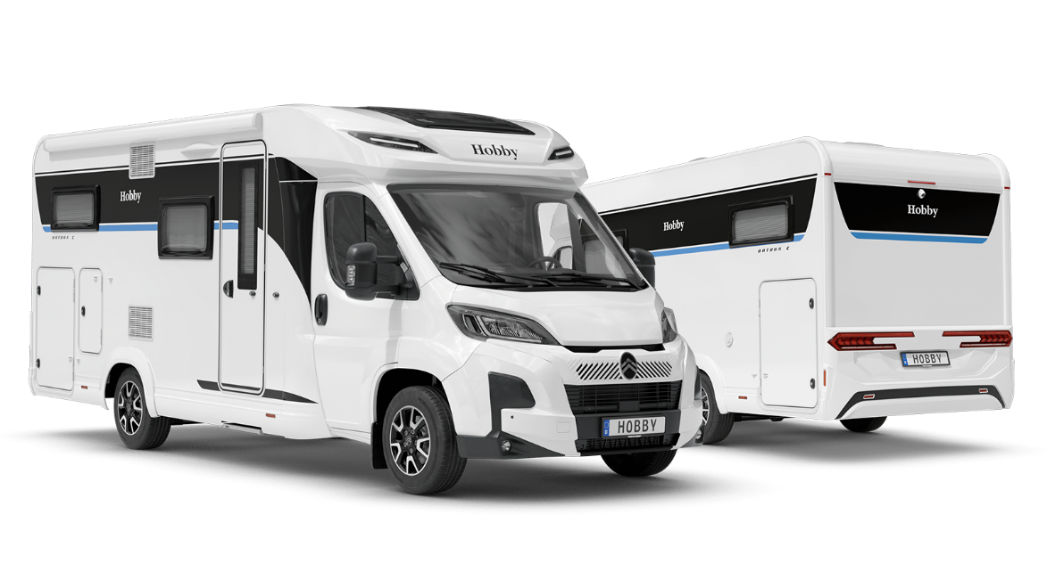
ONTOUR C 680 GE

SMART SPACE UTILISATION FOR UP TO FIVE PEOPLE IN THE ONTOUR T
The three models in the 2.4 m-wide ONTOUR T model range comfortably accommodate up to five people. A highlight in each model is the extra-large L-shaped seating area. All three variants can be optionally fitted with an external gas connection, an oven with electric ignition and a DOMETIC extractor hood.
The ONTOUR T 700 F comes with a double bed in the rear section and the option to convert the seating area and cab into additional berths. This model also features a rear washroom with an integrated shower cubicle. The corner kitchen, separated by a practical counter, divides the seating area from the rear section. The ONTOUR T 700 FH is similarly designed but includes a mechanical drop-down bed over the seating area.
For those who prefer single beds, the ONTOUR T 710 GE is the perfect choice. Its compact washroom is conveniently situated between the seating and sleeping areas, opposite a classic side kitchen. A major advantage of this ONTOUR model is the garage – accessible from both sides – with interior dimensions of 2.80 x 1.1 m (LxH). The garage also features tie-down rails and eyelets, and is heated and well insulated thanks to XPS heat insulation.
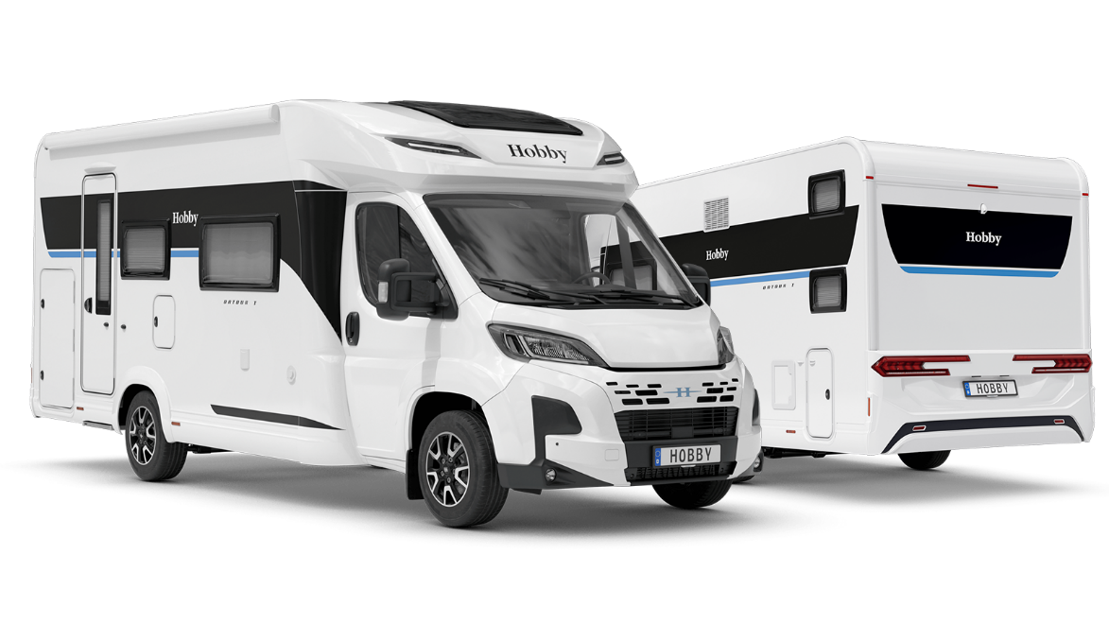
ONTOUR T 700 KMH

Both the ONTOUR C and ONTOUR T layouts offer a host of additional features, including a 133-litre DOMETIC refrigerator and a three-burner gas hob with a glass cover. A special highlight is the new automatic shut-off mechanism for the gas hob, which enhances safety in the living area by automatically turning off the burners via the glass cover’s soft-close mechanism. Standard equipment also includes an awning (2.50 m pull-out depth), an extra-wide habitation entrance door with double lock, a window, a waste bin, storage compartments and a fly screen. As with all Hobby models, the new ONTOUR models come with the standard HOBBYKOMPLETT ALL-INCLUSIVE package. Dispensing with costly mandatory upgrades, all Hobby vehicles come fully equipped and road-ready straight from the factory. The equipment list includes blackout blinds and fly screens for all windows, the GOODSIDE® slatted frame system, XPS heat insulation in the GRP floor, stylish alloy rims, a gas bottle pull-out shelf for 2 x 11 kg bottles, as well as the HOBBYCONNECT system for convenient control of on-board technology via the control panel or app. The modern interior design and blue accent stripes also come as standard.
The ONTOUR C models start at €74,930, while the ONTOUR T models are available from €76,720.

More pictures and information about the models for the 2025 season can be found online at hobby-caravan.de/en, or come and see them for yourself at the Caravan Salon in Düsseldorf from 30 August to 8 September 2024.

Further information is available from the Hobby press office:
presse@hobby-caravan.de or at mediaportal.hobby-caravan.de/en

