HOBBY FAMILY MODELS: ONTOUR A 720 GFM AND ONTOUR T 700 KMH

Fockbek, 28 August 2024. The ONTOUR A 720 GFM is the overcab model in the ONTOUR model range, while the ONTOUR T 700 KMH is a classic semi-integrated motorhome featuring a drop-down bed. Both models are tailored for family travel, ensuring that everyone on board can find their perfect spot. These motorhomes come with approval for six people and are designed for multifunctional use. With abundant storage space and an XL kitchen, there’s room for everything the family needs while on holiday. Built on a 4.25-tonne FIAT chassis with a 140 hp engine, Hobby’s family models have a total length of 7.00 m and 7.20 m, respectively.

THE INCREDIBLY SPACIOUS ONTOUR A 720 GFM
The ONTOUR A 720 GFM includes separate sleeping areas for up to six people, with beds measuring over 2.00 m long by 1.28–1.53 m wide. The large seating area features three double bench seats and is tailor-made for family meals, games and relaxation. Clothing and everyday items can be stored in the illuminated wardrobe, the various storage compartments, or the overcab area during the day. The large garage, accessible from both sides, is insulated, heated and equipped with tie-down rails and eyelets, ensuring everything stays neatly organised on every adventure.
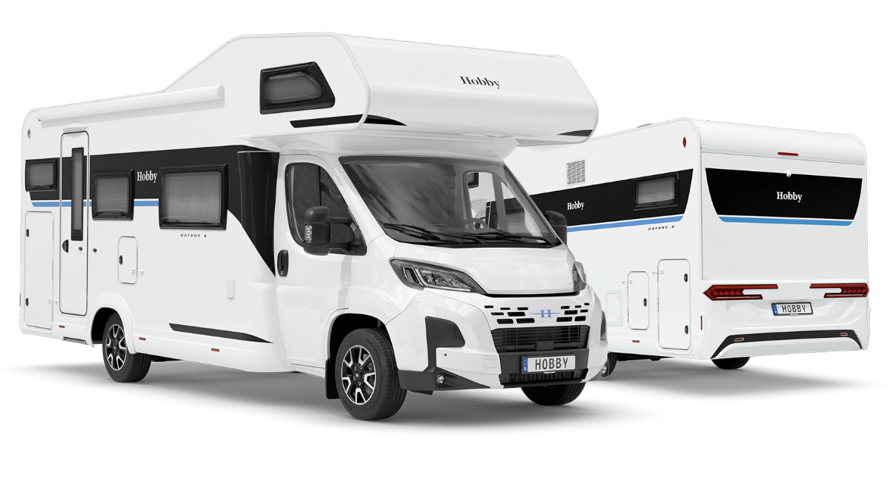
ONTOUR A 720 GFM

ONTOUR T 700 KMH: COMFORTABLE BERTHS FOR THE ENTIRE FAMILY
The ONTOUR T 700 KMH is also pre-configured for family use, with approval for six occupants. Sleeping options include a mechanical drop-down bed measuring 2.00 m x 1.30 m, a children’s bunk bed over 2.00 m long and a multifunctional seating area that can be transformed into a 2.10 x 1.40 m bed in the evening. The FIAT chassis is equipped with the Safety Package and all the assistance systems needed for a stress-free journey. This includes a leather steering wheel with controls, a leather gearstick, the Techno Trim dashboard and adaptive cruise control.
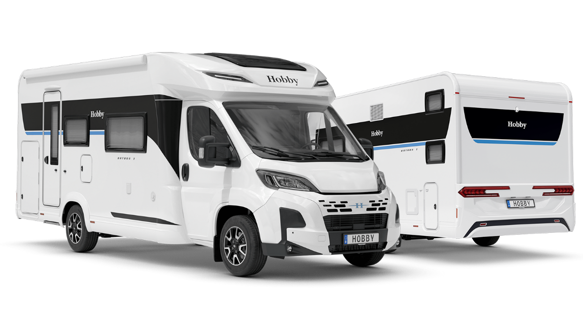
ONTOUR T 700 KMH

XL KITCHEN FOR THE WHOLE FAMILY
Both the ONTOUR A 720 GFM and ONTOUR T 700 KMH ensure that every family member is well looked after. The corner kitchen neatly separates the seating area from the counter, featuring a practical stove-sink combo with a three-burner gas hob, a worktop with a fold-out extension and a storage compartment between the sink and hob that can even be accessed from outside the vehicle. A great convenience is the large 133-litre DOMETIC refrigerator, which can be opened from either side thanks to its double hinge. Opposite the kitchen, the bathroom is fully equipped with an integrated shower and screen, a shower column with fittings and compartments, a swivel toilet and a useful extendable washing line.
Both ONTOUR family models come with the highly practical HOBBYKOMPLETT ALL-INCLUSIVE package, which includes an awning (2.50 m pull-out depth) and an extra-wide habitation entrance door equipped with a double lock, a window, a waste bin, storage compartments and a fly screen. There is also a blackout system for all windows and the cab, fly-screen blinds for all built-in windows, XPS heat insulation in the GRP floor, stylish alloy rims, a gas bottle pull-out shelf for 2 x 11 kg bottles, as well as the HOBBYCONNECT system for easy control of on-board technology via the control panel or app. Additionally, the ONTOUR models are real head-turners with their modern interior design and striking blue accent stripes.
The ONTOUR A 720 GFM and ONTOUR T 700 KMH models come fully equipped and factory-configured, ready for the whole family to hit the road. That means you can avoid the hassle of customising a motorhome to meet your family’s needs.
The ONTOUR A 720 GFM is priced at €83,120, while the ONTOUR T 700 KMH starts at €81,710.

More pictures and information about the models for the 2025 season can be found online at hobby-caravan.de/en, or come and see them for yourself at the Caravan Salon in Düsseldorf from 30 August to 8 September 2024.

Further information is available from the Hobby press office:
presse@hobby-caravan.de or at mediaportal.hobby-caravan.de/en

