THE HOBBY ONTOUR VAN: THE STYLISH VAN WITH TRANSVERSE OR LONGITUDINAL BEDS

Fockbek, 28 August 2024. The new ONTOUR VAN is a versatile all-rounder in the van segment. Built on the latest CITROËN chassis with a 140 hp engine, Hobby offers two layout options: one with a transverse French bed and the other with two longitudinal beds. The sleek interior and Expedition Grey paint finish with blue accents underscore this van’s modern look.

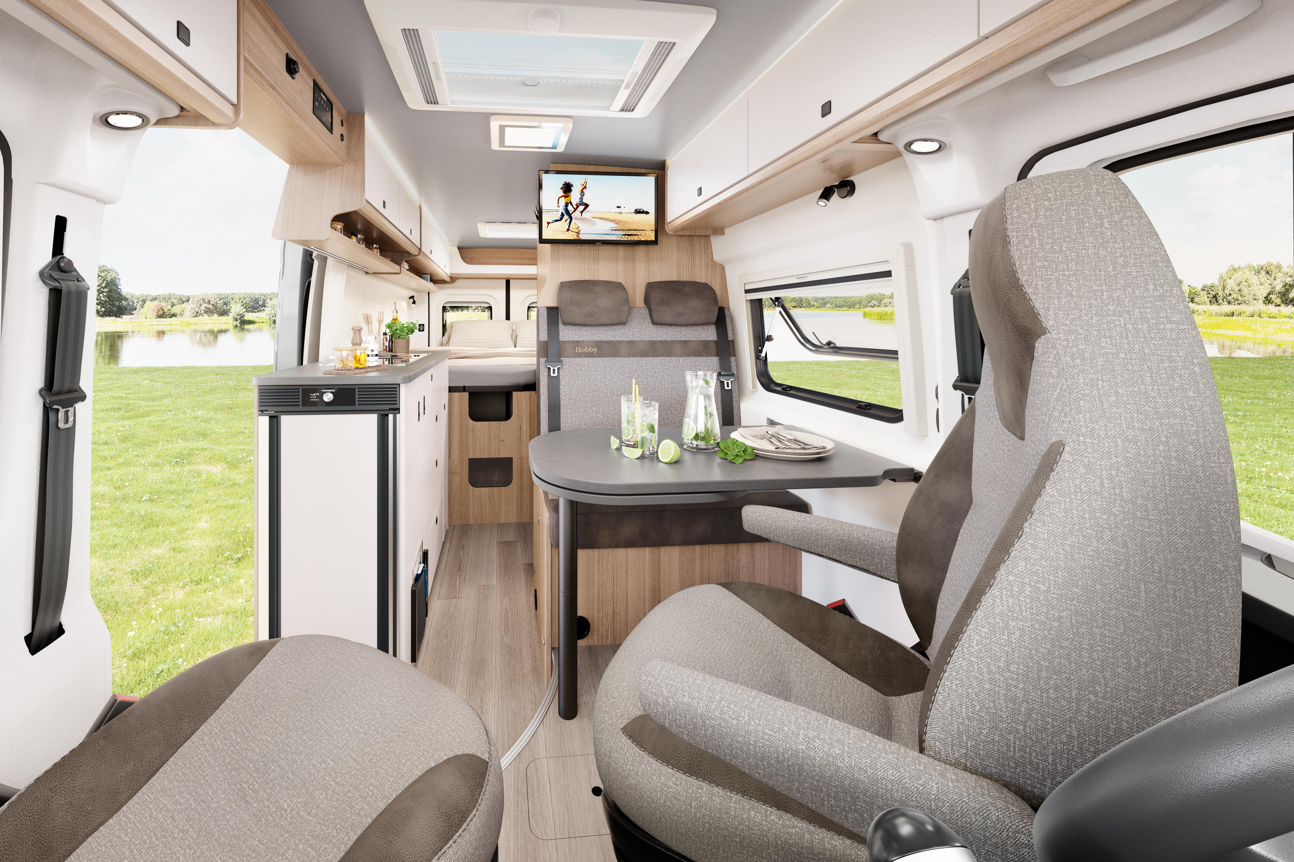

THE PERFECT DAILY COMPANION FOR EVERY TRAVELLER
With its eye-catching Expedition Grey paint finish and blue accent stripes, the ONTOUR VAN stands out even from a distance. The 6.00 m and 6.40 m-long CITROËN chassis is perfect for both daily use and adventurous journeys. In addition to the 140 hp engine, which is available with an optional 8-speed automatic transmission, all models are equipped with a Safety Package that includes various assistance systems. Customers can choose between two layout options: the ONTOUR VAN 600 FT with a transverse double bed, or the ONTOUR VAN 640 ET, which is 40 cm longer and equipped with two longitudinal beds. The GOODSIDE® slatted frame system and REMIS blackout blinds for the front and side cab windows ensure a restful night’s sleep. A compact washroom with a shower and mirror cabinet come as standard, as does a kitchen equipped with a 90-litre DOMETIC refrigerator with a double-hinged door. The seating area in the cab is perfect for dining and relaxation, accommodating up to four people thanks to the table extension. Full-surface B6 high-performance insulation and XPS flooring ensure efficient body insulation on colder days, while the fly screen for the sliding door and the roof awning make warm summer evenings more enjoyable.
In addition to these highlights, the HOBBYKOMPLETT ALL-INCLUSIVE package includes stylish alloy rims, a gas bottle pull-out shelf for 2 x 11-kg bottles, and the HOBBYCONNECT system for control of the on-board technology via the control panel or Bluetooth app.
This makes the ONTOUR VAN a versatile option, ideal for everyday use, short trips or extended travels in any season. Its practical standard features make it especially appealing for those new to camping. The ONTOUR VAN starts at €64,690.
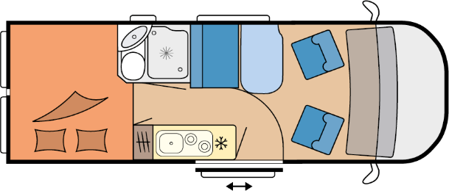

ONTOUR VAN 600 FT
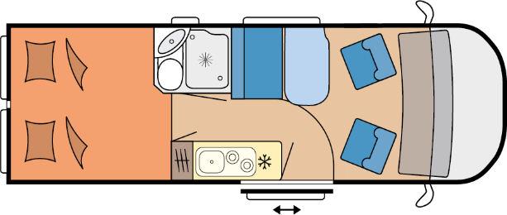

ONTOUR VAN 640 ET

More pictures and information about the models for the 2025 season can be found online at hobby-caravan.de/en, or come and see them for yourself at the Caravan Salon in Düsseldorf from 30 August to 8 September 2024.

Further information is available from the Hobby press office:
presse@hobby-caravan.de or at mediaportal.hobby-caravan.de/en.

