THE HOBBY PRESTIGE VAN: YACHT-INSPIRED DESIGN MEETS SPACIOUS LIVING

Fockbek, 28 August 2024. The new PRESTIGE VAN is a real head-turner in the van segment, with a luxurious interior and ambient lighting that evoke the elegance of modern yachts. The Lanzarote Grey paint finish, accented with red stripes, gives the PRESTIGE VAN a distinctive and unique look. Built on the new 140 hp FIAT chassis, this roomy everyday van also impresses with a spacious seating area in the cab.
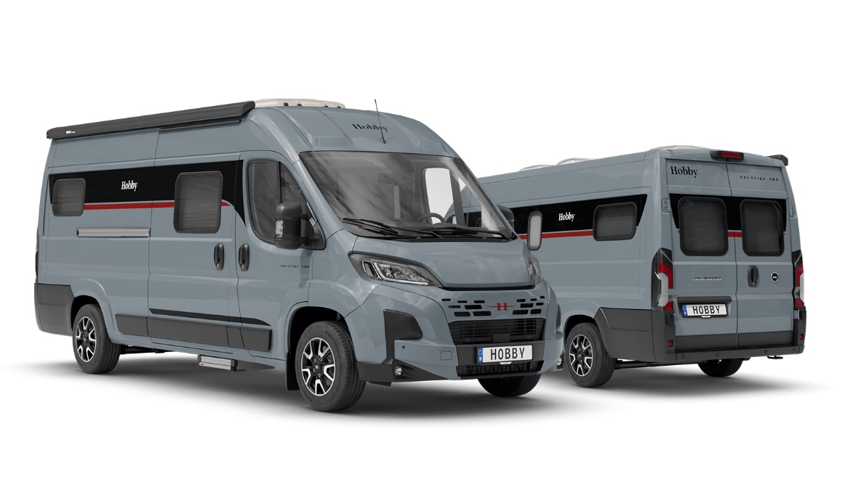

UPMARKET VAN LIFE WITH A MARITIME TOUCH
The PRESTIGE VAN, finished in dark Lanzarote Grey with red accent stripes and built on a FIAT chassis with a 140 hp engine, includes tilting, double-glazed, tinted framed windows that enhance its exceptional ambience. The yacht-inspired interior truly shines, especially in the cab and entrance area, where optional indirect lighting on the wall units enhances the maritime feel. The PRESTIGE VAN’s modern design extends to the HOBBYCONNECT system, allowing you to control the on-board technology via a control panel or Bluetooth app. This makes it easy to adjust the ambient lighting from any part of the vehicle using your smartphone. The layout includes a seating area in the cab, a compact washroom with a shower, and a well-appointed, centrally located kitchen with a spacious 90-litre compressor refrigerator. The rear offers plenty of compartments with fully extendable drawers for convenient storage of belongings and luggage. It’s also where you’ll find the single beds, which are especially comfortable, measuring a generous 2.10 m in length – perfect for taller travellers.
The REMIS blackout system for the front and side windows (cab) and the two single beds with the GOODSIDE® slatted frame system in the rear are part of the familiar HOBBYKOMPLETT ALL-INCLUSIVE package, which also includes full-surface B6 high-performance insulation and XPS flooring for optimal body insulation, a Safety Package with various assistance systems, stylish alloy rims, a fly screen for the sliding door, a roof awning and a gas bottle pull-out shelf for 2 x 11-kg bottles.
The PRESTIGE VAN can also be optionally equipped with a factory-fitted HOBBYTOP panoramic roof, which floods the interior with natural light, and either a 140 hp or 180 hp engine, including an automatic transmission for an enhanced driving experience.
With its sophisticated maritime design, the PRESTIGE VAN redefines luxury van life, offering even the most experienced campers a fresh and unique holiday experience. The PRESTIGE VAN is available from €69,740.

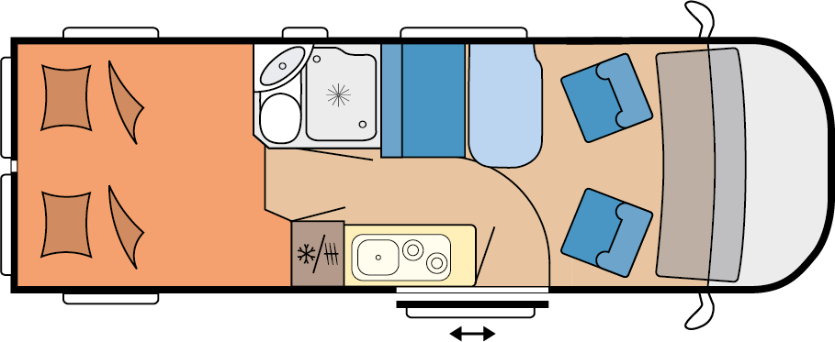

PRESTIGE VAN 640 ET

More pictures and information about the models for the 2025 season can be found online at hobby-caravan.de/en, or come and see them for yourself at the Caravan Salon in Düsseldorf from 30 August to 8 September 2024.

Further information is available from the Hobby press office:
presse@hobby-caravan.de or at mediaportal.hobby-caravan.de/en

