**ALL HOBBY INNOVATIONS FOR THE 2025 CARAVAN AND MOTORHOME SEASON AT A GLANCE**

**Fockbek, 28 August 2024. With a brand-new motorhome range, technical updates across all caravans and vibrant BEACHYs, there’s plenty to discover at Hobby in Hall 9 at the CARAVAN SALON in Düsseldorf, starting on 30 August 2024.**

**ONTOUR VAN AND PRESTIGE VAN: STYLISH CAMPER VANS FOR BOTH EVERYDAY LIFE AND HOLIDAYS**

Hobby’s camper vans now all go by the name VAN. Following the launch of the VW-based MAXIA VAN in the 2024 season. Hobby will unveil its new camper vans on a CITROËN or FIAT chassis, sporting a fresh new look for the upcoming season. These perfectly complement the dynamic exterior design.

The ONTOUR VAN, built on a 140 hp CITROËN chassis and featuring Expedition Grey bodywork with a blue accent stripe as standard, is the perfect camper van for everyday use. With two layout options available, the choice is yours – do you want the bed arranged lengthwise or crosswise? The ONTOUR VAN 600 FT features a transverse double bed at the rear, while the beds in the 40 cm-longer ONTOUR VAN 640 ET are aligned in the direction of travel and equipped with two-metre-long mattresses and the GOODSIDE® slatted frame system. A compact washroom with a shower and mirrored cabinet come as standard, along with a kitchen equipped with a 90 L DOMETIC refrigerator with a double-hinged door.

The PRESTIGE VAN, finished in a darker Lanzarote Grey with a red accent stripe, is based on a FIAT chassis with a 140 hp engine and stands out with its framed windows and exceptional ambience. Inside, the unique and sophisticated interior design is reminiscent of modern yachts. This popular layout includes a seating area in the cab, a compact washroom with a shower, opening windows in the sleeping area, double-glazed and tinted framed windows, single beds at the rear and a well-equipped kitchen.

Thanks to the **HOBBY**KOMPLETT **ALL-INCLUSIVE package**, these vans come fully equipped from the factory with everything needed for an enjoyable adventure: full-surface B6 high-performance insulation and XPS flooring for highly efficient body insulation, the GOODSIDE® slatted frame system, REMIS blackout blinds for the front and side windows (cab), a safety package with assistance systems, stylish alloy rims, a fly screen for the sliding door, a roof awning, a gas bottle pull-out shelf for 2 x 11 kg bottles, and the **HOBBY**CONNECT system that lets you control the on-board technology via the control panel or Bluetooth app.

[You can find the press release for the new ONTOUR VAN model range here](https://mediaportal.hobby-caravan.de/en/press-release/the-hobby-ontour-van-the-stylish-van-with-transverse-or-longitudinal-beds/)

[You can find the press release for the new PRESTIGE VAN model range here](https://mediaportal.hobby-caravan.de/en/press-release/the-hobby-prestige-van-yacht-inspired-design-meets-spacious-living/)

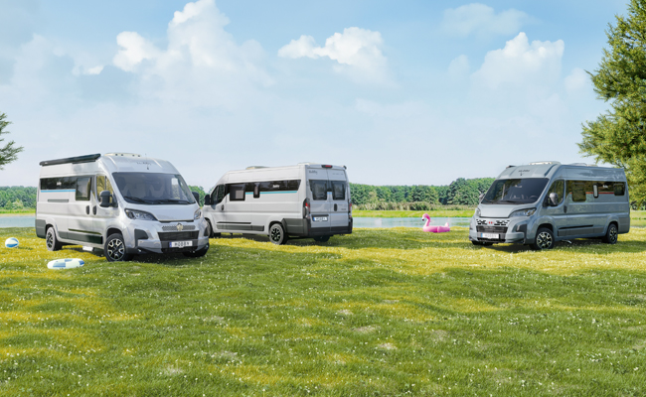

**ONTOUR AND MAXIA: TWO NEW MODEL RANGES FOR SEMI-INTEGRATED MOTORHOMES**

Two new semi-integrated motorhome model ranges will soon be available, including many familiar models. Both ranges are characterised by Hobby’s trademark rear lights and sleek roof vents, integrated perfectly into the modern, dynamic exterior design.

The ONTOUR C is a compact, semi-integrated motorhome. Thanks to its width of 2.23 metres, it can effortlessly negotiate narrow and bendy roads in mountainous regions and busy city centres. Built on a CITROËN chassis with a lively 140 hp engine, both the island-bed and single-bed layouts are optionally available with automatic transmission. The ONTOUR T is a versatile all-rounder on a Fiat chassis with a 140 hp engine. With a width of 2.40 metres, all three layouts feel open and spacious, and can easily accommodate large, cosy L-shaped seating areas. To ensure a good night’s sleep, a large double bed is installed in the rear section of the ONTOUR T 700 F and ONTOUR T 700 FH. As standard, the ONTOUR T 700 FH features two extra berths thanks to the drop-down bed above the seating area, as well as a powerful 180 hp engine with automatic transmission. The ONTOUR T 710 GE takes a classic approach with its compact side kitchen, two single beds and large rear garage.

The MAXIA T combines Scandinavian design with maximum comfort. This model range impresses with its ALL-INCLUSIVE package, including atmospheric ambient lighting, an L-shaped seating area with a 360° swivel pedestal table, and a three-burner gas-on-glass hob. Three layout options are available, offering up to five berths with either a double bed or single beds. The MAXIA T 740 WE and MAXIA T 740 WF boast a spacious rear washroom with a separate shower cubicle. The 4.4-tonne FIAT chassis with a 180 hp engine and automatic transmission is paired with a striking exterior design featuring a black chassis cowl with bronze accents. The 12 V / 230 V power sockets in the garage are an extremely useful feature.

Fully loaded: the special ONTOUR family models

The family-friendly ONTOUR A 720 GFM and ONTOUR T 700 KMH models on a 4.25-tonne Fiat chassis boast a powerful 140 hp engine, automatic transmission, approval for six people, as well as an equipment package that has been specially chosen to meet the needs of families. These incredibly spacious motorhomes have plenty of extra room for sleeping, playing and cooking, as well as large storage spaces for everything that young and old campers need on the road. The overcab of the ONTOUR A 720 GFM serves as extra storage space during the day. At night, it’s transformed into an airy canopy bed. Thanks to the drop-down bed and convertible central seating area, the semi-integrated ONTOUR T 700 KMH can comfortably sleep up to six people. Little ones will find their place to sleep in a children’s bunk bed in the rear section, which becomes a large garage when driving.

No matter which semi-integrated model you choose, thanks to the **HOBBY**KOMPLETT **ALL-INCLUSIVE package**, all motorhomes come travel-ready with many extras, including a safety package with assistance systems, a leather steering wheel with controls, stylish alloy rims, REMIS blackout blinds for the front and side windows in the cab, an attached awning, a fly screen for the habitation entrance door, a GRP floor with XPS heat insulation, a gas bottle pull-out shelf for 2 x 11 kg bottles, a 96-litre waste water tank (heated and insulated), a 133-litre DOMETIC refrigerator (AES) with double-hinged door, and the **HOBBY**CONNECT system that lets you control the on-board technology via the control panel or Bluetooth app.

[You can find the press release for the new ONTOUR C model range here](https://mediaportal.hobby-caravan.de/en/press-release/the-hobby-ontour-c-and-ontour-t-compact-versatile-and-spacious/)

[You can find the press release for the new ONTOUR T model range here](https://mediaportal.hobby-caravan.de/en/press-release/the-hobby-ontour-c-and-ontour-t-compact-versatile-and-spacious/)

[You can find the press release for the new MAXIA T model range here](https://mediaportal.hobby-caravan.de/en/press-release/the-hobby-maxia-t-a-little-more-of-everything/)

[You can find the press release for the special Family models here](https://mediaportal.hobby-caravan.de/en/press-release/hobby-family-models-ontour-a-720-gfm-and-ontour-t-700-kmh/)

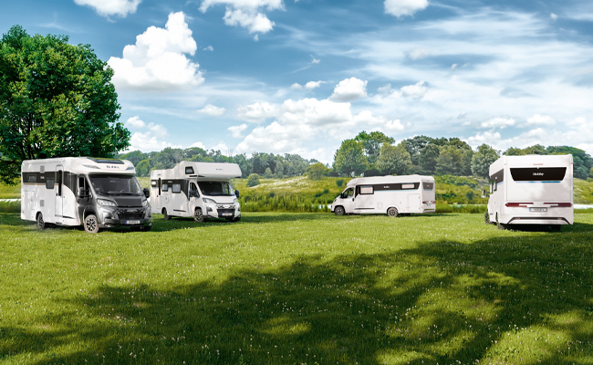

**HOBBY CARAVANS: FURTHER UPGRADES**

For the 2025 season, Hobby offers its customers six model ranges and 46 different variants, all boasting stylish exterior designs and refreshed interiors for the best time of the year. The entry-level ONTOUR 390 SF, which is 2.20 m wide and weighs just 1,200 kg, is priced from €21,100. At the premium end, the flagship MAXIA 660 WQM remains available, starting at €44,770.

Building on last season’s interior updates, including new upholstery and curtains, Hobby caravans now feature further digital enhancements for the coming season. The well-established **HOBBY**CONNECT system, standard across all caravans, will soon include a new E-Gas-Level function. This addition allows customers to control the interior lighting, heating, refrigerator, underfloor heating and roof-mounted air conditioning unit (DOMETIC / TRUMA) via the **HOBBY**CONNECT app, while also providing reliable notifications when a gas bottle needs replacing. New LED lighting ensures an even cosier atmosphere inside the vehicle.

Thanks to the **HOBBY**KOMPLETT **ALL-INCLUSIVE package**, these caravans come road-ready without the need for industry-standard mandatory packages or expensive optional extras. The **HOBBY**KOMPLETT **ALL-INCLUSIVE package** for caravans includes a stabiliser hitch and KNOTT overrun braking system, heavy-duty supports, blackout blinds and fly screens for all windows, a rooflight DOMETIC SEITZ, an LED awning light, a wardrobe with interior lighting, fully extendable drawers with soft-close and push-lock mechanisms, as well as the **HOBBY**CONNECT system that lets you control the on-board technology via the control panel or Bluetooth app.

You can find the press release for the entry-level [ONTOUR](https://mediaportal.hobby-caravan.de/en/press-release/ontour-hobbys-entry-level-caravans-for-the-2025-season/) and [DE LUXE](https://mediaportal.hobby-caravan.de/en/press-release/de-luxe-hobbys-mid-range-all-rounder-for-the-2025-season/) model ranges here

You can find the press release for the mid-range [EXCELLENT](https://mediaportal.hobby-caravan.de/en/press-release/excellent-hobbys-mid-range-all-rounder-for-the-2025-season/) and [EXCELLENT EDITION](https://mediaportal.hobby-caravan.de/en/press-release/excellent-edition-hobbys-mid-range-gem-for-the-2025-season/) model ranges here

You can find the press release for the premium [PRESTIGE](https://mediaportal.hobby-caravan.de/en/press-release/prestige-hobbys-luxury-class-caravans-for-the-2025-season/) and [MAXIA](https://mediaportal.hobby-caravan.de/en/press-release/maxia-hobbys-luxury-class-caravans-for-the-2025-season/) model ranges here

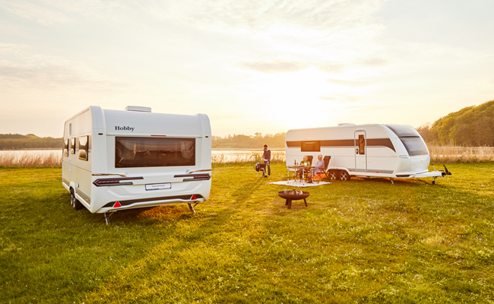

**BEACHY: FRESHER THAN EVER**

Hobby’s popular BEACHY series turns heads wherever it goes, especially by the seaside. And now it’s set to truly shine! The three popular layouts – BEACHY 360, BEACHY 420 and BEACHY 450 – now feature an exterior that radiates joy, adventure and a pure beach vibe. The wave-inspired design is now optionally available in trendy colours like “Ocean Blue”, “Sunny Yellow”, “Pink” and “Lavender”.

With optional electric heating, this iconic caravan can now also serve as a cosy retreat during the colder months, making it perfect for both couples and families. The upgraded utility systems include a fixed fresh water tank and a portable waste water container. Prices remain attractively low, starting at €14,670 for the 2025 season.

[You can find the press release for the BEACHY 2025 here](https://mediaportal.hobby-caravan.de/en/press-release/the-beachy-more-colour-more-freedom/)

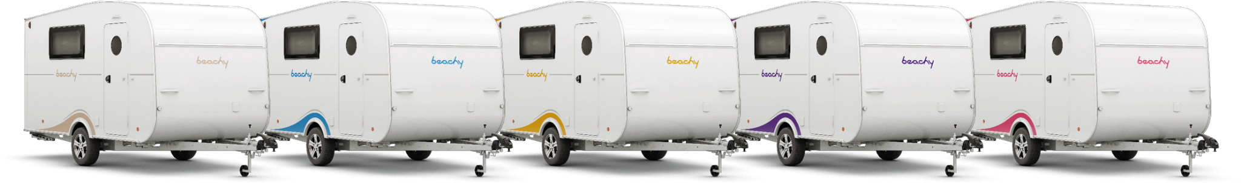

**More pictures and information about the models for the 2025 season can be found online at** [**hobby-caravan.de/en**](https://www.hobby-caravan.de/en/)**, or come and see them for yourself at the Caravan Salon in Düsseldorf from 30 August to 8 September 2024.**

**Further information is available from the Hobby press office:**

[presse@hobby-caravan.de](mailto:presse@hobby-caravan.de) or at [mediaportal.hobby-caravan.de/en](https://mediaportal.hobby-caravan.de/en)