**THE BEACHY: MORE COLOUR, MORE FREEDOM**

**Fockbek, 28 August 2024. Hobby’s BEACHY series has been a hit for years, turning heads at beaches, lakes and campsites alike. Now, this lightweight caravan is available in four vibrant new colours that will bring even more joy to every journey. Plus, all three BEACHY models have been upgraded and are now fully equipped for off-grid camping.**Ein Bild, das Im Haus, Mobiliar, Wand, Kleidung enthält.

**UNIQUELY BEACHY: AT HOME BY THE WATER**

The three popular layouts BEACHY 360, BEACHY 420 and BEACHY 450 now boast a new, even more distinctive exterior design. While maintaining the beloved beach vibe, the series now introduces four new trendy colours. Those who love the maritime vibe can now pair the new “Ocean Blue” with the sand-coloured BEACHY. For anyone yearning to feel the warmth of summer even before they hit the road, “Sun Yellow” is the perfect exterior choice. And if you’re after something more stylish, “Pink” or “Lavender” will surely make a statement. With these beautiful new colours, the BEACHY is guaranteed to spread good vibes wherever it goes.

The dimensions and weight of the three BEACHY models remain unchanged. The numbers after the model name indicate the caravan’s body length in centimetres. For example, the BEACHY 360 has a body length of approximately 3.60 m. The technically permissible total laden mass remains between 900 kg and 1000 kg, ensuring easy manoeuvrability on sandy terrain. In terms of equipment packages, all three models have been upgraded. The compact BEACHY caravan retains its signature simplicity while introducing small enhancements that offer even more flexibility for all kinds of holidays. For those who value independence on their travels, an optional factory-installed electric heater is now available, turning chilly nights into a cosy and comfortable experience. Additional upgrades include a fixed fresh water tank, a portable waste water container, improved roof rainwater drainage, an awning light above the side door and new beach-style storage boxes.

Prices for the 2025 season start at €14,670.00.

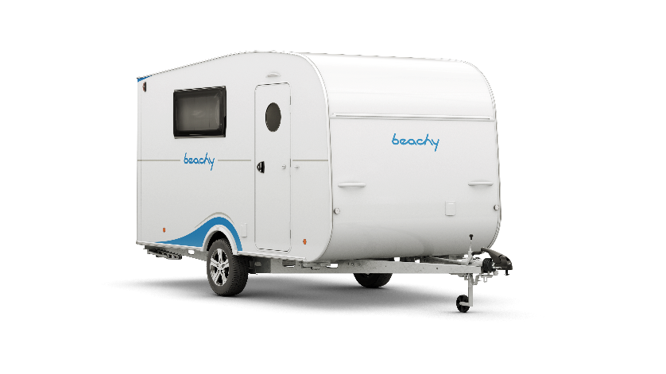

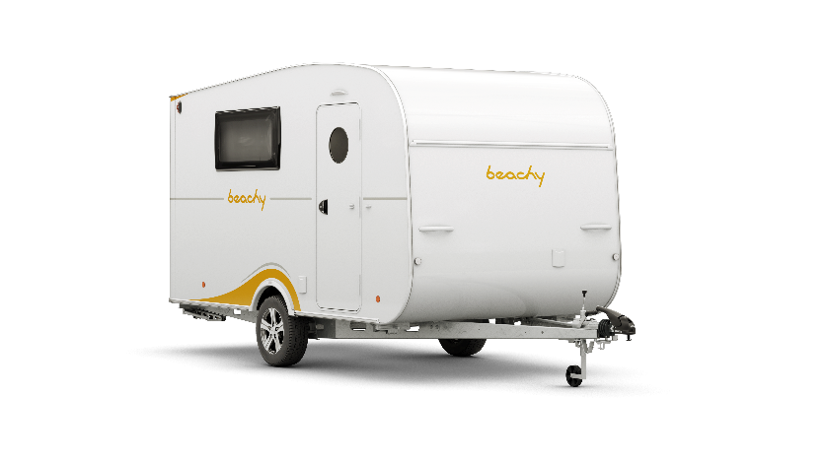

„Ocean Blue“ „Sun Yellow“

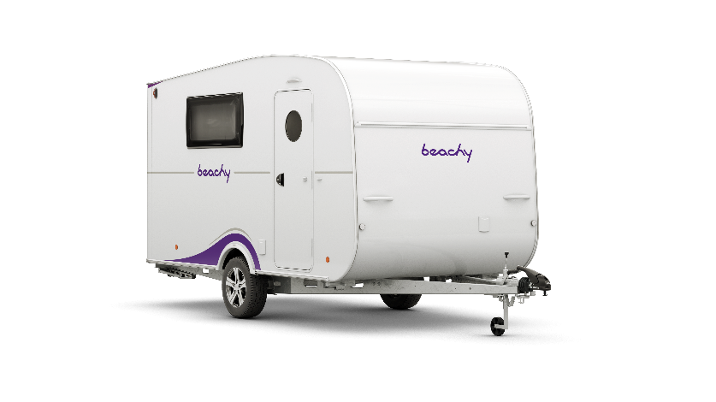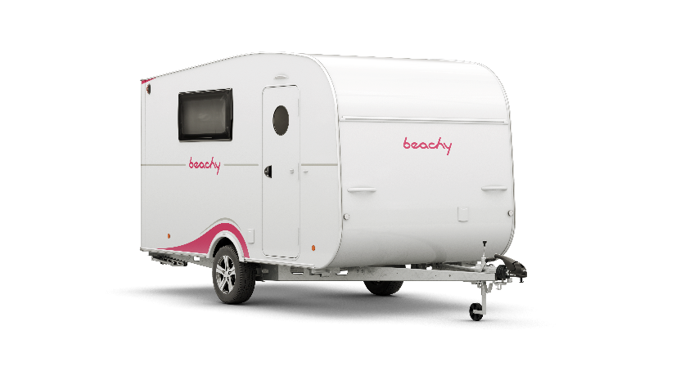

„Pink“ „Lavender“

**More pictures and information about the models for the 2025 season can be found online at** [**hobby-caravan.de/en**](https://www.hobby-caravan.de/en/)**, or come and see them for yourself at the Caravan Salon in Düsseldorf from 30 August to 8 September 2024.**

**Further information is available from the Hobby press office:**

[presse@hobby-caravan.de](mailto:presse@hobby-caravan.de) or at [mediaportal.hobby-caravan.de/en](https://mediaportal.hobby-caravan.de/en)