HOBBY’S MID-RANGE GEM FOR THE 2025 SEASON
Fockbek, 28 August 2024 – Our theme for the upcoming season is “Enduring Camping Passion” – with a focus on durability. While our model range remains diverse, it has been streamlined and updated with fresh interiors. For 2025, we’re taking what’s already great and making it even better. Enter the EXCELLENT EDITION models – mid-range caravans that deliver both comfort and style, perfect for those who want it all on holiday without any compromises. This is the ideal middle ground between entry-level and luxury-class models, and at Hobby, it’s known as the EXCELLENT EDITION.

THE EXCELLENT EDITION – TRAVEL IN STYLE AND COMFORT
Camping continues to be a booming trend, winning over more and more enthusiasts. Once you’ve caught the camping bug, it’s hard to shake. Anyone who spends several weeks a year on the road quickly realises what their caravan needs to provide: a personal touch that reflects their individual taste and style.
As you’d expect, the EXCELLENT EDITION will still be just as stylish in the coming season. Despite the similar names, all of the models are completely separate model ranges. Designed with families and couples in mind, the EXCELLENT EDITION combines minimalist Scandinavian design with a spacious, airy feel and plenty of storage space. With ten versatile layouts starting at €26,970, the EXCELLENT EDITION offers various models, from compact to more spacious options, with widths between 2.30 and 2.50 metres. The EXCELLENT EDITION also offers plenty of flexibility when it comes to the choice of berths, the kitchen area and the location of the washroom.

With its large island bed, you’re guaranteed a great night’s sleep in the single-axle EXCELLENT EDITION 540 UFf. The slightly shorter EXCELLENT EDITION 495 UL, a timeless classic, offers an alternative bed configuration and enough space for four adults. For the 2025 season, spacious wall units and light upholstery combinations bring a bright, open feel to the habitation area. Four of the ten layouts are perfectly suited for families with children of all ages. Like all Hobby caravans, the EXCELLENT EDITION comes ready to hit the road and equipped with everything that makes your holiday the best time of the year – thanks to the “HOBBYKOMPLETT” ALL-INCLUSIVE package.

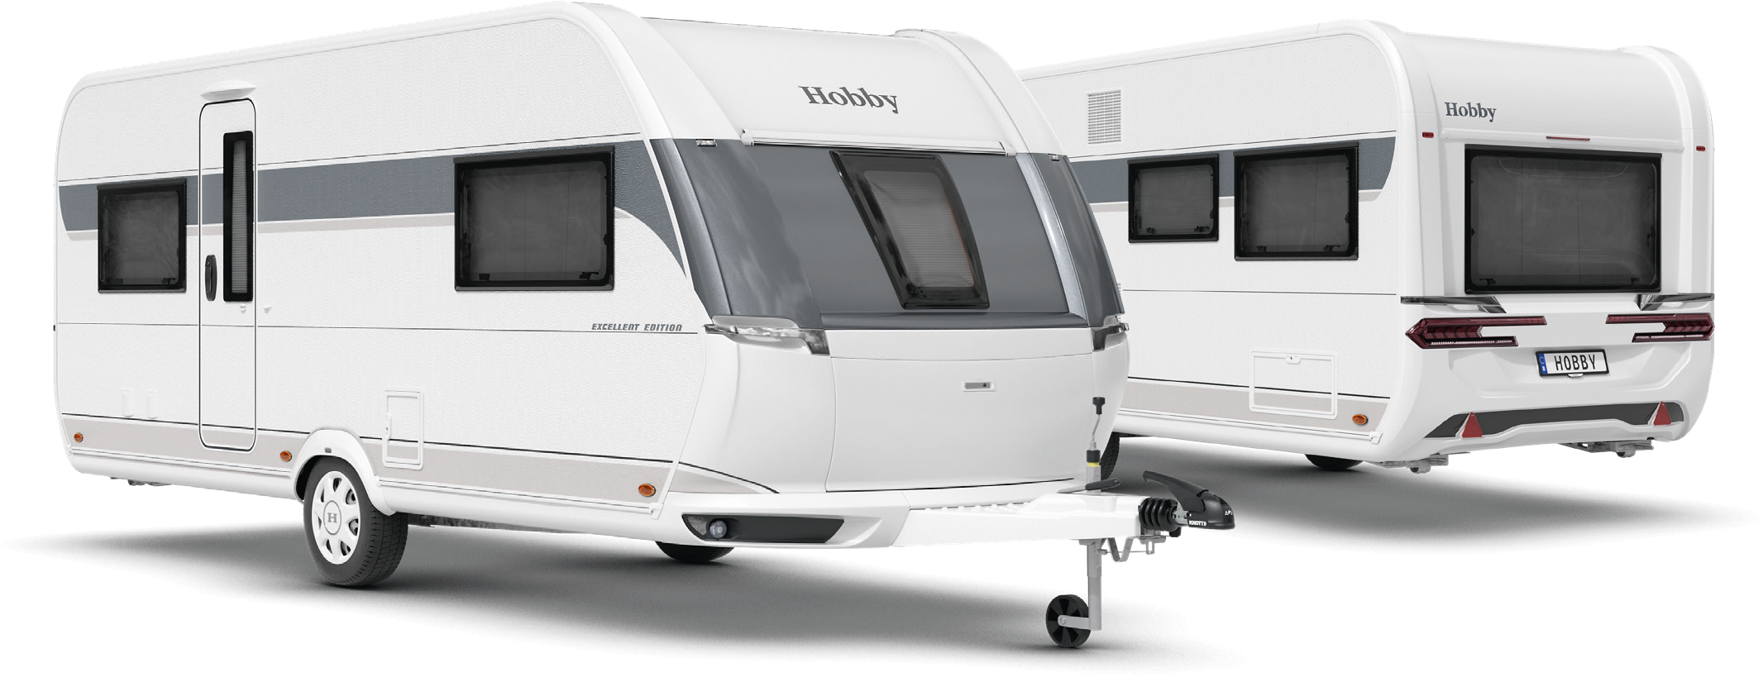Exterior design of the EXCELLENT EDITION 540 UFf

LAYOUTS AT A GLANCE

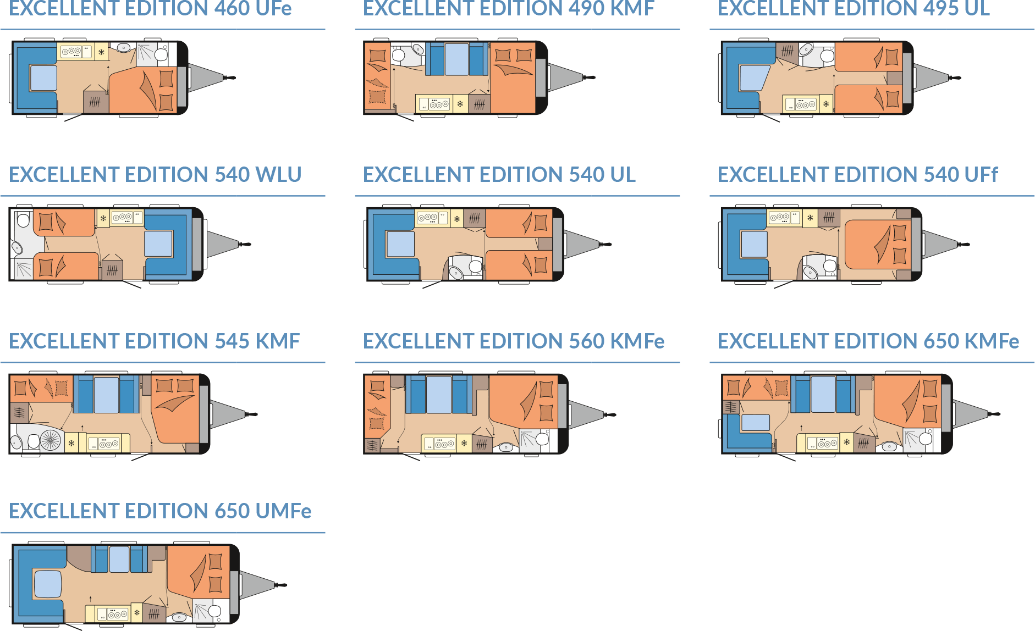

Modern design and comprehensive equipment package
For the 2025 season, the EXCELLENT EDITION joins the ranks of our caravans that boast a sporty and stylish exterior design. With its dynamic, athletic look, this design is truly eye-catching, while still maintaining a sense of harmony. The rear lights and manoeuvring handles blend seamlessly with the flowing curves, giving the EXCELLENT EDITION a modern appearance. Inside, these vehicles deliver on the promise of the exterior: the clean design, featuring minimalist and streamlined wall units, continues throughout the interior. The furniture design gives the EXCELLENT EDITION its homely charm, while the upholstery and anthracite kitchen create a cosy, home-like atmosphere in a compact space.
Minimalist and modern, yet warmly Scandinavian.

HIGHLIGHTS: spacious layouts and superior comfort

495 UL
The structure and design of the 495 UL make it a classic among caravans. The combination of a U-shaped seating area and single beds has been popular since the dawn of camping – and for good reason. The 495 UL offers a timeless, reliable and highly practical layout. The large U-shaped seating area at the rear can be quickly converted into two berths. The kitchenette, featuring a 133L absorption refrigerator, is located at the front, alongside the two single beds. With an optional bed extension, these single beds can be transformed into a spacious sleeping area.

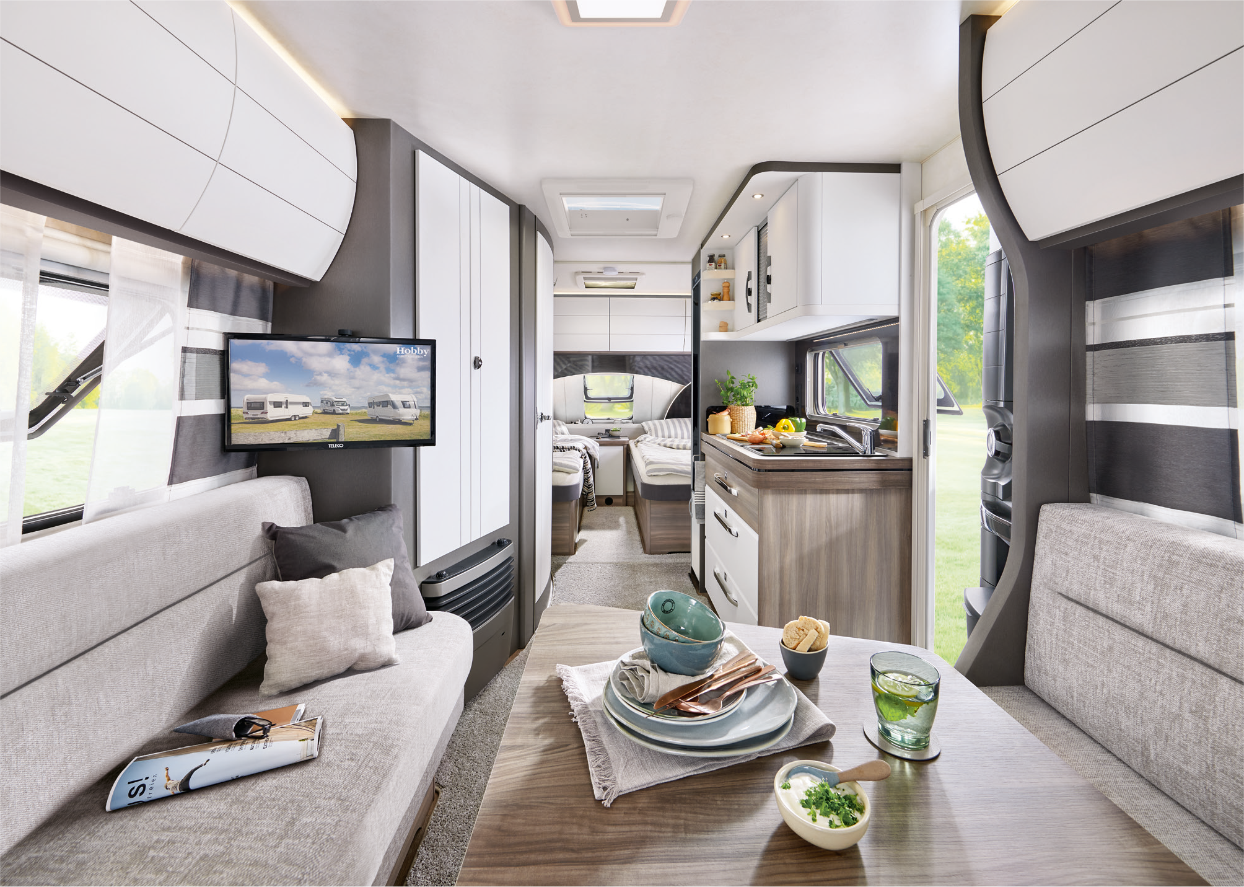
Modern classic: the EXCELLENT EDITION 495 UL
540 UFf
The EXCELLENT EDITION 540 UFf stands out with its spacious island bed in the front section. Offering exceptional comfort, this bed is accessible from three sides and there is ample storage space beneath it. Similar to the 495 UL, a large U-shaped seating area is located at the rear. This can be easily converted into two additional berths when needed. The compact washroom features a shower, ensuring a refreshing start to the day. The modern kitchenette, equipped with a 133-litre absorption refrigerator, offers plenty of space for all your cooking utensils, big or small. The spacious wardrobe is ideal for storing a variety of outfits, ready for any activity and all kinds of weather.

Camping passion, made in Germany
At Hobby, camping passion is crafted in Germany – right here in Fockbek, Schleswig-Holstein. We take pride in our high quality standards, which is why we offer a 12-year watertightness guarantee on all our vehicles. Our product range is as varied as the world of camping itself. Whether you’re looking for caravans, motorhomes or vans – from entry-level models to luxury-class vehicles, with comprehensive standard features or custom options – Hobby has it all. And with the “HOBBYKOMPLETT” ALL-INCLUSIVE package, every vehicle is ready to go, with no ifs, no buts and no hidden costs. That’s pure camping passion, “Made in Fockbek”.

The 2025 EXCELLENT EDITION model range will, of course, be on display at the Caravan Salon Düsseldorf from 30 August to 8 September 2024. And it’s now also available online at hobby-caravan.de/en

Further information is available from the Hobby press office:
presse@hobby-caravan.de or at mediaportal.hobby-caravan.de/en

