Hobby’s MID-RANGE ALL-ROUNDER for the 2025 season
Fockbek, 28 August 2024 – Durability takes centre stage in Hobby’s new season. In short, we’re taking what’s already great and making it even better. While our model range remains diverse, it has been streamlined and enhanced with upgraded interiors. Leading the charge is the DE LUXE model range. DE LUXE represents versatility: from compact caravans for couples to family layouts that offer up to seven berths. And, naturally, every model is equipped with everything you need for an unforgettable camping holiday, thanks to the HOBBYKOMPLETT ALL-INCLUSIVE package.

With 13 layouts to choose from, the Hobby DE LUXE is the perfect caravan for families and couples. This is just one of the many reasons why the DE LUXE consistently tops our bestseller list. Best of all, every layout offers outstanding comfort, whatever your budget.

The DE LUXE – Your spacious home from home
Camping remains one of the top holiday choices, with more and more people – especially couples and families – living their dream of owning a camping vehicle that perfectly meets their needs. In the mid-range segment, the DE LUXE is often the go-to choice—and with the HOBBYKOMPLETT ALL-INCLUSIVE package, it’s road-ready from the get-go. With widths ranging from 2.30 to 2.50 metres, both smaller and larger models are available. Whether with a double bed, single beds or a practical drop-down bed, this caravan impresses with its versatile options. And with five different children’s bed models, the Hobby DE LUXE offers a great deal of flexibility, especially for camping trips with kids. Weighing from 1,350 kg upwards, it’s also suitable for smaller towing vehicles and electric cars. And the price is just as attractive: the DE LUXE starts at just €24,110.

The DE LUXE 515 UHL shines with its drop-down bed and numerous additional berths, comfortably sleeping up to six adults. The DE LUXE 490 KMF is tailored towards family-friendly travel: the children’s bed layout provides berths for up to five people. Thanks to the HOBBYKOMPLETT ALL-INCLUSIVE package, all mid-range models in the DE LUXE range come fully equipped with everything you need – whether you’re travelling with five or six people. At Hobby, there are no additional or mandatory packages – just your perfect travel companion, ready to hit the road straight from the factory for the perfect holiday.
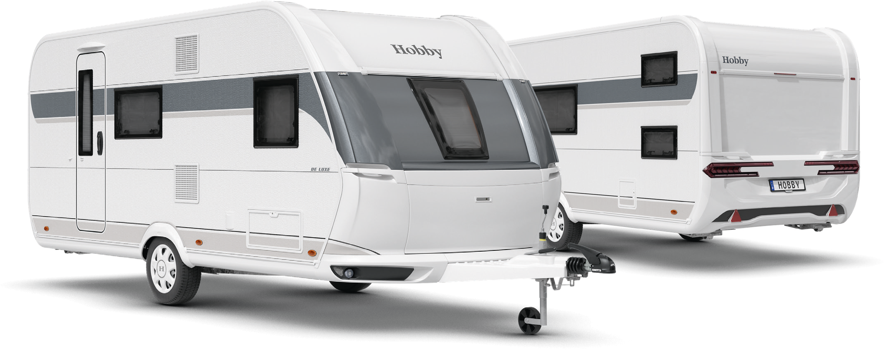
Exterior design of the DE LUXE 490 KMF

LAYOUTS AT A GLANCE

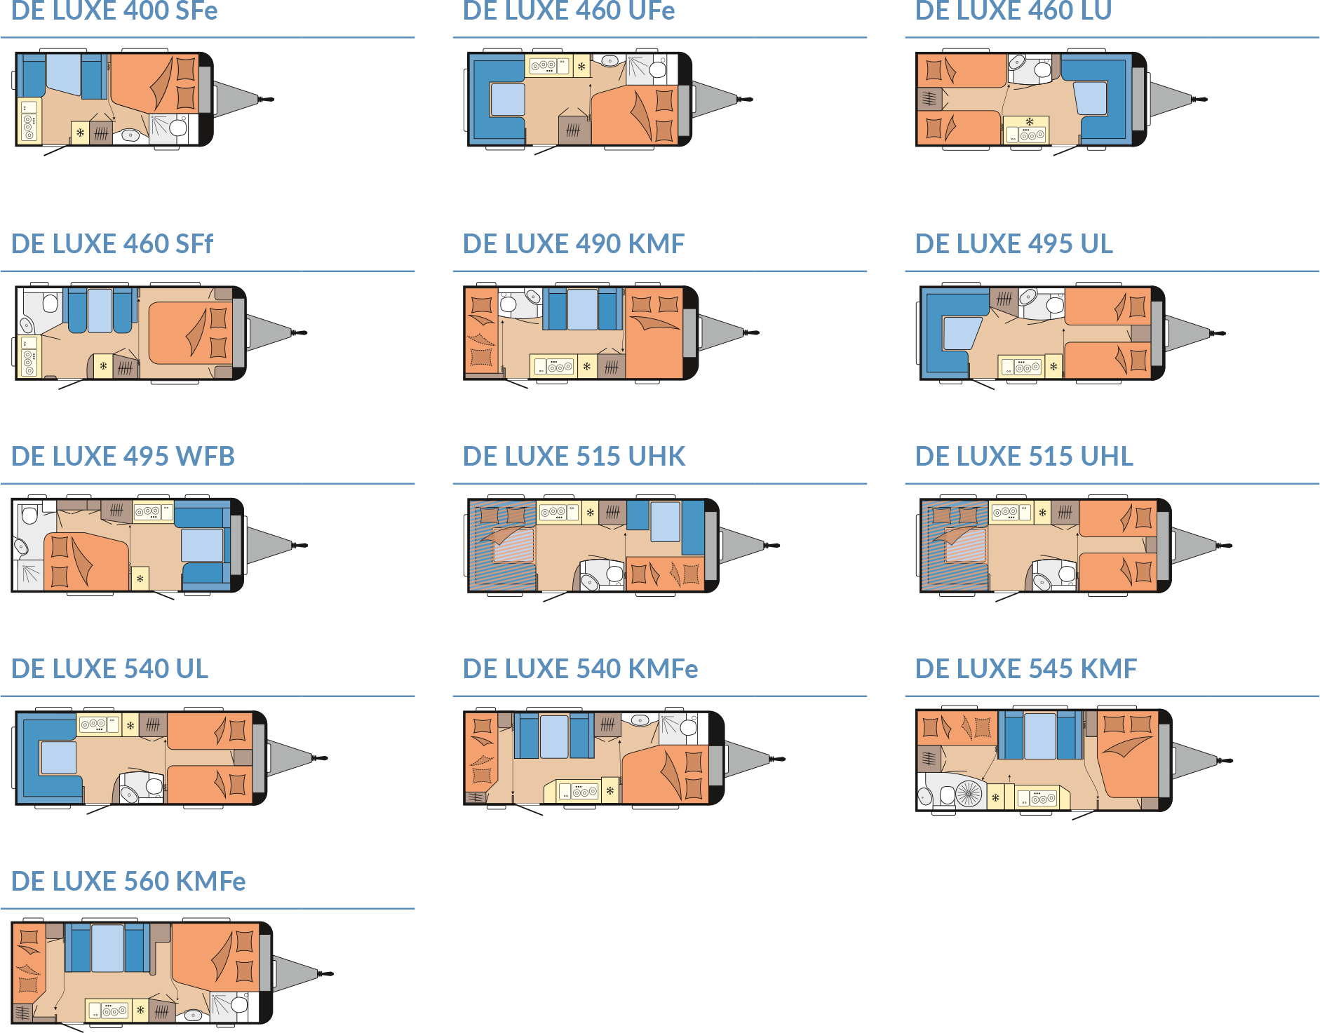

Modern design and comprehensive equipment package
For the 2025 season, the DE LUXE sports a sleek and stylish exterior design: dynamic, yet harmonious and well-balanced. The manoeuvring handles and rear lights blend seamlessly with the flowing contours, giving the DE LUXE a contemporary look. This modern aesthetic continues into the interior, where linear wall units with grey accents create a clean, contemporary and inviting living space. Both the furniture, with its cosy upholstery, and the anthracite-coloured kitchen contribute to the tidy and harmonious overall design.

HIGHLIGHTS: SPACIOUS LAYOUTS WITH EVERYTHING INCLUDED

490 KMF
The 490 KMF offers a wealth of features: bunk beds, a transverse bed, a central seating area and a kitchenette. Each element is strategically positioned to make the most of the available space while keeping things cosy. With just a few quick adjustments, the seating area can be transformed into two additional berths. Whether you’re travelling as a couple or using all five berths, there’s ample storage space for luggage and provisions, ensuring everyone is well accommodated. And in the fully equipped kitchen, you can easily prepare breakfast, snacks or dinner for everyone on board.
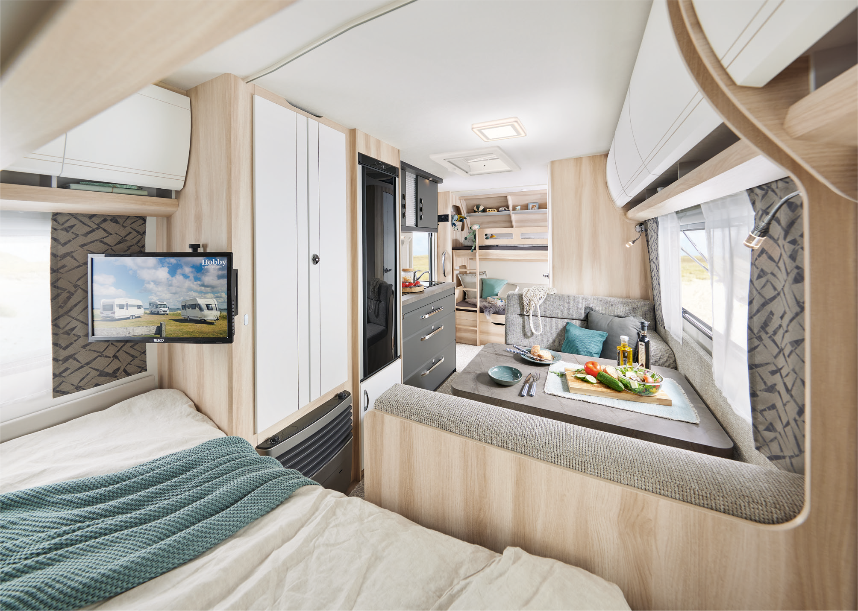
Room for everyone: the DE LUXE 490 KMF
515 UHL
The 515 UHL is the ideal caravan for those who appreciate flexibility. It comes with single beds, a drop-down bed and a U-shaped seating area, offering four berths and plenty of seating options. If needed, the seating area can be effortlessly transformed into two additional berths. The spacious side kitchen, featuring a 133-litre absorption refrigerator, provides enough room for all your favourite ingredients. This setup is perfect for aspiring chefs – the ample worktop space and storage solutions ensure every kitchen utensil has its place while on the road.

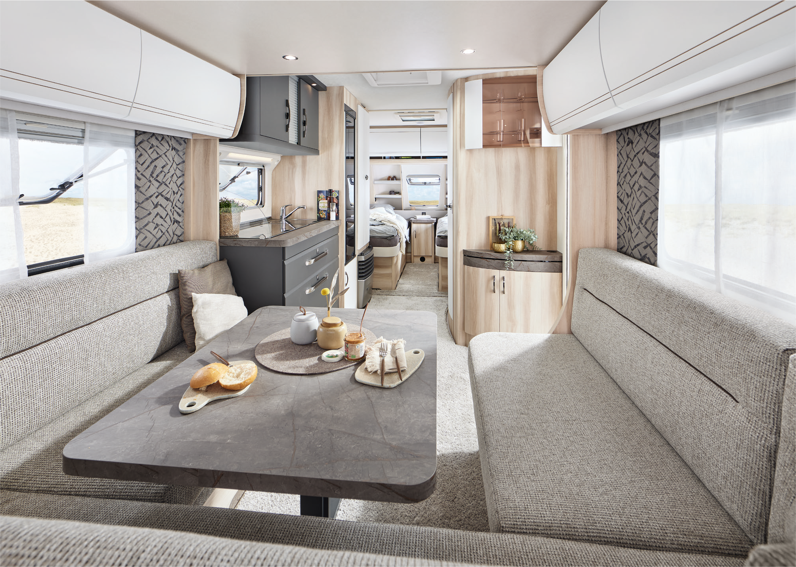
Home from home: the DE LUXE 515 UHL

Camping passion, made in Germany
At Hobby, camping passion is crafted in Germany – right here in Fockbek, Schleswig-Holstein. We take pride in our high quality standards, which is why we offer a 12-year watertightness guarantee on all our vehicles. Our product range is as varied as the world of camping itself. Whether you’re looking for caravans, motorhomes or vans – from entry-level models to luxury-class vehicles, with comprehensive standard features or custom options – Hobby has it all. And with the HOBBYKOMPLETT ALL-INCLUSIVE package, every vehicle is ready to go, with no ifs, no buts and no hidden costs. That’s pure camping passion, “Made in Fockbek”.

The 2025 DE LUXE model range will, of course, be on display at the Caravan Salon Düsseldorf from 30 August to 8 September 2024. And it’s now also available online at hobby-caravan.de/en

Further information is available from the Hobby press office:
presse@hobby-caravan.de or at mediaportal.hobby-caravan.de/en

