HOBBY’S MID-RANGE ALL-ROUNDER FOR THE 2025 SEASON
Fockbek, 28 August 2024 – New season, consistent quality. At Hobby, everything is focused on delivering the best possible camping experience for the new season. With a streamlined model range and refreshed interiors, Hobby vehicles are set to take the 2025 season by storm. Leading the charge is the EXCELLENT model range, which represents comfort and modern travel at its finest. It’s the perfect choice for those who feel at home somewhere between our entry-level and luxury-class models, and who don’t want to compromise while on the road.

THE EXCELLENT – BUILT FOR TWO
Camping continues to be a top holiday choice, with more and more couples discovering the romantic allure of a getaway in a mobile home. Once you’ve felt the irresistible combination of freedom and closeness a caravan offers, it’s hard to go back. For couples ready for an elegant, fresh start after many years of holidays in the family caravan, or who want their first purchase to be a comfortably appointed, mid-range caravan, the EXCELLENT offers four versatile layouts starting from €27,800. With a width of between 2.30 and 2.50 m, both smaller and larger models are available. The EXCELLENT caters to a variety of tastes when it comes to the choice of berths, kitchen design and washroom placement.

If you’re looking for a caravan with a rear washroom, the EXCELLENT model range offers three suitable layouts. The 460 SL provides plenty of comfort within a compact footprint. For those who prefer more space, the 495 WFB and 540 WFU offer larger layouts with a double bed and a full-width rear washroom.
All EXCELLENT layouts feature white high-gloss wall units, illuminated shelves with decorative elements, and indirect strip lighting. These elements bring a touch more elegance to the EXCELLENT model range for the 2025 season. Like all Hobby caravans, the EXCELLENT comes fully loaded with the HOBBYKOMPLETT ALL-INCLUSIVE package, so it’s ready to hit the road and equipped with everything you need to make your holiday the best time of the year.

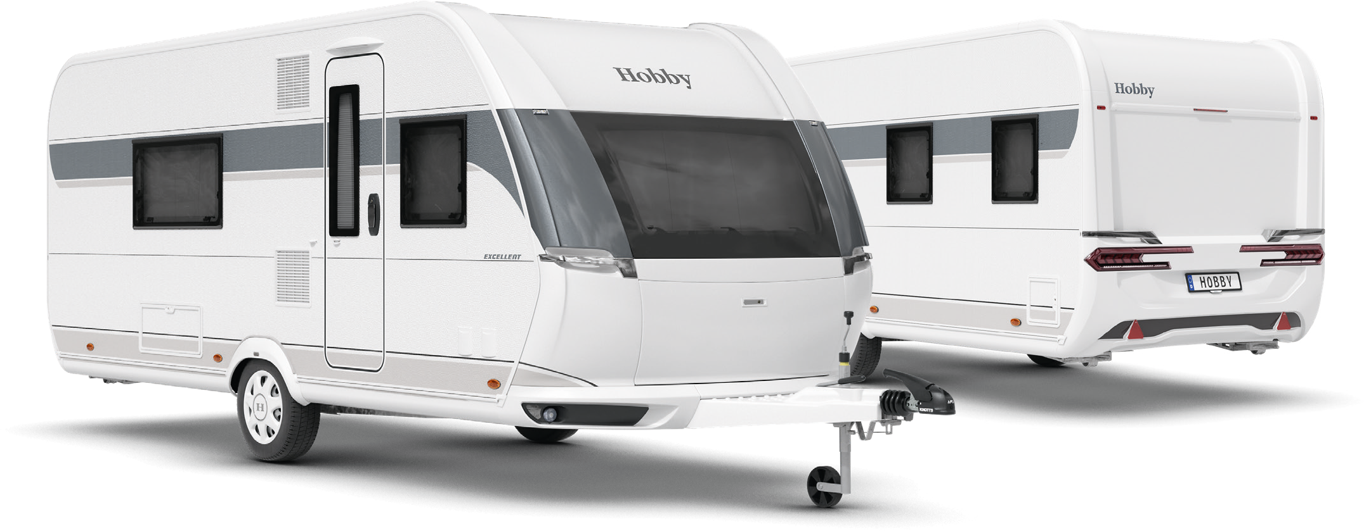Exterior design of the EXCELLENT 495 WFB

LAYOUTS AT A GLANCE

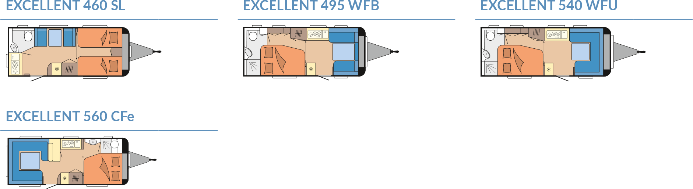
Modern design and comprehensive equipment package
Like all our caravans, the EXCELLENT enters the 2025 season boasting a fresh and modern exterior design: sporty, dynamic and yet harmonious and well-balanced. Flowing, organic shapes, along with seamlessly integrated manoeuvring handles and rear lights, give the EXCELLENT a contemporary style. Naturally, the interior lives up to the promise of the exterior. Linear wall units with grey accents create a modern, clean and inviting living space. The furniture, complete with comfortable upholstery, and an anthracite-coloured kitchen complement the minimalist, uncluttered overall design. With the EXCELLENT, an attractive exterior design and outstanding interior features go hand in hand.

HIGHLIGHTS: compact layouts, maximum functionality

460 SL
The compact EXCELLENT 460 SL impresses with its fully equipped rear kitchen and single beds at the front. If you so wish, these beds can be combined into a spacious sleeping area with the optional bed extension. With up to four berths, this layout is perfect for children, grandchildren or guests.

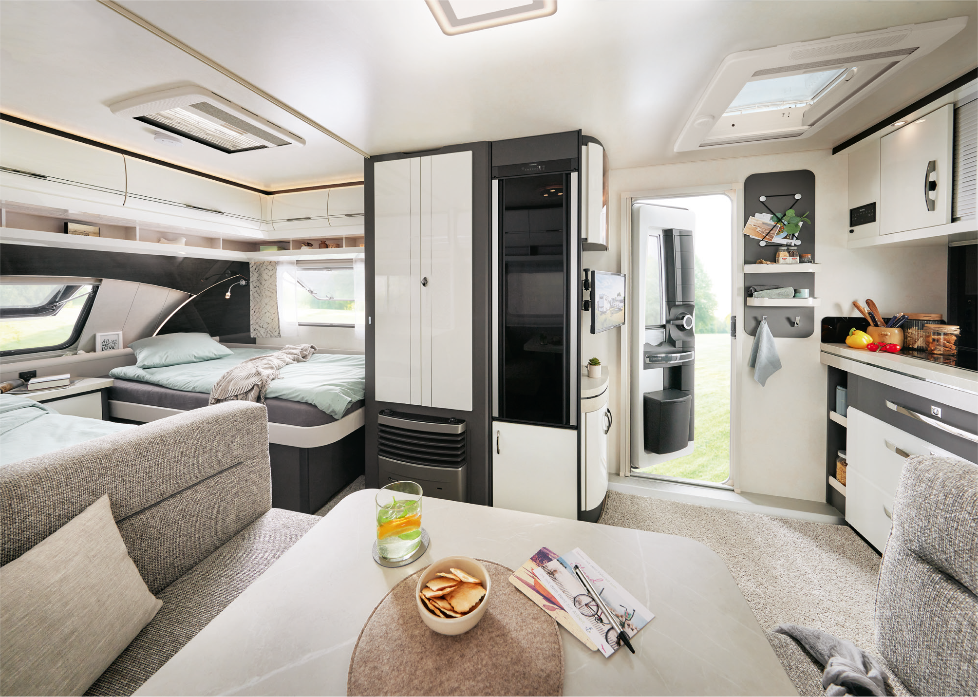
The EXCELLENT 460 SL has everything you need
495 WFB
For those who prefer a bit more space, the EXCELLENT 495 WFB is worth a look. At the front, you’ll find a cosy face-to-face front seating area, seamlessly connected to the side kitchen – keeping everything within easy reach. The side kitchen, equipped with a 133-litre refrigerator, provides plenty of storage space for provisions and kitchen utensils. At the rear, there’s a large double bed. Naturally, the space beneath the bed is also utilised, providing room for suitcases, bags, boxes or other luggage items. The rear washroom spans the full width of the 495 WFB, delivering the level of comfort you’re used to at home. The almost identical 540 WFU offers the same features, but with a bit more space in the U-shaped seating area.

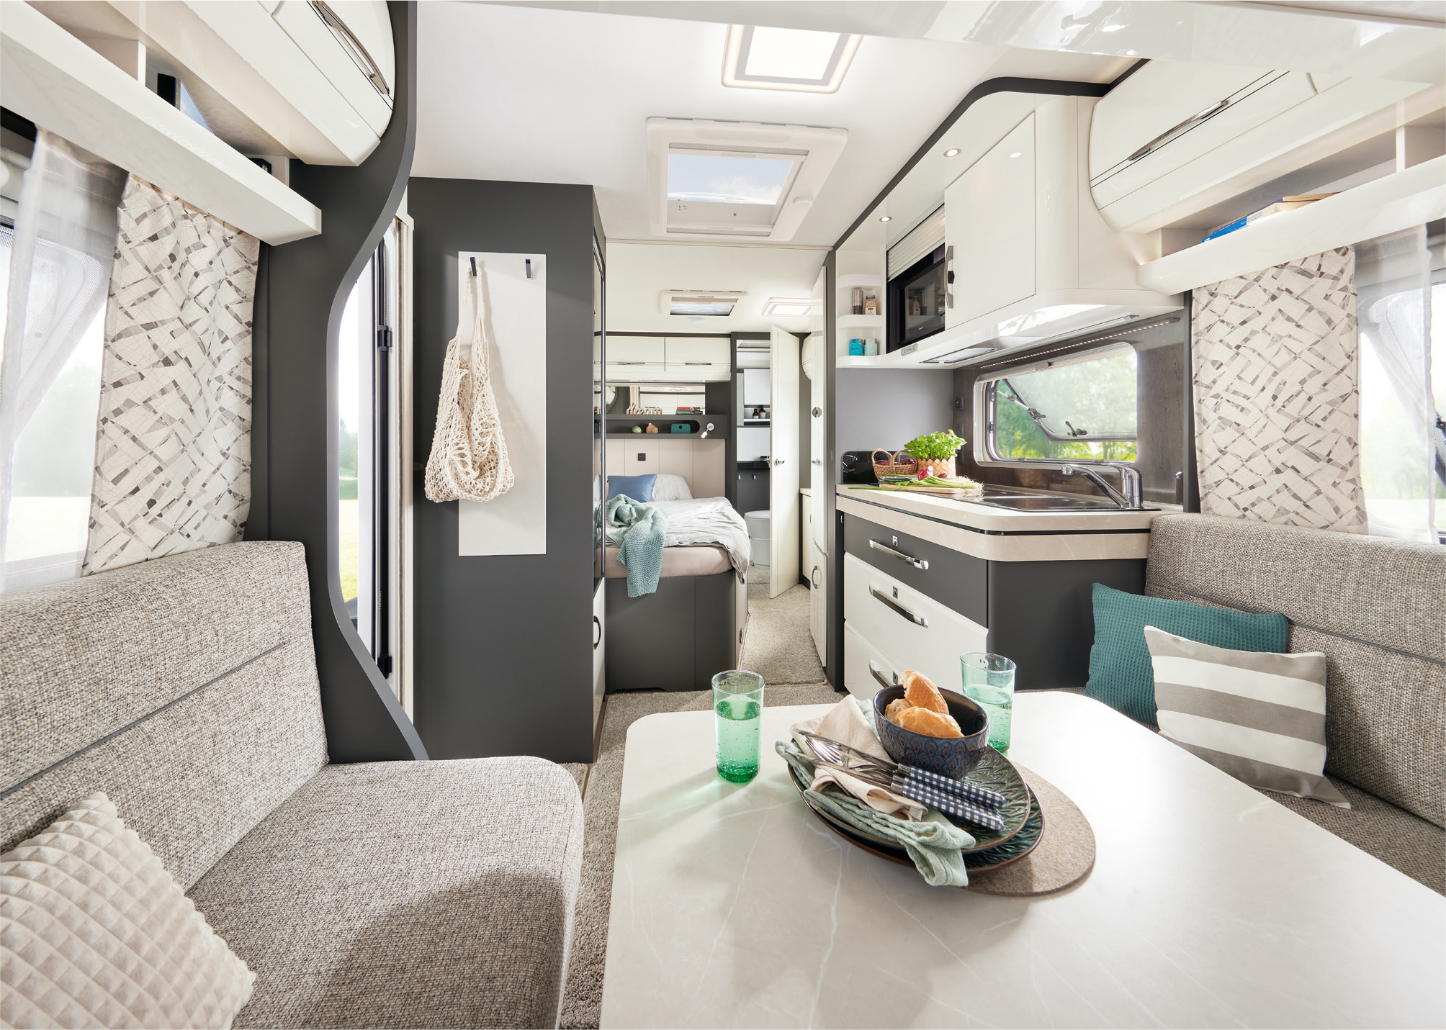
A fresh new look in the EXCELLENT 495 WFB

Camping passion, made in Germany
At Hobby, camping passion is crafted in Germany – right here in Fockbek, Schleswig-Holstein. We take pride in our high quality standards, which is why we offer a 12-year watertightness guarantee on all our vehicles. Our product range is as varied as the world of camping itself. Whether you’re looking for caravans, motorhomes or vans – from entry-level models to luxury-class vehicles, with comprehensive standard features or custom options – Hobby has it all. And with the HOBBYKOMPLETT ALL-INCLUSIVE package, every vehicle is ready to go, with no ifs, no buts and no hidden costs. That’s pure camping passion, “Made in Fockbek”.

The 2025 EXCELLENT model range will, of course, be on display at the Caravan Salon Düsseldorf from 30 August to 8 September 2024. And it’s now also available online at hobby-caravan.de/en

Further information is available from the Hobby press office:
presse@hobby-caravan.de or at mediaportal.hobby-caravan.de/en

