HOBBY’S LUXURY-CLASS CARAVANS FOR THE 2025 SEASON
Fockbek, 28 August 2024 – Hobby will kick off the new season with a streamlined and refreshed product line-up that combines the usual “Made in Fockbek” quality with a range of new features and updates. A standout in Hobby’s luxury class is the MAXIA model range. Camping enthusiasts can choose from X luxury-class caravan layouts within the MAXIA model range, which rival high-end holiday apartments in both design and comfort. The entire model range is fully winterised and, with up to seven berths, is ideal for large families.

THE MAXIA – PERFECT FOR SEASONED CAMPERS
With the family, as a couple or with friends – camping is hard to beat when it comes to the perfect holiday. Once you’ve experienced the joy of outdoor living, it’s easy to become a devoted enthusiast. And when the campsite becomes your favourite destination, the dream of owning your own caravan quickly takes shape. For experienced campers and those looking to step up to the luxury class, the MAXIA is the ultimate choice. Minimalist design, natural colours and Nordic cosiness remain the hallmarks of this popular model range. The MAXIA models are ideal year-round companions, and with the HOBBYKOMPLETT ALL-INCLUSIVE package, they are road-ready from just €38,610.

The panoramic kitchen window at the front of the MAXIA 660 WQM is just one of the model range’s many impressive extra features, enhancing the “luxury apartment” vibe. The MAXIA caravans also thoughtfully address the needs of families. The MAXIA 595 KML has a family layout with a unique multifunctional rear section. With more than nine possible configurations, it redefines flexibility: in just a few simple steps, up to three children’s beds can be set up or taken down. A play den, a children’s seating area, a bolthole for your four-legged friends or more storage space can be created just as easily.

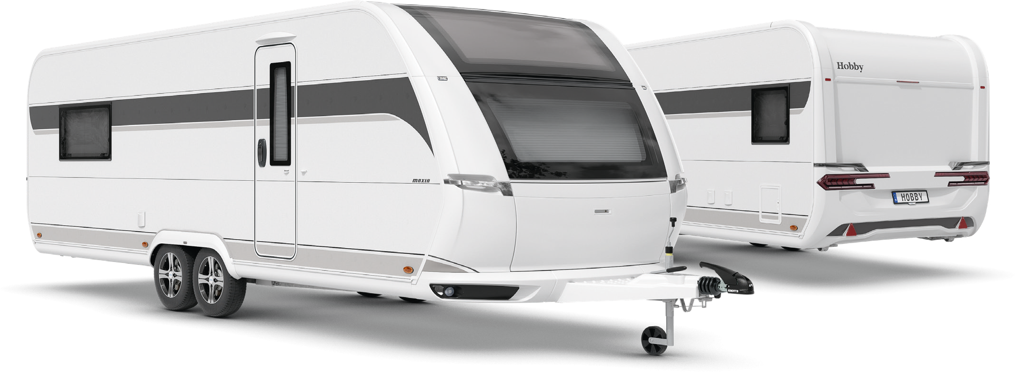
Exterior design of the MAXIA 660 WQM

LAYOUTS AT A GLANCE

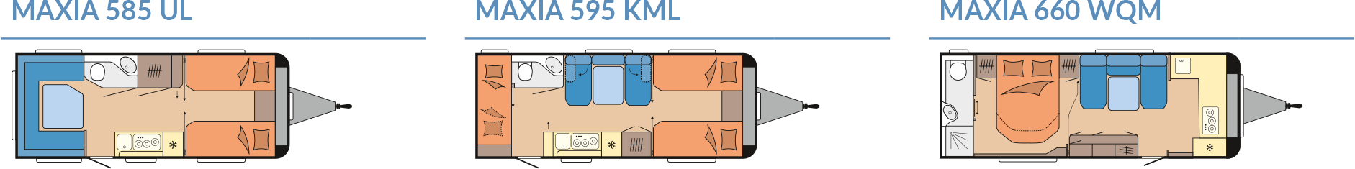

Modern design and comprehensive equipment package
In terms of the exterior design, the luxury-class MAXIA caravans boast the same sleek, dynamic looks as the rest of our line-up for the 2025 season. The new exterior combines sporty elements with a harmonious shape and colour scheme. Flowing contours, seamlessly integrated manoeuvring handles and rear lights give the MAXIA a fresh, modern style. This contemporary design flows seamlessly into the interior, where wall units with grey design accents and clean lines create an inviting, modern living space. Cosy upholstery, paired with a functional anthracite kitchen, completes the cohesive and harmonious overall aesthetic.

HIGHLIGHTS: compact layouts, maximum functionality

595 KML
The MAXIA 595 KML stands out with its unique multifunctional rear section that offers over nine different configurations. With just a few simple adjustments, you can set up or stow away up to three children’s beds. The space also caters to the imaginative play of young campers, easily transforming into a play den, a children’s seating area or a retreat for pets. Alternatively, it can be used as extra storage space for luggage. With up to seven berths, the 595 KML provides enough room for the whole family. The single beds can be expanded into a cosy family bed, and the central seating area and spacious kitchen ensure that everyone’s needs are covered.

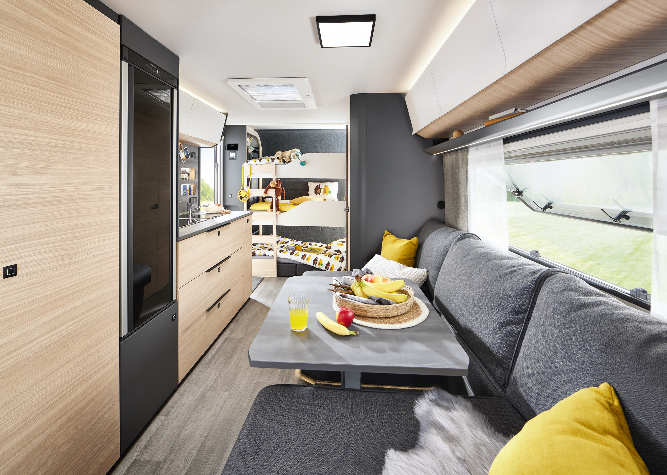
Everything a family needs for the road: the MAXIA 595 KML

660 WQM
Big, bigger, MAXIA: measuring up to 20 square metres, the MAXIA feels like a holiday apartment on wheels. This luxury caravan leaves nothing to be desired. The MAXIA 660 WQM boasts an island bed, a large central seating area, a front kitchen and a rear washroom. In short, this caravan offers all the creature comforts of a luxury apartment.
The spacious washroom and the colour-coordinated living and kitchen areas elevate this premium caravan to the next level. A highlight is the bright and airy front kitchen, complete with a 157-litre refrigerator and an expansive work surface. The large sofa with two chaises longues completes the perfect mobile living experience.

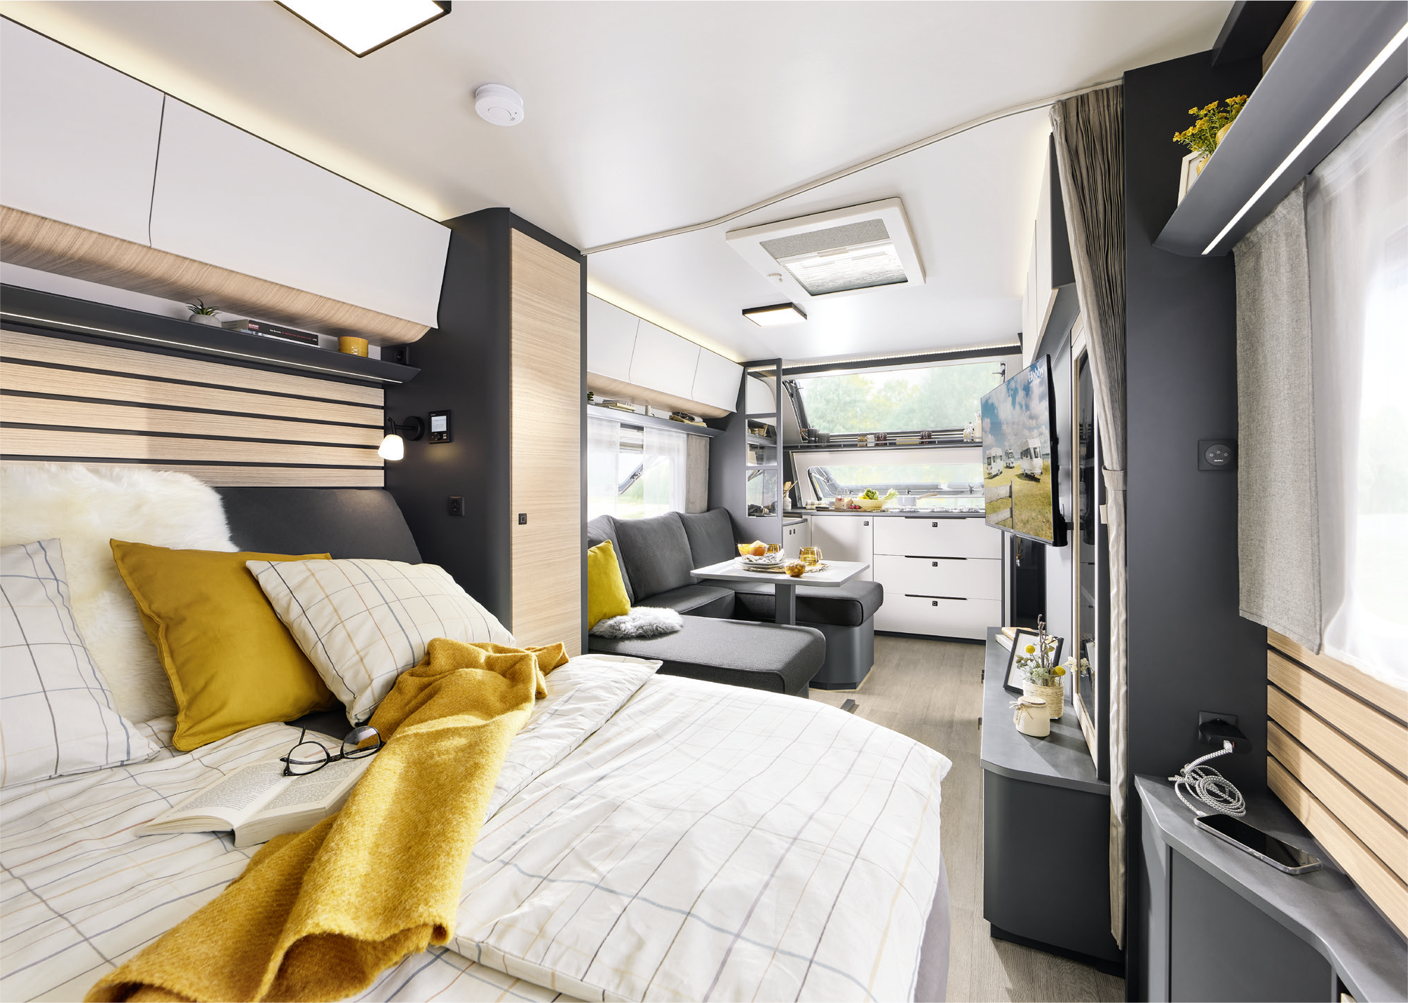
Camping with a luxury-apartment feel: the MAXIA 660 WQM

Camping passion, made in Germany
At Hobby, camping passion is crafted in Germany – right here in Fockbek, Schleswig-Holstein. We take pride in our high quality standards, which is why we offer a 12-year watertightness guarantee on all our vehicles. Our product range is as varied as the world of camping itself. Whether you’re looking for caravans, motorhomes or vans – from entry-level models to luxury-class vehicles, with comprehensive standard features or custom options – Hobby has it all. And with the HOBBYKOMPLETT ALL-INCLUSIVE package, every vehicle is ready to go, with no ifs, no buts and no hidden costs. That’s pure camping passion, “Made in Fockbek”.

The 2025 MAXIA model range will, of course, be on display at the Caravan Salon Düsseldorf from 30 August to 8 September 2024. And it’s now also available online at hobby-caravan.de/en

Further information is available from the Hobby press office:
presse@hobby-caravan.de or at mediaportal.hobby-caravan.de/en

