HOBBY’S ENTRY-LEVEL CARAVANS FOR THE 2025 SEASON
Fockbek, 28 August 2024 – The new season at Hobby is all about durability.
With a streamlined model range and refreshed interiors, Hobby vehicles are set to take the 2025 season by storm. Leading the way is the ONTOUR model range, representing modern, hassle-free camping for everyone with compact, versatile layouts and fresh designs, offering unbeatable value. The ONTOUR models offer three layouts with a choice between single beds, a double bed and children’s beds, ensuring there’s something for every budget.

THE ONTOUR – PERFECT FOR FIRST-TIME CAMPERS
Camping remains one of the most popular holiday choices. Once you’ve experienced it, there’s no going back. It’s no surprise that more and more couples and families are choosing to turn their dream of owning a caravan into reality. For those new to camping, the ONTOUR is the perfect starting point – and with the HOBBYKOMPLETT ALL-INCLUSIVE package, it’s ready to hit the road from day one. At 2.20 m wide, this entry-level model is compact enough to be easily manoeuvred by newcomers. At the same time, this small yet spacious caravan can comfortably accommodate a family with up to three children. Weighing from 1,200 kg upwards, it’s also suitable for smaller towing vehicles and electric cars. And the price is just as attractive: the ONTOUR starts at just €21,100.

The ONTOUR 390 SF is the smallest model in the range, with up to four berths. The 460 DL, featuring longitudinal beds and a dinette, also comfortably sleeps up to four people. The ONTOUR 470 KMF offers even more space, with a children’s bed layout providing up to five berths. Thanks to the HOBBYKOMPLETT ALL-INCLUSIVE package, all three entry-level models come fully loaded with everything you need for your travels. At Hobby, “all-inclusive” means exactly that – there are no additional or mandatory upgrades, just your perfect travel companion, ready to hit the road straight from the factory for the perfect holiday.

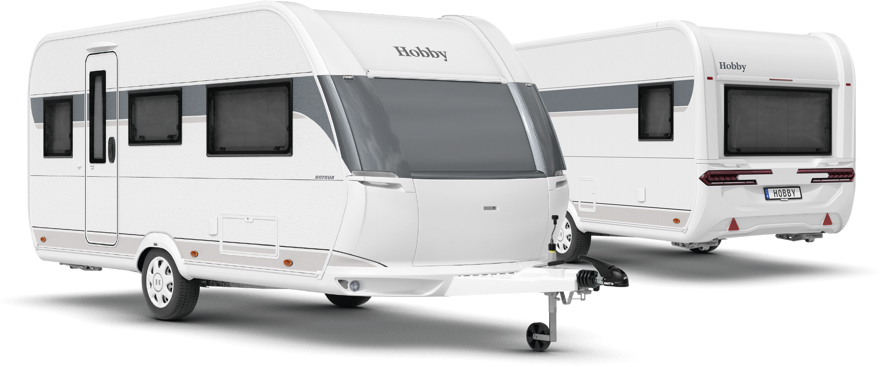
Exterior design of the ONTOUR 460 DL

LAYOUTS AT A GLANCE

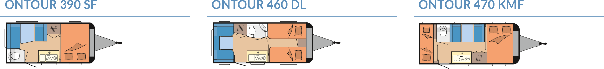

Modern design and comprehensive equipment package
Like all our caravans, the ONTOUR enters the 2025 season boasting a sporty, dynamic and harmonious exterior design. Flowing cONTOURs, seamlessly integrated manoeuvring handles and rear lights give the ONTOUR a fresh, contemporary style. This modern aesthetic extends into the interior, where linear wall units with grey accents create a clean, modern and inviting living space. The furniture, complete with comfortable upholstery, and an anthracite-coloured kitchen complement the minimalist, uncluttered overall design.

HIGHLIGHTS: compact layouts, maximum functionality

390 SF
Though the 390 SF has the shortest layout in the entire Hobby range, this entry-level model still impresses with a spacious and comfortable double bed. The side seating area and transverse bed at the front make intelligent use of the available space. The seating area can be quickly and easily converted to create two additional berths. Whether you’re travelling as a couple or a group of four, the stylish anthracite-coloured kitchen makes it easy to prepare meals quickly for everyone. 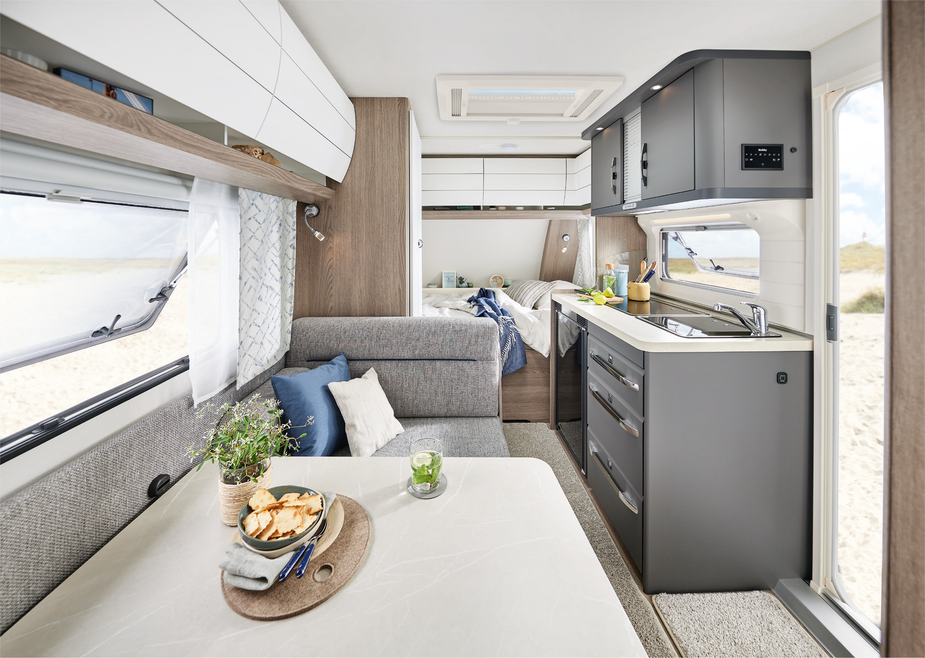
The ONTOUR 390 SF comes with everything you need
460 DL
Our most compact layout with longitudinal beds. With a dinette in the rear section and two single beds at the front, it combines an optimal room layout with plenty of flexibility. An optional bed extension lets you transform the front area into a large sleeping space. And by converting the dinette, which only requires a few adjustments, you’ll have four berths ready in no time. The side kitchen, equipped with a 98-litre refrigerator and a three-burner hob, offers ample storage space for all your culinary needs.
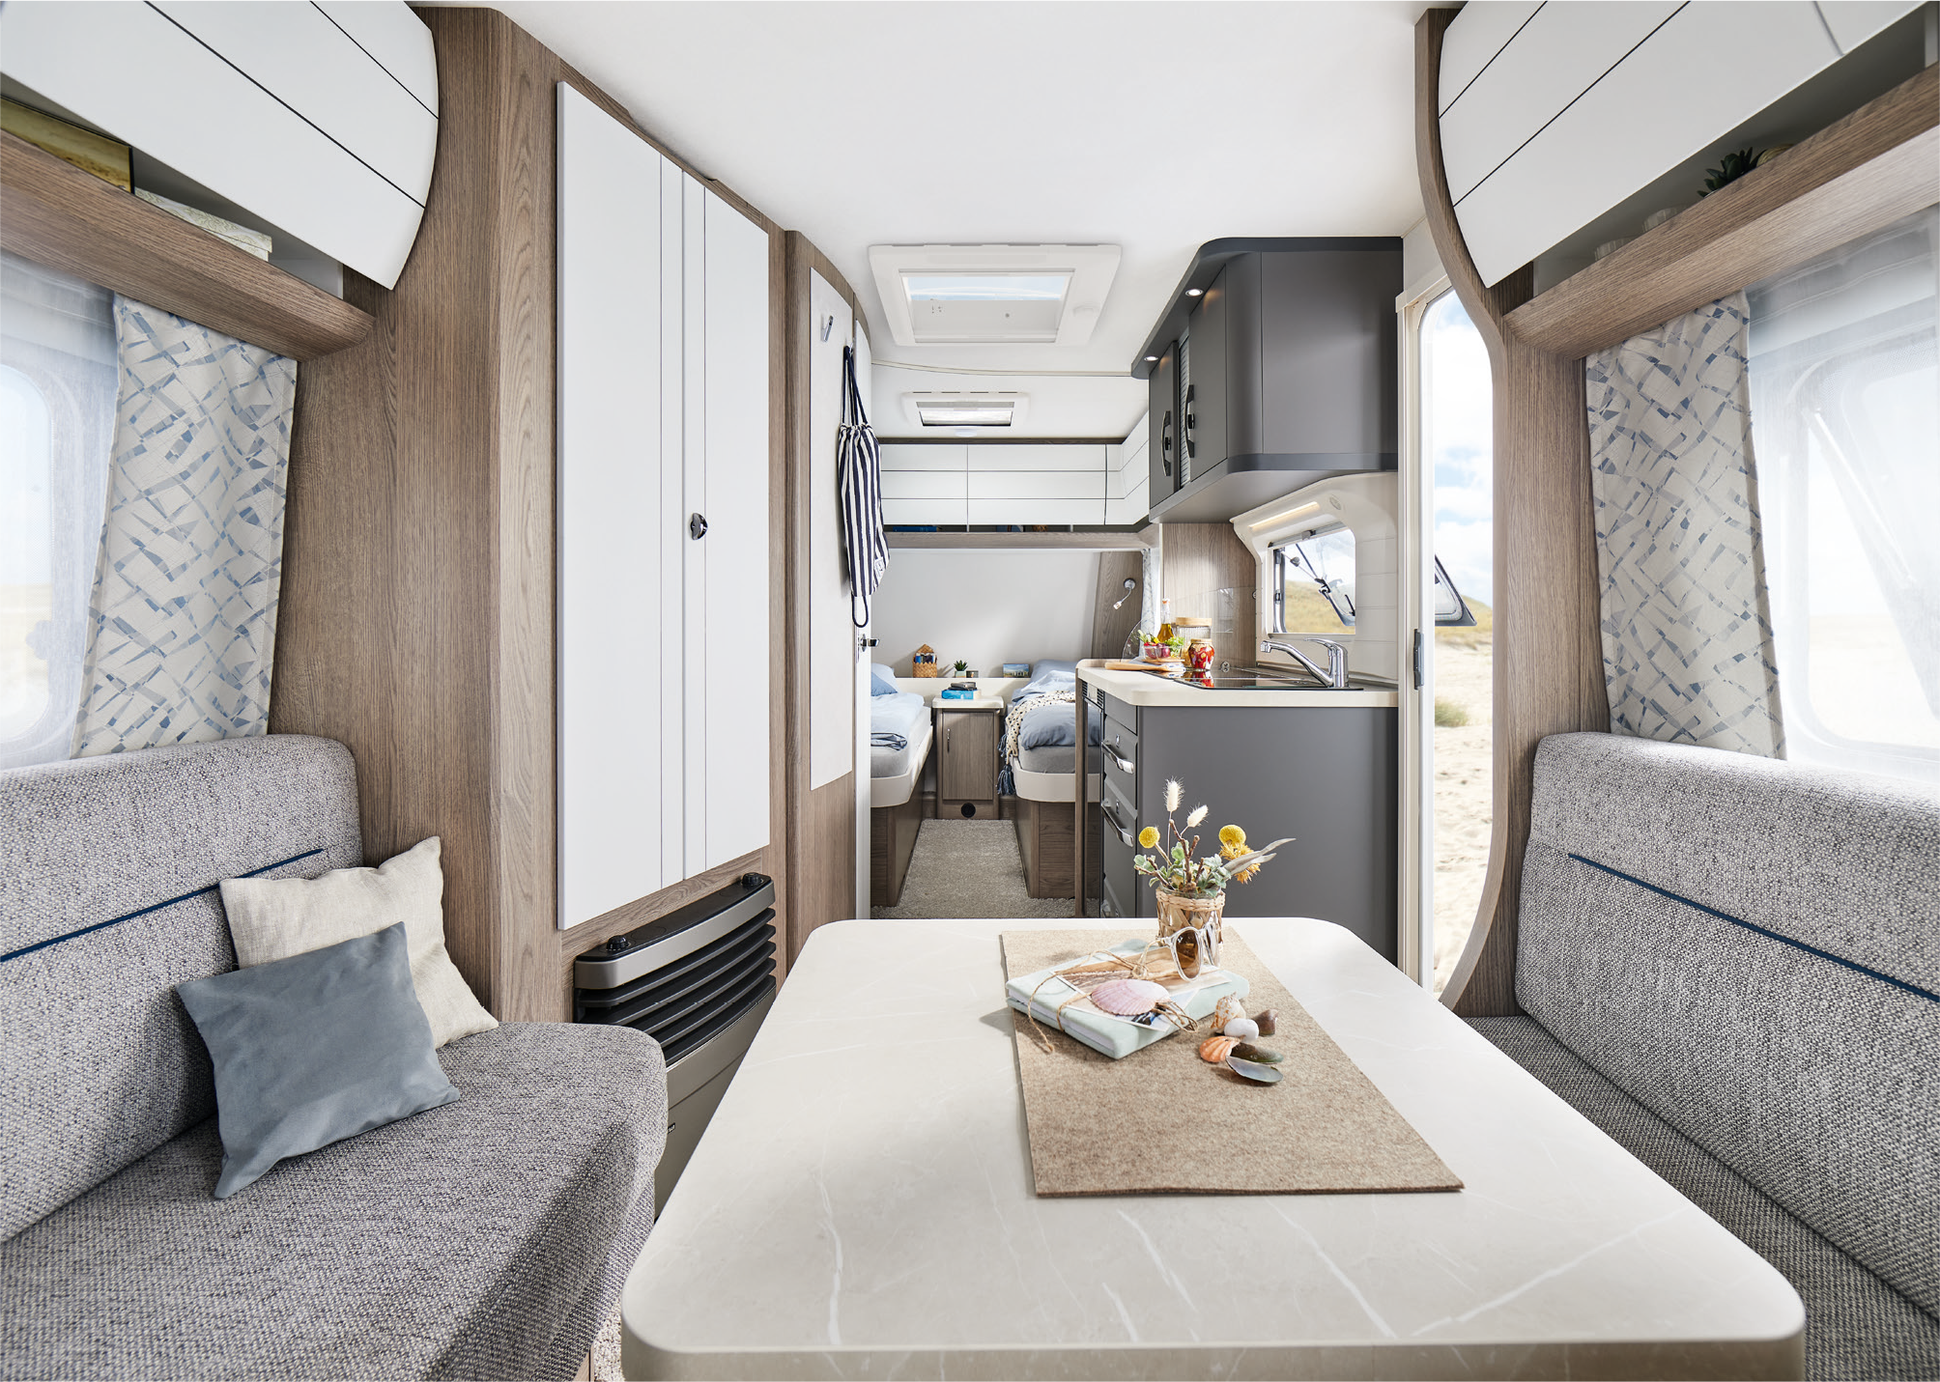
Fresh look in the ONTOUR 460 DL

Camping passion, made in Germany
At Hobby, camping passion is crafted in Germany – right here in Fockbek, Schleswig-Holstein. We take pride in our high quality standards, which is why we offer a 12-year watertightness guarantee on all our vehicles. Our product range is as varied as the world of camping itself. Whether you’re looking for caravans, motorhomes or vans – from entry-level models to luxury-class vehicles, with comprehensive standard features or custom options – Hobby has it all. And with the HOBBYKOMPLETT ALL-INCLUSIVE package, every vehicle is ready to go, with no ifs, no buts and no hidden costs. That’s pure camping passion, “Made in Fockbek”.

The 2025 ONTOUR model range will, of course, be on display at the Caravan Salon Düsseldorf from 30 August to 8 September 2024. And it’s now also available online at hobby-caravan.de/en

Further information is available from the Hobby press office:
presse@hobby-caravan.de or at mediaportal.hobby-caravan.de/en

