HOBBY’S LUXURY-CLASS CARAVANS FOR THE 2025 SEASON
Fockbek, 28 August 2024 – For the new season, Hobby is taking what’s already great and making it even better. To achieve this, it has focused on meaningful updates and practical optimisations. The result is a streamlined model line-up, stylish and functional interior upgrades, and a fresh exterior facelift. Leading the charge in the luxury-class model range is the PRESTIGE series. With ten layouts, the PRESTIGE offers everything in abundance: plenty of space, exceptional comfort and a range of sleeping options. The focus here is on longer layouts with tandem axles and expansive seating areas. Every layout in this model range is suitable for use in winter and, with up to seven berths, the PRESTIGE is perfect for larger families.

THE PRESTIGE – READY FOR ANY ADVENTURE
For seasoned campers, the PRESTIGE is the top choice. It’s also ideal for anyone looking to take their camping experience to the next level. Designed for even the longest adventures, this luxury-class caravan is the perfect companion for those with discerning tastes. With ten distinct layout options, it offers the flexibility needed to satisfy a wide variety of requirements. The PRESTIGE luxury-class caravan is available from €35,220. All models come equipped with the HOBBYKOMPLETT ALL-INCLUSIVE package, which includes a powerful heating system, optimal heat insulation, as well as modern thermal protection and body technology. This means that even freezing temperatures won’t cause you any problems when camping during the winter. Optional features like the ALDE hot water underfloor heating add an extra layer of comfort in seven models.

Built to meet the highest standards – across the board. That’s the essence of PRESTIGE. The single-axle 560 FC stands out thanks to its couch seating area, which creates a cosy living-room vibe. The 720 KWFU takes a different approach, serving as a versatile family caravan with solutions for every scenario. Stylish ambient lighting elevates the premium living experience, while the extra-large wall units provide ample storage for all manner of items, helping to maintain the uncluttered interior design. Four layouts feature large couch U-shaped seating areas and corner kitchens with surprisingly generous work surfaces and storage options. With exceptional details like heated coat hooks, it’s clear that the PRESTIGE will take your camping experience to the next level.

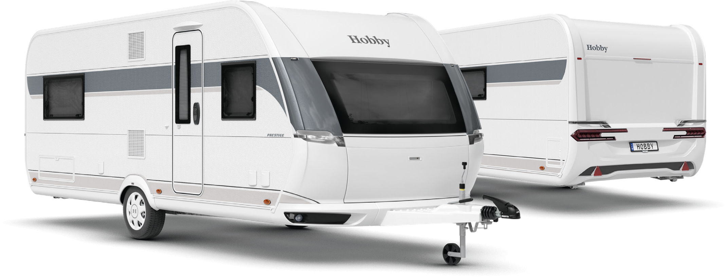
Exterior design of the PRESTIGE 560 FC

LAYOUTS AT A GLANCE

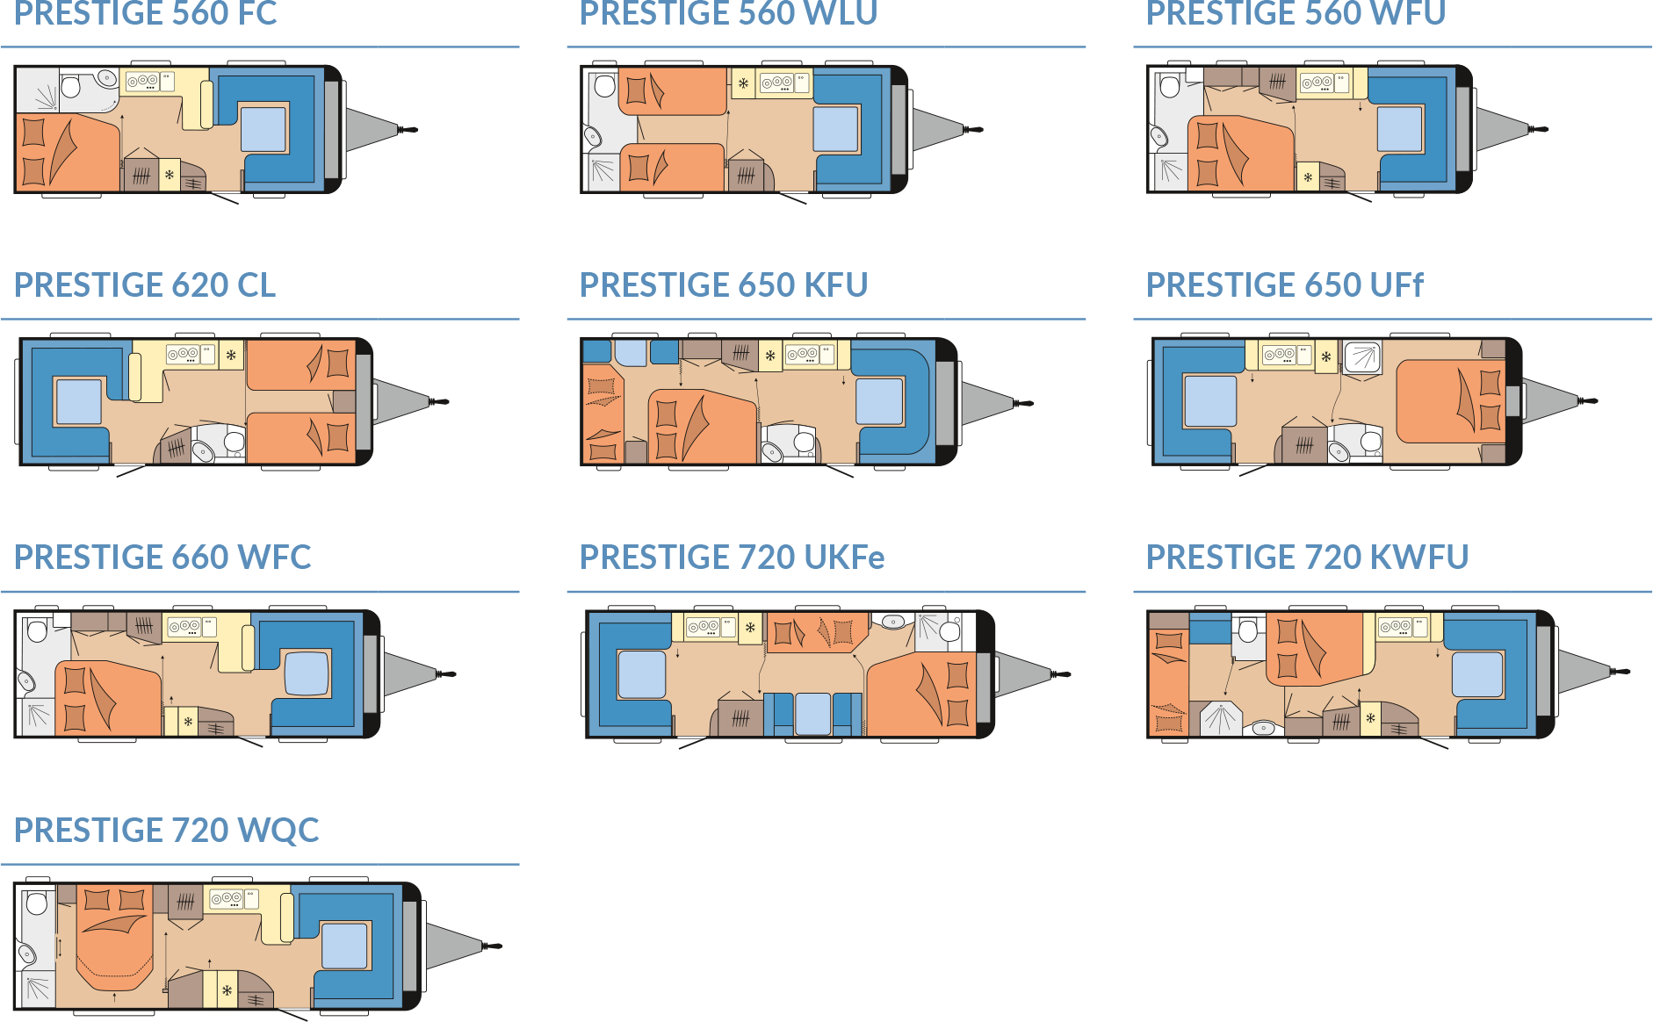

Modern design and comprehensive equipment package
For the 2025 season, the PRESTIGE boasts a sporty and distinctive look. Its exterior design masterfully blends contemporary dynamism with timeless harmony. The contours flow seamlessly, and exterior elements like the manoeuvring handles and rear lights are perfectly integrated into the cohesive overall design. The interior is just as impressive, boasting a comprehensive equipment package. Minimalist furniture, such as the linear wall units with thoughtfully placed design accents, radiates style and sophistication. Homely upholstery in calm, timeless tones, a modern kitchen and a well-equipped washroom ensure that every need is met while travelling. And the feeling of being at home hits you as soon as you step on board.

HIGHLIGHTS: compact layouts, maximum functionality

560 FC
The PRESTIGE 560 FC brings the comfort of home to the road. A large double bed at the rear promises a restful and cosy night’s sleep. The spacious U-shaped seating area comfortably accommodates both fellow travellers and guests. A highlight is the large panoramic window, which further enhances the sense of space in this already roomy caravan. The corner kitchen is not just stylish and modern but also extremely practical, with plenty of workspace, counter space and storage space. The washroom prioritises comfort, offering a separate shower, washbasin and toilet.
720 KWFU
The PRESTIGE 720 KWFU, 2024 model, is the quintessential family caravan. With a double bed and a bunk bed that can accommodate up to three tiers, every family member will have their favourite spot. The spacious U-shaped seating area, complete with a panoramic front window, is ideal for gathering the family – whether for breakfast, dinner or game time. The chic kitchenette is designed for convenience, with everything easily accessible for quick and effortless meal preparation. The well-thought-out washroom concept extends into the bathroom, where the shower cubicle, separate washbasin with a large mirror, and toilet can all be used independently for maximum functionality.

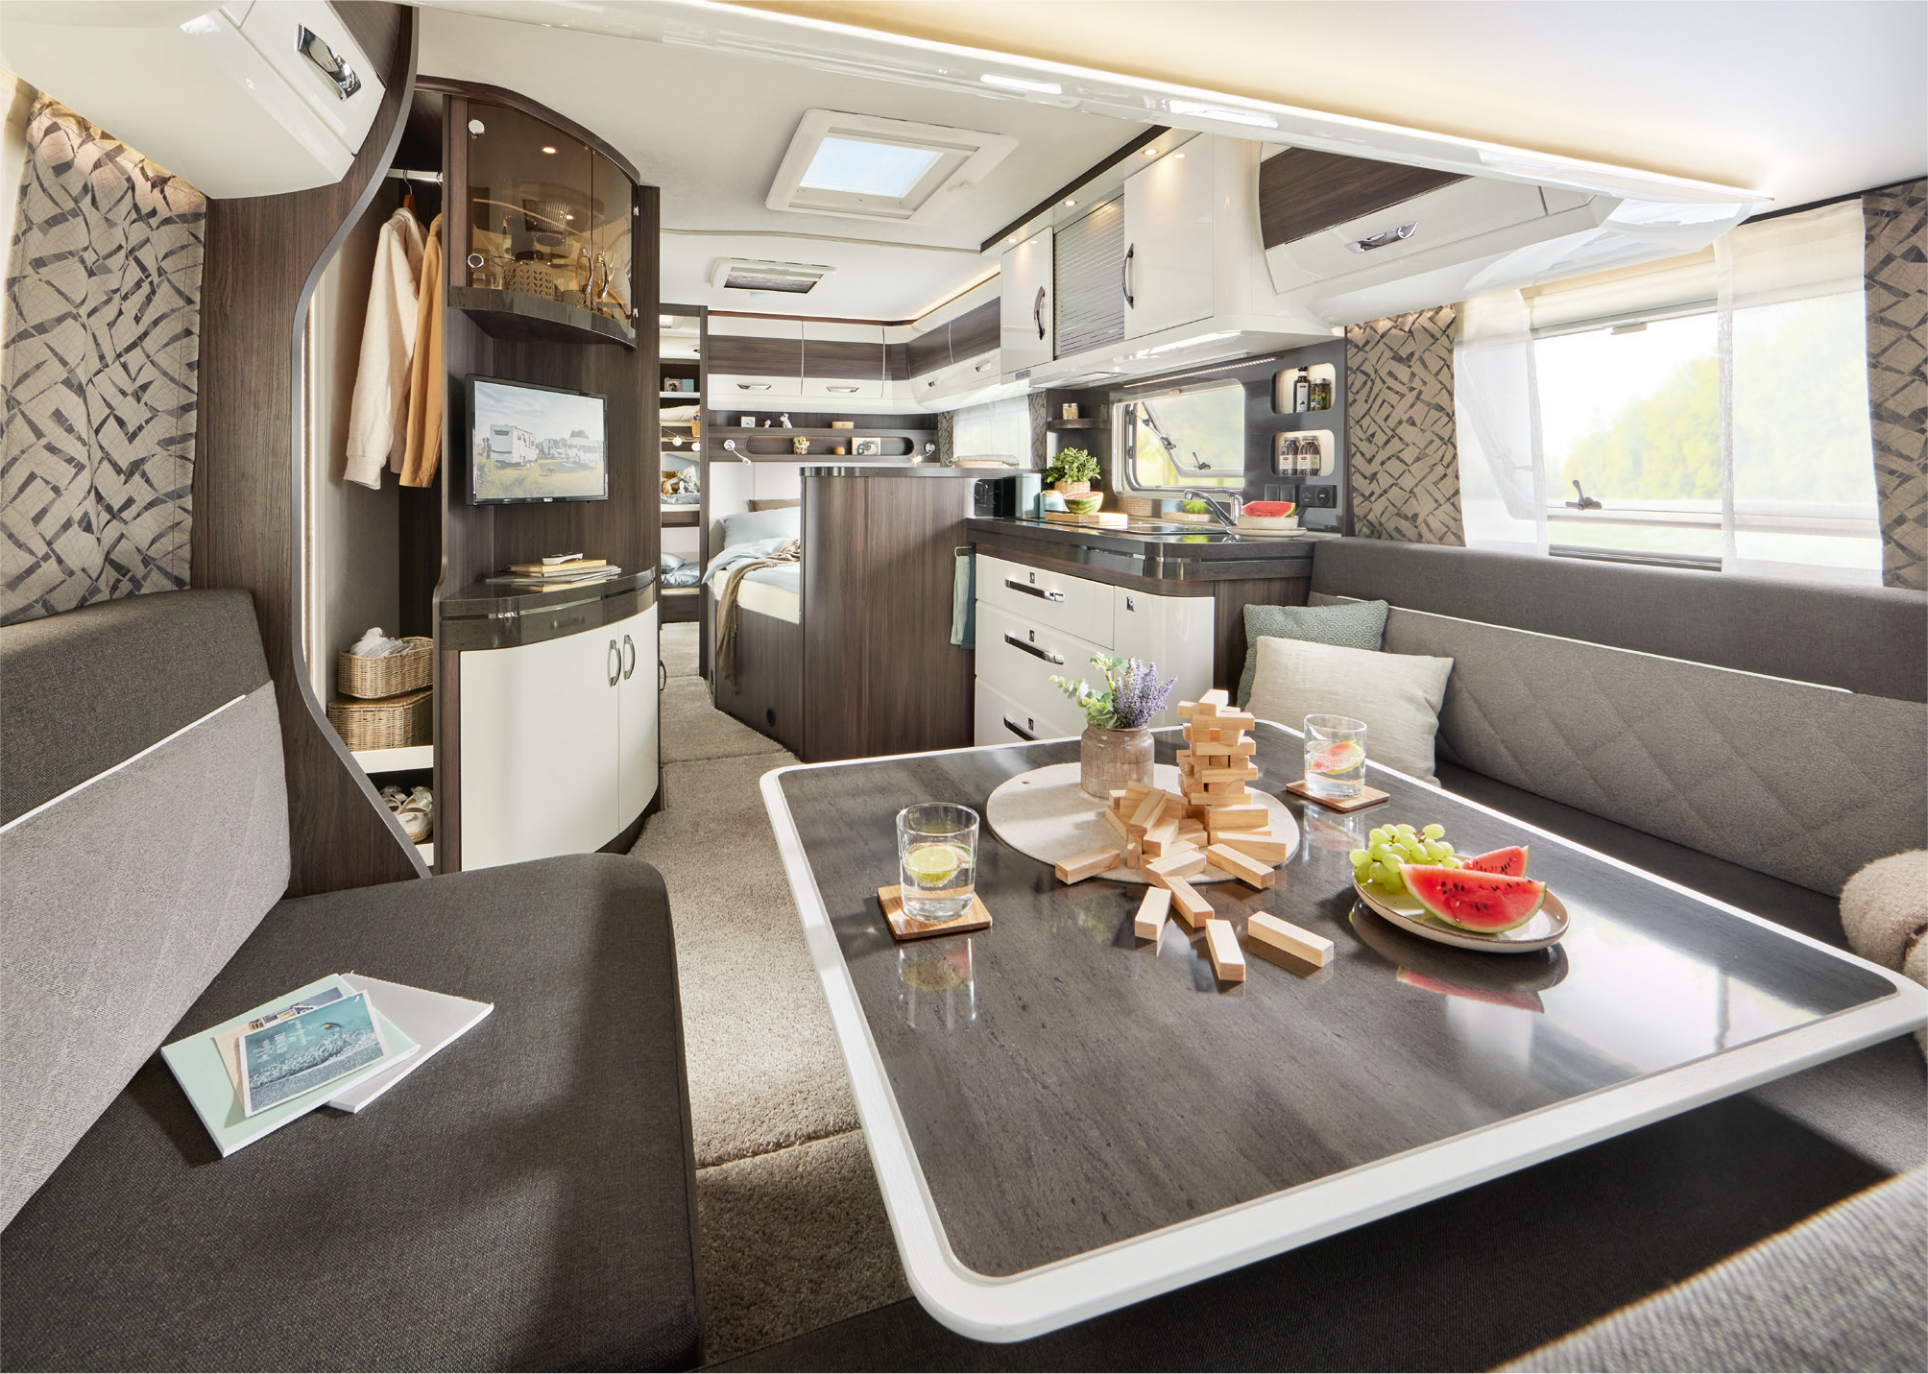
Made for families: the PRESTIGE 720 KWFU

Camping passion, made in Germany
At Hobby, camping passion is crafted in Germany – right here in Fockbek, Schleswig-Holstein. We take pride in our high quality standards, which is why we offer a 12-year watertightness guarantee on all our vehicles. Our product range is as varied as the world of camping itself. Whether you’re looking for caravans, motorhomes or vans – from entry-level models to luxury-class vehicles, with comprehensive standard features or custom options – Hobby has it all. And with the HOBBYKOMPLETT ALL-INCLUSIVE package, every vehicle is ready to go, with no ifs, no buts and no hidden costs. That’s pure camping passion, “Made in Fockbek”.

The 2025 PRESTIGE model range will, of course, be on display at the Caravan Salon Düsseldorf from 30 August to 8 September 2024. And it’s now also available online at hobby-caravan.de/en

Further information is available from the Hobby press office:
presse@hobby-caravan.de or at mediaportal.hobby-caravan.de/en

